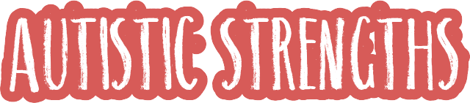

The autistic brain comes with certain strengths or “superpowers”, although all children are unique and not all strengths will apply to all children. Understanding and celebrating the different ways in which the autistic brain works can help your child to flourish.

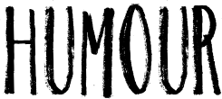















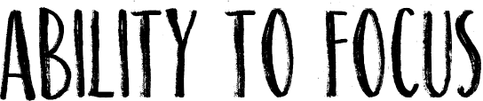



Can you think

of more?

Designed by CAMHS NDC Pathway, December 2019.