C:\Users\psansom\AppData\Local\Microsoft\Windows\INetCache\Content.Word\Chain lines.png

**Framework for Integrated Care (Community)**

NHS England and NHS Improvement

**Framework for Integrated Care** **(Community)**

Version number: 3.1 Draft

First published:

Updated: February 2022

Prepared by: NHS England and NHS Improvement Health and Justice Children and Young People Team in association with Dr Andrew Rogers, Consultant Clinical and Forensic Psychologist, and NEL Healthcare Consulting.

Many thanks to the following organisations/individuals for their contributions and support:

* Department for Education,
* Department for Health and Social Care,
* Local Government Association,
* NHS England Children and Young People Mental Health Team,
* NHS England Children and Young People with Complex Needs and Looked After Children Transition,
* Peer Power,
* Public Health England,
* Dr Duncan Law, Consultant Clinical Psychologist,
* Dr Celia Sadie, Consultant Clinical Psychologist,
* Dr Kate Ward, Clinical Psychologist
* Dr Oliver White, Consultant Child & Adolescent Forensic Psychiatrist.

# Contents

Contents 3

1. Executive Summary 5

2. Introduction 8

3. Trauma-Informed Approaches 11

4. Framework for Integrated Care for the Community in detail 13

4.1 Vision, mission and objectives (see also Appendix 7.1) 13

4.2 Overarching Principles (see also Appendix 7.2) 14

4.3 Input, drivers, activities, outputs, outcomes and impact 15

5.4 Inputs 16

4.5. Children and young people (see diagram in Appendix 7.3) 18

4.5.1 Children and young people drivers 18

4.5.2 Children and young people activities 18

4.5.3 Children and young people outputs 18

4.5.4 Children and young people outcomes (short-term) 19

4.6 Staff (see diagram in Appendix 7.4) 19

4.6.1 Staff drivers 19

4.6.2 Staff activities 19

4.6.3 Staff outputs 20

4.7 Organisational (see diagram in Appendix 7.5) 20

4.7.1 Organisational drivers 20

4.7.2 Organisational activities 20

4.7.3 Organisational outputs 21

4.7.4 Organisational outcomes (short-term) 21

5. Glossary and key terms 22

6. References 27

7. Appendices 28

7.1 – Vision, Mission and Objectives 28

7.2 – Overarching principles  29

7.3 – Children and young people logic model 30

7.4 – Staff logic model 31

7.5 – Organisation logic model 32

# Executive Summary

The Framework for Integrated Care (Community) has been developed to support improved outcomes and a reduction of health inequalities amongst a small but very worrying cohort of children and young people whose needs do not fit “neatly” within statutory services. These complex children have a disproportionate impact across systems which should support them, but which do not meet their needs well in practice.

Together Integrated Care Partnerships and Integrated Care Boards will be responsible for developing a plan to meet the health needs of the population within their defined geography and for securing the provision of health services to meet the needs of the system population as part of the NHS system transformation. This framework is designed to be used at a system level to support communities and populations.

Within the Core20PLUS5 approach to tackling health inequalities, it is highly likely that these children are within the 20% most deprived population within England, and are at risk of suffering from some of the key 5 areas of focus, and maybe at risk of developing or suffering severe mental illness and chronic respiratory disease. There are high levels of disproportionality in children in contact with the youth justice system, across protected characteristics such as gender and ethnicity, as well as long-term neuro disability needs.

Designed within the context of system transformation, the Framework for Integrated Care (Community) has been developed to provide the new structures forming part of this transformation with a ‘scaffold’ to support local services to better provide for these children, rather than prescribing a fixed and top-down service delivery model. Integrated care is about giving individuals the support they need through improved join- up across systems. It removes traditional divisions between hospitals and family doctors, between physical and mental health, and between NHS and social care. In the past, these divisions have meant that too many people experienced disjointed care or fell into ‘gaps’ between services. This Framework is intended to allow for innovation and collaboration that stretches across traditional agency boundaries and which promotes genuine integration and co-production. This new model of working acts as a catalyst for cultural and organisational change, with the aim of developing and enhancing services that promote safeguarding, prevent re-traumatisation and enable children and young people with complex needs to thrive. It is anticipated that this Framework may influence support for a wider cohort of children and young people beyond those very complex children, and include those with learning disability, autistic spectrum condition, or both. Implementation of this Framework should also enable an in increase in community-based support and reduce the reliance on specialist hospitals.

The Framework is evidence based and has evolved from learning through previous projects that were part of the Children and Young People Mental Health Transformation Workstream within NHS England and NHS Improvement, including the roll out of Community Forensic CAMHS across England, the introduction of the Framework for Integrated Care (SECURE STAIRS) into the children and young people secure estate and the development of Collaborative Commissioning Networks.

The main principles of the Framework are:

1. **Every Interaction Matters**: There is a focus first on building and supporting positive collaborative relationships.
2. **Children and young people** and the **relationships they experience** are at the **centre of all care** they receive through genuine **co-production**.
3. This spending most time with the young people are the **primary facilitators of change.**
4. **Positively influencing** the day to day care is the basis of any intervention and the primary focus of support.
5. **All behaviour is understandable in context**; there is a focus on developing an understanding of each child’s behaviours and needs based on their story **(Formulation).**
6. There is a commitment by all to build and **sustain trauma informed organisations.**

The Framework aims to build trauma-informed care and formulation-driven, evidence-based, whole system approach to providing integrated support and creating change for the most vulnerable. It offers an approach for *“those involved in the direct care of the young person to form a pragmatic, developmentally and contextually appropriate understanding of a complex presentation, which, supported by psychologically informed formulation, helps to inform and prioritise appropriate interventions”* (Rogers and Budd, 2015), and support those who deliver them.

The remainder of this document provides more background and detail on the way in which the Framework is intended to function.

# 2. Introduction

There exists a cohort of vulnerable children and young people with complex needs who experience some of the highest levels of health inequality in society. Their needs are defined as ‘complex’, as they often are:

* **Multiple** (i.e. not just in one domain, such as mental and physical health);
* **Persistent** (i.e. long term rather than transient, including for example learning disability, autism or both);
* **Severe** (i.e. not responding to standard interventions); and
* **Framed by family and social contexts** (i.e. early family disruption, loss, inequality, prevalence of Adverse Childhood Experiences).

The recently published THRIVE Framework for system change conceptualises the mental health and wellbeing needs of children, young people and families into five needs-based groupings[1]. The cohort of vulnerable children and young people with complex needs, shares similar characteristics to those described in THRIVE’s needs-based groupings of ‘Getting More Help’ – *those who need more extensive and specialised goals-based help*- and ‘Getting Risk Support’ –*those who have not benefitted from or are unable to use help, but are of such risk that they are still in contact with services*.

Services across multiple sectors collectively struggle to meet the needs of children and young people with the most complex needs. Similarly, many children and young people struggle to access, respond and maintain progress with the support and interventions offered. This can be due to multiple reasons:

* Existing provision may not be well-equipped or may lack specific expertise to respond to needs and presentation, including trauma-informed ways of working;
* The involvement of multiple professionals may lead to inconsistency in approach and a lack of continuity of care and/or not meeting needs in a ‘holistic’ way;
* The interventions provided are often single modality driven (such as Cognitive Behavioural Therapy or medication), and involve the children and young people individually, failing to address the wider systemic context[2];
* The child or young person and/or family/carer may be unwilling or unable to engage (e.g. due to a lack of trust in statutory services or because entry points are difficult to navigate).
* Services and/or therapeutic interventions are not always appropriately reasonably adjusted for children and young people with learning disabilities, autism or both

This often results in the child’s or young person’s underlying needs not being met by current services, and in turn reinforcing vulnerability and high-risk behaviours. As a result, anxiety in staff (and parents/carers), working directly with those complex children and young people, can increase due to concern for them. These challenging interactions between children and young people with complex needs, their families and carers, stressed staff, and pressured organisations can often become counterproductive to offering a therapeutic system (Bloom, 2006) and instead perpetuate the cycle of high harm, high risk and high vulnerability.

The challenges around this group of children and young people are not new. Recent national and local initiatives have worked to improve the support, quality, and range of health services these children receive. As a result, there are pockets of promising practice across the country. However, the systems these services are trying to operate in are rarely integrated with each other, resulting in silo based working and ultimately, complex unmet needs for these children and young people across the community.

System transformation that is in progress is intended to increase the level of integration between different services. The Health and Care Bill introduced in Parliament on 6 July 2021 confirmed the Government’s intentions to introduce statutory arrangements for Integrated Care Systems (ICSs) from April 2022, in line with NHS recommendations. ICSs are intended to bring the NHS together locally to improve population health and establish shared strategic priorities within the NHS, connecting to partnerships across the ICS. Along with this change, Clinical Commissioning Groups (CCGs) will be absorbed by ICSs and abolished as statutory organisations.

Together the Integrated Care Partnerships and Integrated Care Boards will be responsible for developing a plan to meet the health needs of the population within their defined geography and for securing the provision of health services to meet the needs of the system population. In tandem, Clinical Commissioning Groups will be merged with their local ICS Health and Care Partnership, and NHS England will be able to delegate S7A public health services to one or more ICSs, or groups of ICSs. ICSs and local authorities will be given a duty to collaborate with each other. Partnership working across health, social care and wider organisations is promoted throughout the White Paper.

Predating this planned system transformation, but aligned to it with its targeted population and need driven design within specific vanguards, the NHS Long Term Plan 2019 made the following commitment that references the Framework for Integrated Care (Community):

*In selected areas, we will also develop new services for children who have complex needs that are not currently being met. For 6,000 highly vulnerable children with complex trauma, this will provide consultation, advice, assessment, treatment and transition into integrated services.*

This commitment now forms part of the NHS England and NHS Improvement Covid restore and recovery plan. It provides an opportunity to strengthen and support the new structures that are part of system transformation to pull together to provide services more effectively for these children with complex needs, reducing health inequalities and contributing to wider social goals by helping to prevent children ending up in secure care, whether this is a justice or welfare setting or the secure mental health estate.

# 3. Trauma-Informed Approaches

Children and young people with complex needs, whilst being far from a homogenous group, almost universally have common, complex histories of survival, attachment and relational disruption and trauma. The resulting complex needs often underpin behaviours that can be considered as high risk to self or to others, and/or can leave young people particularly vulnerable to harm and exploitation from others. As a result, services need to acknowledge the psychological and social factors in the development of complex needs, and children and young people presenting to services should have their behaviours understood in the context of their lived experience (Rogers and Budd, 2015).

Trauma-Informed Approaches (TIAs) are based on the understanding that many of these children and young people already in contact with services have experienced adversity and trauma and may consequently find it difficult to develop trusting relationships with staff providing care, and feel safe within services (Sweeny and Taggart, 2018). This understanding needs to permeate service relationships and delivery. TIAs are informed by neuroscience, psychology and social science as well as attachment and trauma theories, and give central prominence to the complex and pervasive impact adversity and trauma has on a person’s worldview and interrelationships.

Within TIAs the basic safety of environments is prioritised (physical, psychological, social and moral). Training, reflective practice (including clinical supervision) and support for staff is seen as essential to help them recognise and focus on the impact of trauma on children and young people and their support systems. Steps are taken to build a sense of community and shared responsibility between staff and service users. This means that services prioritise building trusting mutual relationships first.

TIAs are not simply trauma-specific interventions or services. They can include those, but also incorporate key trauma principles and practices across the whole organisational and system cultures. *“A program, organization, or system that is trauma-informed* ***realizes*** *the widespread impact of trauma and understands potential paths for recovery;* ***recognizes*** *the signs and symptoms of trauma in clients, families, staff, and others involved with the system; and* ***responds*** *by fully integrating knowledge about trauma into policies, procedures and practices, and seeks to actively* ***resist re-traumatization****.”* (“SAMHSA’s Concept of Trauma and Guidance for a Trauma-Informed Approach”, 2014)[3].

The DART Framework; AMBIT[4]; MAC-UKs ‘integrate’ model[5]; Trauma Recover Model and Enhanced Case Management[6] and Framework for Integrated Care (SECURE STAIRS) developed for the current youth justice and welfare secure estate; are promising examples of trauma-informed approaches introduced in the UK. In particular, the Framework for Integrated Care (SECURE STAIRS) for the Children and Young People Secure Estate (CYPSE) aims to support trauma-informed care and formulation-driven, evidence-based, whole systems approaches to creating change for children and young people within the CYPSE. The Framework for Integrated Care (SECURE STAIRS) for the CYPSE has been running since 2016, and feedback to date, from children, young people and staff within the secure estate, has been very positive.

# 4. Framework for Integrated Care (Community) in detail

## 4.1 Vision, mission and objectives (see also Appendix 7.1)

The **Vision** is:

To facilitate integrated trauma-informed systems that enable children and young people with complex needs to thrive.

The **Mission 2030** is:

To effect cultural change through developing local, sustainable and trauma-informed children's emotional wellbeing services by:

1. Working collaboratively across services to co-ordinate, integrate and deliver trauma-informed care;
2. Genuine co-production with children and young people with complex needs, and their families, to develop services and systems that are accessible and acceptable to them;
3. Working with the child directly, through relationships with staff in the role of ‘young people’s advocates’ , who are psychologically informed and well supported, have a positive view of young people and are able to understand them and who advocate for and support them effectively along their journeys.

The key **Objectives** are:

1. Improved children and young peoplewellbeing, i.e.:

Displaying direct improvement in their MH, emotional regulation and well-being;

* + Previously unmet emotional and behavioural need in this group of children and young people is now met;
  + Reduced number of children and young people being excluded from mainstream provision of core services.

1. Reduction in high-risk behaviours, i.e.:
   * Reduced frequency and severity of identified behaviours that indicate the potential for harm (to self, others or from others);
   * Reduced frequency and severity of behaviours that could be described as challenging
   * Reduced number of children and young people offending and reoffending.
2. Reduced mental health concern, i.e.:
   * Improved resilience and reduced anxiety of children and young people staff, family members and carers;
   * Children and young people, staff, family members and carers feel empowered (involved in the care planning process), supported (formally & informally) and informed (understand what they are doing and why).
3. Organisations that are more trauma-informed, i.e.:
   * Increased awareness of the impact of trauma at an individual, organisational and community level;
   * Increased awareness and support for staff to recognise and manage their own responses when working with complex trauma;
   * Enhanced feelings of psychological safety for children and young people, staff, family members and carers.
4. Improved purpose/occupation, i.e.:
   * Children and young people are supported by staff to re-enter/remain in mainstream education where appropriate (or local specialist provision for children with SEND where previously indicated), and enjoy and achieve through positive learning experiences;
   * Improved education attendance and engagement as well as prevented sanctions, planned isolations and school exclusions.
5. Improved stability of home, i.e.:
   * Reduced number of children and young people being moved on a regular basis.
   * Reduction of admission to Tier 4 provision
   * Reduction in unnecessary/inappropriate out of area placements

## 4.2 Overarching Principles (see also Appendix 7.2)

The Framework for Integrated Care is based on six key principles (see figure 1) which underline the service, and when implemented will help meet the objectives, and overall impact the service aims to achieve. In addition to the six key principles outlined here, any service created should also align to the THRIVE Framework principles.

The six overarching principles of the Framework for Integrated Care are:

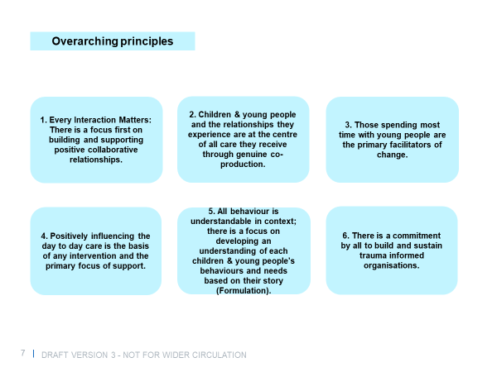

**Figure 1.** Overarching Principles of the Framework for Integrated Care.

## 4.3 Input, drivers, activities, outputs, outcomes and impact

The necessary actions and resulting benefits of the overarching principles will be realised at different points in the mobilisation, transition and transformation process of implementation. These changes have been split out with the following criteria:

|  |  |
| --- | --- |
| Types of change | Definition |
| **Inputs** | The resources required to achieve the activities and outcomes to deliver the Framework. Local areas will define their specific proposals of the team and local governance required to deliver this service. |
| **Drivers** | The elements that fundamentally underpin the service, necessary to produce the described outputs. |
| **Activities** | The actions undertaken to produce the described outputs. |
| **Outputs** | Outputs are the tangible results which are achieved immediately after undertaking an activity. |
| **Outcomes/ Objectives** | Outcomes are mid-term results. They are not seen immediately after the end of the activity but after some time. They are the changes expected within the environment, and relate to the initially set goals and the activities undertaken.  For this Framework the outcomes have been split into two:   * Outcomes (Shorter term) * Objectives (Longer term) |
| **Impact/**  **Vision** | Impact is the long-term outcomes achieved and include the wider health and social outcomes as a result of the project. |

The components listed above are aligned to children and young people (see section 4.5), staff (see section 4.6) and organisational (see section 4.7). This structure and relationships of all components is shown in the diagram below:

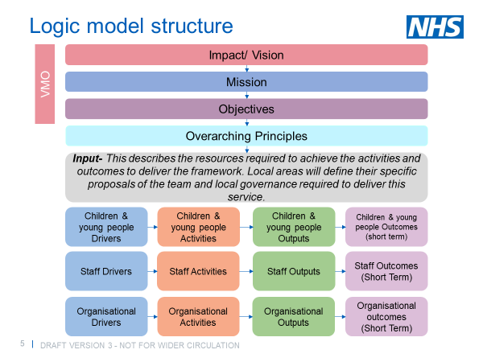

**Figure 2.** *Structure of the Framework for Integrated Care.*

## 4.4 Inputs

There are multiple ways of operationalising the principles, therefore specific inputs and approaches to deliver the activities and outcomes in this Framework may vary by local area and service provided. Local systems and organisations will develop their tailored responses to the Framework, depending on the specific needs of their local cohort. For instance, the complex needs service may consist of the following:

* Senior clinical leadership and oversight to influence relationships and organisational change across agencies and set up and embed credible and reflective practice;
* Young people’s advocates (e.g. youth worker, peer support worker) trained in psychological principles, knowledgeable and skilled in engaging with the children and young people and the system around them;
* A team in the community to support the coordination of services around the children and young people and act as an advocate for them;
* An offer of direct interventions from specialist mental health practitioners where risk is high and need is indicated through the formulation process;
* Additional expertise as needed, such as neurodevelopmental and/ or speech, language and communication therapy, to cater for these children or young people.
* Reasonable adjustments in access and provision for children and young people with learning disabilities, autism or both.
* Clear links to local area commissioners to identify and address any gaps within existing provision, to ensure a flexible response across partner organisations and services.
* Ability and/or process to ensure timely responses across established support and services, including adjustment to any eligibility criteria

## 4.5. Children and young people (see diagram in Appendix 7.3)

### 4.5.1 Children and Young People drivers

|  |  |
| --- | --- |
| 1. | The presenting situation is assessed with clarity around the children and young peoples pathway, environmental context and life experiences – Their “story”. |
| 2. | There is an emphasis on individual and community collaboration and co-production. Children and young people and staff come together to agree goals for children and young people, ensuring care is person centred and every interaction has a positive impact on the children and young people’s journey of care. |
| 3. | Interventions are multi-systemic and multi modal, provided where need is indicated, driven by the agreed formulation (‘their story’) and not solely influenced by a particular diagnosis or label. All interventions are tailored to each children and young people’s risks and needs with content, intensity and timing of the intervention specified. |
| 4. | All interventions adopt a strength-based approach. That is, they identify the children and young people’s strengths – personal, community and social networks- and maximise those strengths to enable them to achieve their desired outcomes. |
| 5. | All interventions are integrated, taking care to avoid specialist interventions being provided in isolation to the wider day to day support of the children and young people. Staff are mindful of the number of specialist interventions that are being provided and how they may overlap and cause confusion. |
| 6. | There is sustainability planning from the outset around maintaining goals after interventions have been provided. |

### 4.5.2 Children and young people activities

* Staff work together to carry out a joint mapping process to understand which children and young people have complex needs, this process is repeated on a regular basis.
* Staff work together to develop developmentally informed multi-factorial formulations (see glossary) for each child identified with complex needs based on ‘their story’, which the children and young people and family is involved in producing, that clarifies what activates and maintains problems for them.
* Staff work together to provide effective holistic care for the children and young people, driven by the formulation.
* Young person’s advocates champion for the children and young people and help them and their families navigate the system (e.g. skilled in engaging children and young people, trained in psychological principles and trauma-informed ways of working).
* Staff follow up with the children and young people at regular intervals to ensure needs are being met.
* Staff carry out clear real-life outcome monitoring for each children and young people; including the frequency and severity of high-risk behaviours and movements towards goals. This is regularly evaluated using a formulation-based approach at multi-disciplinary team (MDT) reviews.

### 4.5.3 Children and young people outputs

* Staff have a shared understanding of which children and young people have complex needs, and the nature of these needs.
* Comprehensive interventions for each children and young people that are coordinated, prioritised and driven by the agreed formulation that the children and young people is able to engage with.
* Staff know how to work in a multi-disciplinary and multi-systemic way to provide effective care.
* Reduction in silo-based working and an improvement in cross-system integration
* Provide a supportive, reliable network that the children and young people can trust.
* Children and young people with learning disabilities, autism or both (at risk of secure placement or admission to a specialist hospital) are discussed with the lead commissioner and included in the Dynamic Support Register (DSR), and/or offered a community Care Education and Treatment Review (CETR)
* Children and young people know who their ‘young person’s advocate’ is, who will help them navigate services, and feel able to approach them for help.
* Children and young people are better supported to transition to other services as appropriate.
* Opportunities are provided for children and young people to support others and build their community.
* Opportunities are provided for children and young people to engage in occupation which is meaningful to them (e.g. through youth worker apprenticeships, peer support to other children and young people etc.).
* Children and young people make progress towards goals that remain relevant to them by the end of the intervention, as developed through the formulation process.

### 4.5.4 Children and young people outcomes (short-term)

* Improved coordination and whole system approach to meet need in a holistic way driven by formulation.
* Children and young people feel safe, supported, cared for, and have an improved experience and navigation through the service.
* Improved relationships between staff.
* Improved relationships between staff and children and young people.
* Children and young people are supported earlier in the pathway.

## 4.6 Staff (see diagram in Appendix 7.4)

### 4.6.1 Staff drivers

|  |  |
| --- | --- |
| 7. | Emotionally resilient staff, who are able to remain child-centred in the face of challenging emotions and behaviours. |
| 8. | Staff have the skill set appropriate to the interventions needed to support children and young people with complex needs. |

### 4.6.2 Staff activities

* Training in the Framework for Integrated Care principles.
* Training in child development, attachment and trauma-informed practice.
* Training in learning disabilities and autism – Oliver McGowan Mandatory Training Tier Two
* Supervision for all staff involved.

### 4.6.3 Staff outputs

* Staff have a clear understanding of the Framework for Integrated Care principles and outcomes.
* Enhanced trauma-informed knowledge and practice amongst staff.
* Staff understanding the demands of working with complexity, child development, attachment trauma, and other relevant key theories through training.
* Staff have the skills they need to work with children and young people with complex needs.
* An understanding of learning disability and autism
* Reflective staff who are able to consider the impact of trauma at all levels.
* Cared for staff through effective management, reflective practice (i.e. clinical supervision) and support.
* Staff feel more supported through reflective practice (i.e. clinical supervision).
* Reflective practice (i.e. clinical supervision) is seen by all staff as a real offer via protected time built into the regime/day.6.6.4 Staff outcomes (short-term)
* Enhanced confidence and resilience of staff in understanding and working with complex children and young people.
* Increased care-giver sensitivity and improved capacity to mentalise.
  + Possibly evidenced by:
    - Use of more empathic, care-focused language and interactions
    - Increased retention across all services.
* Increased staff well-being and satisfaction.
  + Possibly evidenced by:
    - Reduced staff sickness or vacancies and reduced agency staff.

## 4.7 Organisational (see diagram in Appendix 7.5)

### 4.7.1 Organisational drivers

|  |  |
| --- | --- |
| 9. | All services and senior management have an understanding of the organisational impact of working with trauma. |
| 10. | There is a commitment to developing psychological safety within and across organisations to allow for open and honest communication. |
| 11. | There is a shared commitment to true collaboration and integration to include cross-agency and cross-disciplinary working. |
| 12. | There is a shared commitment to develop a culture of learning; accepting incidents will happen and review learning without blame. |

### 4.7.2 Organisational activities

* Inter and intra-agency support for the Framework for Integrated Care.
* Training in leadership development.
* Organisations facilitate aligned and robust leadership across agencies, with a focus on developing positive interagency leadership relationships.
* Conflicts across agencies are acknowledged as inevitable, recognised early and steps are taken to address them with a focus on peace and the building or reparation of relationships.
* Organisations develop an agreed vision and shared understanding of trauma-informed working with children and young people, families and carers with complex needs.
* Organisations create joint robust policies and procedures that are trauma-informed and trauma responsive, to create a safe environment and deliver the service.
* Local planning to determine how outcomes will be achieved over time.
* Organisations create signed agreements to work collaboratively to support children and young people.

## 4.7.3 Organisational outputs

* Improved collaborative leadership.

Enhanced inter and intra agency collaboration to provide holistic care.

### 4.7.4 Organisational outcomes (short-term)

* Improved working relationships and communication between staff and across agencies.
  + Possibly evidenced by:
    - Improved communication and support processes at all levels and between levels of the system.
* Staff working more effectively together.

Improved cross-agency commissioning for vulnerable children and young people and families

# 5. Glossary and key terms

|  |  |
| --- | --- |
| Adverse Childhood Experiences | The term Adverse Childhood Experiences incorporates a wide range of stressful events that children can be exposed to whilst growing up. While the types of adversities defined as Adverse Childhood Experiences may vary across contexts, typically, they include harms that affect the child directly, such as neglect and physical, verbal and sexual abuse; and harms that affect the environment in which the child lives, including exposure to domestic violence, parental separation or divorce, or living in a home with someone affected by mental illness, substance abuse, or who has been incarcerated. A study across England estimated that 47% of adults have experienced Adverse Childhood Experiences (Bellis et al, 2014). |
| Care | *Used throughout the Framework for Integrated Care in the broadest sense of the word.*  Care is the provision of what is necessary for the health, welfare, maintenance, and protection of someone or something, whoever that may be provided by i.e. healthcare, social care, parental care etc. |
| Care Education Treatment Review | Care Education and Treatment review (CETR). The CETR process provides an additional level of assurance and is triggered at the point when CYP with learning disability autism or both are identified as potentially being admitted to a specialist learning disability or mental health inpatient setting. |
| Co-production | A partnership approach between practitioner and young person that allows each to learn from the other, draws on the strength and knowledge of each and allows more balanced power within relationships to be experienced by all. This can enable enhanced ownership of services for young people alongside practitioners, which means they will have a vested interest in their own service and how it responds to their needs (MAC-UK). |
| Complex needs: High risk, high harm, high vulnerability characteristics | The term complex needs can be used to describe a number of different presentations, but for this paper it refers to children and young people who present with high risk and high harm behaviours and are highly vulnerable to harm from others. They may have several, but often many of the following characteristics:   * + Experience of abuse, neglect and/or other adverse childhood experiences;   + At risk of exclusion or out of mainstream education;   + Looked after children with complexities (e.g. late entry to the looked after system such as during secondary education; and will often have had multiple placements);   + Learning disabilities, autism or both   + Special Educational Needs and Disabilities (SEND) and/or specific learning disabilities   + Speech, language and communication needs;   + Neurodevelopmental needs (e.g. traumatic brain injury, ASD, including those which may not have been recognised or assessed yet);   + Physical health problems (often unidentified);   + Substance misuse;   + Offending behaviour or victims of criminal behaviour;   + Experience of criminal exploitation or at risk of being exploited (e.g., gang affiliated, subject to radicalisation to extremism or at risk of radicalisation);   + Sexually exploited;   + Sexually harmful behaviour;   + Regularly go missing. |
| CYPSE | Children and Young People Secure Estate includes Secure Children’s Homes, Secure Training Centres and Young Offender Institutions. |
| Dynamic Support Register (DSR) | There is a requirement for clinical commissioning groups (CCGs) to develop and maintain registers to identify people with a learning disability, autism or both who display, or are at risk of developing, behaviour that challenges or mental health conditions who were most likely to be at risk of admission.”  <https://www.england.nhs.uk/learning-disabilities/dynamic-registers-and-dynamic-systems/> |
| Formulation | A formulation (or ‘my story’) is a collaboratively developed and shared understanding of a child’s needs that summarises the core difficulties, explains why they may be happening and, drawing on psychological theory, is an attempt to make sense of them.  A formulation draws together all the relevant information about a young person and their experiences into a shared and coherent ‘story’ (or hypothesis), as an attempt to explain their current presentation. This hypothesis, draws on psychological theory and may incorporate, but is not tied to any particular label or diagnosis. A formulation is a ‘plausible account’ of a young person’s situation that has personal and/or collective meaning.  Formulations:   * Summarise the young person’s core difficulties; * Suggest how their difficulties may relate to one another, by drawing on psychological theories and principles; * Aim to explain, on the basis of psychological theory, the development and maintenance of their difficulties, at this time and in these situations; * Indicate a plan of intervention which is based in the psychological processes and principles already identified; * Are open to revision and re-formulation.   *Adapted from Johnstone & Dallos (2006)*  Interventions are driven by the shared understanding developed by the formulation. |
| Intervention | *Used throughout the Framework for Integrated Care in the broadest sense of the word.*  All contacts with children and young people should be seen as an opportunity to effect change through building strong, safe and secure relationships - ‘Every Interaction Matters’. As such, any contact, assessment, or professional involvement with a young person or their support system (e.g. through a parent/ carer relationship), should be viewed as an intervention in itself.  Interventions may be:   * Delivered in a group or in a one-to-one basis; * Formal and structured (e.g. psychological therapy, medication, education or psycho-educational intervention), or less formal and unstructured (e.g. play, engaging in social spaces (building relationships), engaging in meaningful occupation/activities); * Undertaken with the individual CYP, or targeted at their wider support system (e.g. intervention with parents/ carers, intervention with professionals/ staff/ support system); * Simply 'being' with – as opposed to 'doing' an intervention - can also be an intervention in itself (e.g. caring relationships between CYP and parents/ carers). |
| LTP | Long Term Plan |
| MH | Mental Health |
| Mentalisation | *“The process by which we make sense of each other and ourselves.”* (Bateman & Fonagy 2010)  Mentalisation is the ability to understand the mental state, of oneself or others, that underlies overt behaviour.  In simple terms, it is imagining the needs, feelings, beliefs, goals, purposes, and reasons behind people’s behaviour in a curious way, so as to try to better understand them and their needs. |
| Psychological safety | The shared belief that every member of a team can feel able to speak up with thoughts, ideas, questions, or concerns, without the fear of punishment or humiliation. |
| Secure Estate | A secure centre providing accommodation and care for children and young people under 18 for welfare or justice reasons: Young Offender Institutions, Secure Training Centres and secure children’s homes. |
| SECURE STAIRS | A Framework for Integrated Care for the CYPSE, that has been produced to support the integrated care of children and young people within the secure estate.  SECURE elements of the framework:  S – staff with skill sets appropriate to the interventions needed  E – emotionally resilient staff able to remain child-centred in the face of challenging behaviour  C – cared for staff: supervision and support  U – understanding across the establishment of child development, attachment, trauma and other key theories  R – reflective system, able to consider impact of trauma at all levels  E –“Every Interaction Matters”–a whole system approach  STAIRS elements of the framework:  S – scoping covering what the presenting problems are, who the key players are in the young person’s “home” life and what change is wanted by whom  T – targets agreed by the establishment, the young people and their “home” environment for their time in the estate –“your time here matters” – what are we looking to achieve?  A – activators of the young person’s difficulties with reaching their targets identified  I – interventions developed at multiple levels (from those delivered by frontline carers to those provided by specialist departments) that address those activators  R – review of movement towardstargetsregularlyundertakenandusedtoevaluateandreviseplansas necessary  S – sustainability planning considered from the outset  <https://www.emerald.com/insight/content/doi/10.1108/SC-07-2018-0019/full/html>  <https://www.england.nhs.uk/commissioning/health-just/children-and-young-people/> |
| Staff | Refers to all persons across all agencies (including well supported parents and carers) who are directly in contact with children and young people as part of the complex needs service. |
| Supervision | “*Supervision is a joint endeavour in which a practitioner with the help of a supervisor, attends to their clients and themselves as part of their client practitioner relationships and the wider systemic context, and by doing so improves the quality of their work, transforms their client relationships, continuously develop themselves, their practice and wider profession” (Hawkins and Shohet 2012)*    The provision of supervision for all staff working [directly with young people] is central to safe and effective practice within a clinical governance framework. It can be used as a tool to ensure a healthy workforce and encourage reflective experiences and continual development (Bainbridge, 2006; Smith, 2006).  Supervision:   * Supports the safety, safeguarding and quality of care for the client * Supports practitioners to develop, refine and re-refine formulations and interventions * Supports the practitioners and helps maintain morale * Promotes reflection, including on the personal impact of the work and helps manage concerns to assist in maintaining the level and standard of functioning.   This is different to line management, conducted via regular one-to-ones, in order to meet service objectives and individual performance management.  Supervision may be undertaken in 1:1 or group settings. It is a psychologically-informed process that provides a genuine, safe space for staff to reflect on themselves and their work, and should be facilitated by an experienced professional with a good psychological understanding of practice and specific training and competencies in the provision of supervision. |
| Trauma | In understanding trauma-informed practice, as outlined in this framework, it is important to *“adopt a broad definition of the term trauma that extends beyond [the diagnostic label of] ‘post-traumatic stress disorder’”* (Sweeney et al.). The definition used in this framework and outlined below therefore includes recognising social trauma and the complex interactions and impacts of multiple life ‘threats’ or traumas.  **Event**  Trauma includes experiencing an event or situation that involves real or perceived threat. Trauma can be experienced following a single event or a series of events compounded over time. Commonly understood forms of trauma include physical and sexual violence, childhood abuse and neglect, natural disasters and community violence (e.g. bullying, war, gang culture, rape). Less well-understood forms of trauma include racism, urbanicity, poverty, inequality, oppression and historical trauma (the legacy of entire groups having experienced violence such as slavery, the Holocaust or genocide)  Service implications: Responses to trauma should include understanding of the past and current contexts and conditions of people’s lives.  **Experience**  Reactions to the same event can differ from person to person; the same event may or may not be experienced as traumatic by different people. Trauma must be understood in the context of the individual’s experience of the event. No two people will experience the exact same thing in the exact same way. Traumatic events involve ‘power over’, whereby one person, group or event has power over another. Experiences of trauma can lead to feelings of guilt (‘Why me?’), shame (‘It’s my fault’) and betrayal, which can shatter trust. The experience of and meaning-making around trauma are connected to individual and cultural beliefs, social supports, gender, age and a multitude of other factors.  Service implications: Services can re-traumatise trauma survivors, particularly where they are based on ‘power-over’ relationships and there is a lack of trust. Re-traumatisation in support systems can prevent good outcomes from being achieved.  **Effect**  The adverse effects of trauma can occur immediately or have a delayed onset. The duration of effects can be short term or lifelong. An individual may not necessarily connect trauma experiences with their effects. There is a growing body of evidence that trauma can affect a person’s physical, mental and emotional health, neurological development and development of interpersonal skills.  Interpersonal relationships can be significantly affected as trauma survivors may struggle to trust others. The ability to cope with day-to-day life and normal daily struggles can be affected. Cognitive processes can be disrupted, including memory, attention and thinking. Trauma effects, including terror, hypervigilance, constant arousal, psychosis, numbing and dissociation; these cause exhaustion and wear people down.  Service implications: The wide-ranging effects of trauma on survivors suggest a need for a holistic approach to services and supports.  (Sweeney et al, 2018, p. 321). |
| YOT | Youth Offending Team |
| Young Person’s Advocate | Dedicated resource, supported through access to regular supervision and with competencies in understanding, engaging and working with children and young people and families. Their role is to engage and build relationships with CYP, advocate for them, help coordinate access to services and provide additional interventions as appropriate and guided by the formulation.  Key characteristics of these individuals include:   * commitment to maintaining and improving practice, by attending regular training and supervision * flexibility in working with the young people in a range of settings and promoting their personal, educational, health and social development through all interactions * ability to develop and maintain strong relationships with other professionals working with the young people * ability to empathise, relate and actively listen * support high quality information gathering and sharing * good knowledge and understanding of the physical, social and emotional developmental needs of CYP * understanding of trauma-informed youth work practice and awareness of child protection and safeguarding practices |

# 6. References

Substance Abuse and Mental Health Services Administration, 2014. *SAMHSA's Concept of Trauma and Guidance for a Trauma-Informed Approach,* Rockville: HHS Publication No. (AMA) 14-4884.

Rogers, A. & Budd, M., 2015. Developing Safe and Strong Foundations: The DART Framework. In: A. Rogers, J. Harvey & H. Law, eds. *Young People in Forensic Mental Health Settings, Psychological thinking and practice.* s.l.:Palgrave Macmillan, pp. 356-389.

Sweeney, A., Clement, S., Beth, F. & Kennedy, A., 2016. Trauma-informed mental healthcare in the UK: what is it and how can we further its development?. *Mental Health Review Journal,* 21(3), pp. 174-192.

Sweeney, A. et al., 2018. A paradigm shift: relationships in trauma-informed mental health services. *BJPsych Advances,* Volume 24, pp. 319-333.

Sweeney, A. & Taggart, D., 2018. (Mis)understanding trauma-informed approaches in mental health. *Journal of Mental Health,* pp. 27:5, 383-387.

# 7. Appendices

## 7.1 – Vision, Mission and Objectives

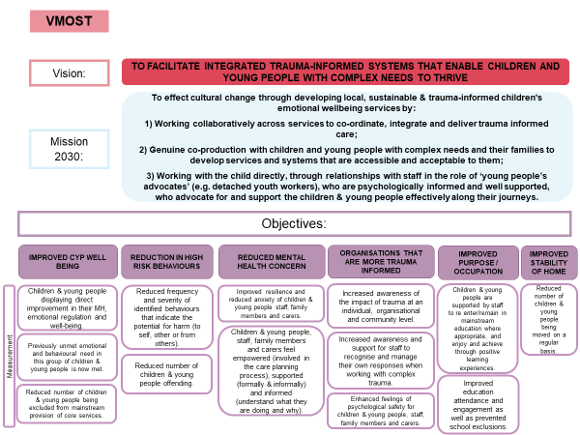

## 7.2 – Overarching principles



## 7.3 – Children and young people logic model

## 

## 7.4 – Staff logic model

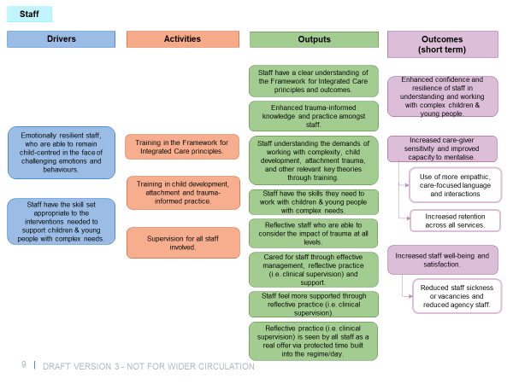

## 7.5 – Organisation logic model

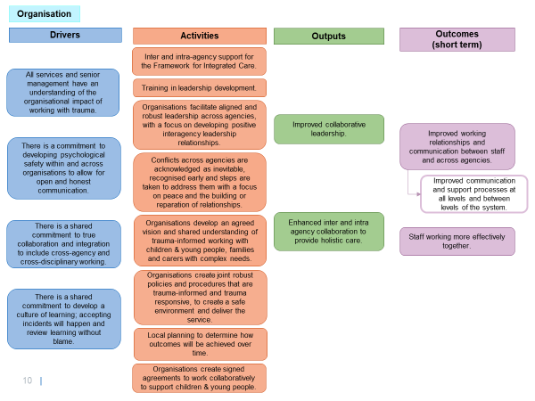

1. Wolpert, M., Harris, R., Hodges, S., Fuggle, P., James, R., Wiener, A., Munk, S. (2019). *THRIVE Framework for system change*. London: CAMHS Press. <https://www.annafreud.org/media/9242/thrive-framework-for-system-change-2019.pdf>
2. Bronfenbrenner, U. (1992). Ecological systems theory. In R. Vasta (Ed.), Six theories of child development: Revised formulations and current issues (p. 187–249). Jessica Kingsley Publishers.
3. NB this document uses the English spelling throughout, with the exception of when words have been quoted.
4. AMBIT- <https://www.annafreud.org/training/mentalization-based-treatment-training/ambit-training-programme/>
5. MAC-UK- <https://www.mac-uk.org/our-approach>
6. Trauma Recovery Model - <http://www.traumarecoverymodel.com/>