The Whiteleaf Centre  
Oxford Health NHS Foundation Trust  
Bierton Road

Sapphire Way  
Aylesbury

Bucks  
HP20 1EG

Please note – Peach Tree House is the building to the right of the main Whiteleaf Building.

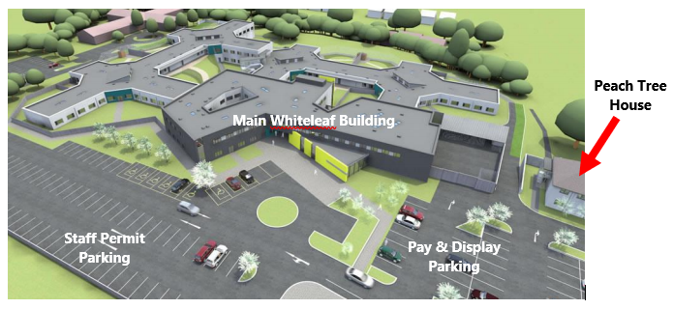

**CAR PARKING CHARGES**

Please be advised that there are now parking charges in force at The Whiteleaf Centre. The charges are as follows:

|  |  |
| --- | --- |
| Up to 30 minutes | Free |
| Up to 1.5 hours | £1.00 |
| Up to 2.5 hours | £2.00 |
| Up to 3.5 hours | £3.00 |
| Over 3.5 hours | £4.00 |

Please make sure you have change available as there are parking attendants in force and will issue parking tickets.