**Saffron House,  
Oxford Health NHS Foundation Trust,  
Easton St,  
High Wycombe**

**HP11 1NH**

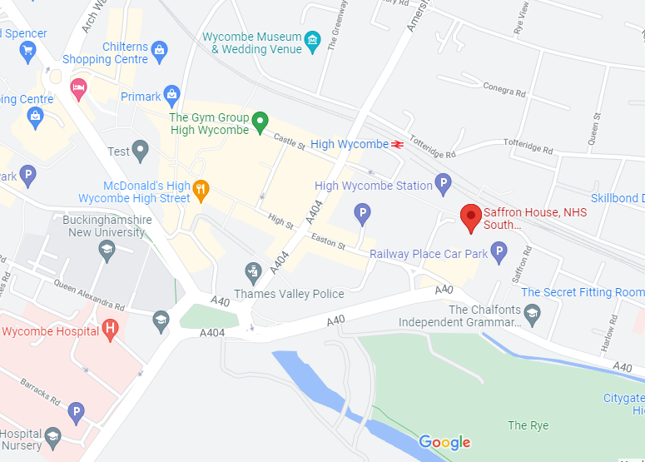

**Parking**

There are several multi-storey car parks, the nearest on Easton street which currently charges £9/day. An open car park is available on Totteridge Road (first right after the station) for £9/day