Oxfordshire Mental Health Partnership Passport Assessment
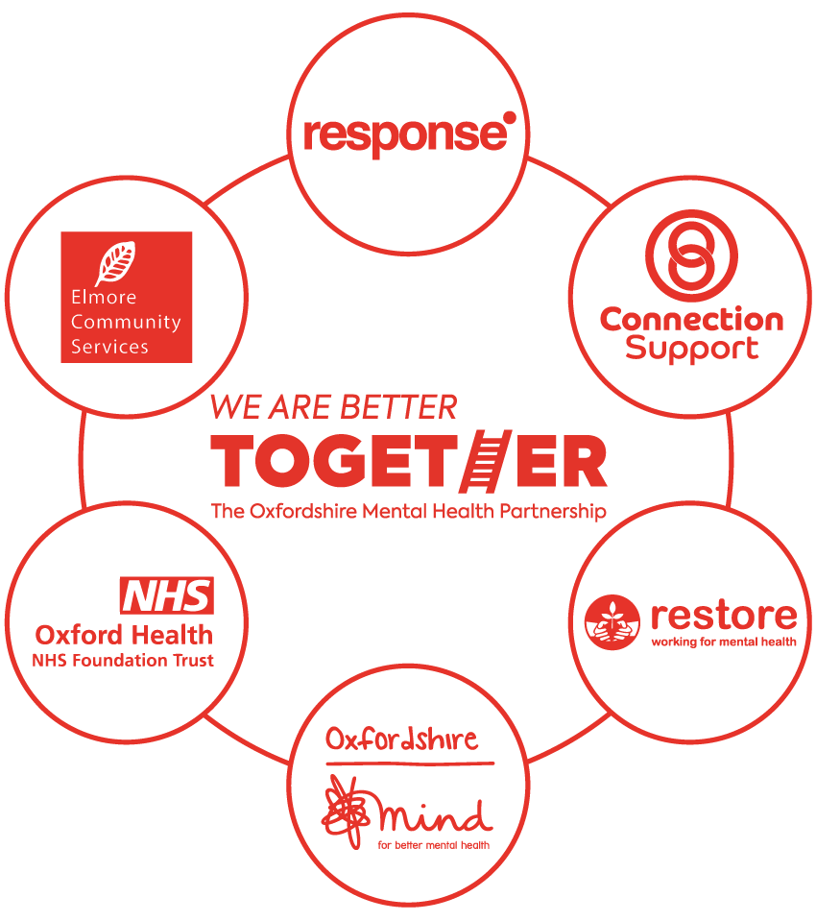

Six mental health organisations from the NHS and the third sector form the Oxfordshire Mental Health Partnership (OMHP). By working together, we aim to make it easier for people with mental health problems to get the best possible support when and where they need it. These organisations are Oxford Health Foundation Trust, Connection Support, Oxfordshire Mind, Response, Elmore Community Services and Restore.
The Oxfordshire Mental Health Partnership offers a variety of mental health services (see ‘Information on services’ document for more detail).
This passport can be filled out by you or someone else on your behalf.
The passport can be used as an initial referral into the Partnership mental health services and if you wish to use services from another organisation within the Partnership.
Please fully complete the sections of the form relevant for the organisation you are applying for. In order to ensure we are able to safely offer the correct type of support and/ or accommodation we require full and frank disclosure of mental health history including all risk areas. Unless we are satisfied that we have sufficient information we may not be able to carry out an assessment.
Some services may require a copy of your Care Programme Assessment dated within the last 6 months and Risk Assessment or other relevant supporting documents. Failure to include the documents requested will delay your application.
Please send the completed passport assessment and any supporting documents to the organisation you are referring to.
Please be aware the consent and Data Protection agreement is on the final page and needs to be signed and dated.
The passport assessment does not replace the OCCG Adult and Older Adult Mental Health pro forma used by GPs to refer into the Adult Mental Health Team and specialised treatment teams.

Initial referral
Is this a new referral into the OMHP? Yes ☐ No ☐
Have you engaged with any of the services within the Partnership previously? Yes ☐ No ☐
If yes, please provide detail:

Organisation(s) to be referred to:

Housing Wellbeing
☐ ☐ ☐ ☐ ☐

If you are unsure which service you want to be referred to, please see the referral form guide for further details.

A. Personal details
Name: NHS Number:

Date of Birth:
National Insurance Number:
Marital status:

Married ☐
Civil Partnership ☐
Widowed ☐
Separated ☐
Not Disclosed ☐
Not known ☐
Divorced/Dissolved ☐
Single ☐
Home address:

GP Name and Address:
Please note you must be registered to a GP in Oxfordshire to be eligible for our services.

Please provide details of any adjustments required to attend an assessment:

Would you need an interpreter for an assessment? Yes ☐ No ☐
If yes, please provide details:

Are you a carer, parent or being cared for? Carer ☐ Parent ☐ Being cared for ☐ None ☐
Has a carer’s assessment been arranged for you? Yes ☐ No ☐

B. Mental Health and Support Needs
What would you like support with?
Please detail below about what type of support you would like, e.g. help with housing, benefits, employment, peer support, getting active, improving your mental health.

Do you have a diagnosis? Yes ☐ No ☐
If yes, please provide details:

Do you agree with this diagnosis? Yes ☐ No ☐

If known, what care cluster have you been allocated?

If known, when were you given your cluster number?

How has your mental health affected you in the past?

How is your mental health currently affecting you?

C. Psychiatric History
Have you ever been subject to a Mental Health Section?

Are you currently subject to a Mental Health Section? Yes ☐ No ☐

Please give details of any medication you are currently taking:

Do you look after your own medicine? Yes ☐ No ☐
D. About You
What are your hobbies and interests? Feel free to include things that you have enjoyed in the past.

What would you like to achieve in the next few months? (e.g. housing, employment, personal)

What would you like to achieve in the long term? (e.g. housing, employment, personal)

Do you take part in any activities? (e.g sport, socialising, crafts, gardening)

Do you have any Spiritual or Cultural needs?

E. Family History and Support Networks
Please provide detail around your family medical and psychiatric history:

What is the current support structure around you? (e.g. family, friends, carers, other services)

F. Employment
Are you currently employed (paid/other) or in education? Yes ☐ No ☐
How long have you been employed/in education?

Please give details of any employment or education:

How many hours do you work/are you in education?

G. Physical Health
Do you have any current physical health concerns?

Have you had any previous medical issues?

What was the date of your last annual physical health review?
Do you have any allergies? Yes ☐ No ☐
If yes, please provide details:

If you know, please provide your:
Height:
Weight:
BMI:

H. Smoking Status
Do you currently smoke? Yes ☐ No ☐
If so, how many a day?

Have you ever smoked? Yes ☐ No ☐
Do you want advice to help you stop smoking? Yes ☐ No ☐
I. Alcohol use
Do you currently drink alcohol? Yes ☐ No ☐
If so, how much?

Please provide detail of your drinking history:

Do you want advice on reducing/stopping your alcohol intake? Yes ☐ No ☐
Please state if you have any physical or mental health issues because of alcohol:

J. Substance use
Do you currently use any illicit substances (including non-prescriptive drugs)? Yes ☐ No ☐
Have you ever used illicit substances? Yes ☐ No ☐
Have you had any substance misuse issues including prescribed medication? Yes ☐ No ☐
Please provide detail of past and current drug use:

Do you ever buy substances, including medication, using the internet? Yes ☐ No ☐
Please provide detail:

K. Risks
It is helpful for services to know of any potential risk to yourself or others so they can support you and run safe services.
Please note these risks may need to be verified by a professional.

Do you feel there is a historical or current risk of the following:

Self Harm ☐
Physical Health/falls ☐
Accidental harm ☐
Suicide ☐
Misuse of Medication ☐
Substance misuse ☐
Self-neglect ☐
Risk from others ☐
Sexual offending ☐
Damage to property ☐
Alcohol misuse ☐
Violence/aggression ☐
Risk to others ☐
Multi-Agency Public Protection Arrangements ☐
Disengagement ☐
Fire-setting ☐
Risk to children ☐
Deprivation of Liberty Safeguards ☐
Absconding/escaping/wandering ☐
Risk related to social media ☐
Previous loss of tenancy ☐
Subject to Child protection plan ☐
Driving Offences ☐
Other ☐

Please provide details of those ticked:

L. Safeguarding
Safeguarding is about protecting people from abuse, preventing abuse from happening and making people aware of their rights. Abuse is always wrong and no adult should have to live with abuse.
Do you have any safeguarding concerns about the following?
Physical abuse ☐ Psychological abuse ☐ Financial abuse ☐
Neglect ☐ Self Neglect ☐ Sexual abuse ☐
Domestic abuse ☐ Modern slavery☐

Please provide details of those ticked:

Has a safeguarding alert been raised? Yes ☐ No ☐
Date raised:

M. Capacity
'Mental capacity' means being able to make your own decisions.
Have you ever had a capacity assessment? Yes ☐ No ☐
Have you ever had an Independent Mental Capacity Advocate? Yes ☐ No ☐
If yes to either, please provide details:

N. Extra information on finance
(this only needs to be filled out if being referred to Mind Housing, Response, Connection Support or Elmore)
Where do you receive your income from:
Salary ☐
Benefits:
ESA ☐
PIP/DLA ☐
Universal Credit ☐
Other ☐ (please state) _________ ____

Are you eligible for Housing Benefits? If you are unsure and applying for supported housing please clarify by calling the Benefits for Better Mental Health on 01865 247788 Yes ☐ No ☐
Do you have a Housing Benefit Reference Number? Yes ☐ No ☐
If yes, please state your Housing Benefit Reference Number:
Do you have any outstanding debts/arrears? Please provide details

Do you have any savings/assets? What are they?

Are you under Money Management? If yes, please provide their contact details
Yes ☐ No ☐
Name:
Service:
Telephone number:
Email address:
Job title:
Mobile number:

Do you have a bank account? Yes ☐ No ☐
If so, are you willing to pay the housing service charge by standing order (only applicable if applying to housing)? Yes ☐ No ☐

O. Housing
(only needs to be filled in if applying to Mind Housing, Response or Elmore)
The following statements need to be checked yes in order to be eligible for supported housing.
Are you registered with an Oxfordshire GP? Yes ☐ No ☐
Have you been allocated a care cluster of 4-17? Yes ☐ No ☐

What is your current housing situation:

Family home ☐
Homeless ☐
Supported Housing ☐
Private rented ☐
Sofa surfing ☐
Specialist Placement ☐
Hospital ☐
Other ☐
Homelessness Service ☐
At risk of losing your current accommodation ☐

Please provide detail:

Are you on the council housing register? Yes ☐ No ☐
If yes, under which local authority?

Housing history – this section should include at least 5 years housing history
If details are not available or known, please state other
Full address | Type of accommodation (e.g. private rented, family home, supported housing, sofa-surfing, hospital) | Did you have a tenancy/licence agreement at this address? | Period in accommodation (dates) | Reason for leaving accommodation

Please select below what type of supported housing you would like to be referred to and the area. See the accompanying guide for further details around this.
☐ Oxfordshire Mind Transitional Housing Recovery Service
☐ Oxford City ☐ West Oxfordshire ☐ South Oxfordshire

☐ Response Area Teams
☐ Oxford City ☐ North Oxfordshire
☐ Response Recovery Campus
☐Response Oxfordshire Care and Support Services

Passport
This only needs to be filled in if you are currently accessing Partnership services and want to access others
Date of current assessment | Referring organisation | Date forwarded | To be referred to | Reason for referral | Signature
 | Mind Wellbeing ☐  Mind Housing ☐  Response ☐  Connection Support ☐  Elmore ☐  Restore ☐ |  | Mind Wellbeing ☐  Mind Housing ☐  Response ☐  Connection Support ☐  Elmore ☐  Restore ☐
 | Mind Wellbeing ☐  Mind Housing ☐  Response ☐  Connection Support ☐  Elmore ☐  Restore ☐ |  | Mind Wellbeing ☐  Mind Housing ☐  Response ☐  Connection Support ☐  Elmore ☐  Restore ☐
 | Mind Wellbeing ☐  Mind Housing ☐  Response ☐  Connection Support ☐  Elmore ☐  Restore ☐ |  | Mind Wellbeing ☐  Mind Housing ☐  Response ☐  Connection Support ☐  Elmore ☐  Restore ☐
 | Mind Wellbeing ☐  Mind Housing ☐  Response ☐  Connection Support ☐  Elmore ☐  Restore ☐ |  | Mind Wellbeing ☐  Mind Housing ☐  Response ☐  Connection Support ☐  Elmore ☐  Restore ☐

Equal Opportunities Monitoring Form
We are committed to providing a service that is fair and available to everyone. To help us monitor this, please answer the following questions.
What is your gender?
Male ☐ Female ☐ Other Gender Identity ☐

Do you consider yourself to have a disability?
Yes ☐ No ☐

What is your ethnicity?
- White
English/Welsh/Scottish/British ☐
Irish ☐
Gypsy or Irish Traveller ☐
Any other White background, please describe ☐

- Mixed/Multiple Ethnic Groups
White and Black Caribbean ☐
White and Black African ☐
White and Asian ☐
Any other mixed/multiple ethnic background,
please describe ☐

- Asian/Asian British
Indian ☐
Pakistani ☐
Bangladeshi ☐
Chinese ☐
Any other Asian background, please describe ☐

- Black/African/Caribbean/Black British
African ☐
Caribbean ☐
Any other black/African/Caribbean background,
please describe ☐

- Other Ethnic Group
Arab ☐
Any other ethnic group, please describe ☐

Information for service users
Preservation of your privacy is important and the Oxfordshire Mental Health Partnership (OMHP) is committed to using your personal information responsibly. The OMHP comprises the following organisations: Oxford Health NHS Foundation Trust, Response Organisation, Oxfordshire Mind, Elmore, Restore and Connection Support.
An organisation in the OMHP will collect information from you when you make an enquiry about our services or when another organisation or person refers you to our services. That information includes personal details, information about your mental and physical health, risks to yourself or others and other support needs you may have including housing.
Your personal information will be used to assess your needs, for quality monitoring requirements and to support the development of future services so that we can ensure that you and others receive the best services possible.
By signing the passport assessment, you enable us to request information from and to share your information with relevant organisations you wish to receive services from. If you do not wish us to request and share information for this purpose, this may affect an organization within OMHP being able to offer you a service based on your needs.
The passport assessment is a system to ensure you do not have to go through the process of re-referring to other mental health services.
All personal information will be treated as confidential and subject to the General Data Protection Regulations and Data Protection Act 2018. All organisations within the Oxfordshire Mental Health Partnership are registered under the Data Protection Act 1998. Your information will be held securely which includes being held on a secure data base. All partner agencies will take reasonable precautions to prevent the loss, misuse or alteration of information you give us.
You may, at any time, request access to the personal information held about you. The information will usually be provided within one month of the request unless the request is complex.
If you are in any way unhappy with the way that we have handled your information, please tell us and we will try and put it right. If you are still unhappy, you can raise it with the Information Commissioners Office on 0303 123 1113 or at https://ico.org.uk/concerns Your personal information is important to us. Please note there are some very rare circumstances in which we may share your information with third parties even if you have not given us permission to do so. These are:
- If there is a serious risk to you or other people
- Where there is a legal requirement to do so for example a serious crime has been committed or there are child protection issues
In this situation, we will always seek to obtain your permission first before sharing your information, unless we strongly believe that it would be unsafe to do so.
Signature (referrer):

Signature (service user):

Date:

