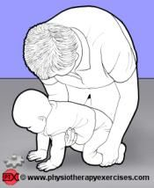
Crawling
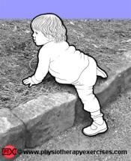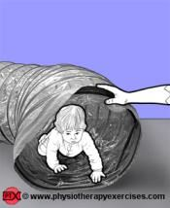

Why crawling is important
- Independence and confidence
- Strengthening muscles
- Building blocks for improved gross motor skills
- Develops balance
- Allows a child to explore their surroundings which gives them the opportunity to learn

What to check for

  - Head in line with body and looking ahead
  - Body straight and shoulders level
  - Hands under shoulders, with elbows straight fingers open and pointing roughly forwards
  - Knees under hips, and legs parallel

Once your child starts moving it is important that you ‘child proof’ their surroundings, removing articles that may cause them harm.

Ways to progress and challenge
- Give them cushions and other soft safe items to crawl over.
- Give them items to crawl through, under or round to develop their balance and spatial awareness.
- Help them crawl up or down stairs – ensure they are closely supervised for safely.

