Movement Break Ideas with a Peanut Ball
A peanut ball has a wide range of therapeutic benefits and can be a fun and engaging way to add play-based therapy into your child’s daily routine. Below are some fun activities and exercises to do with your child using a peanut ball to incorporate sensory strategies and proprioception to improve self-regulation.
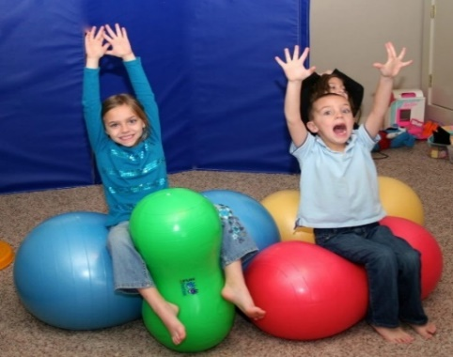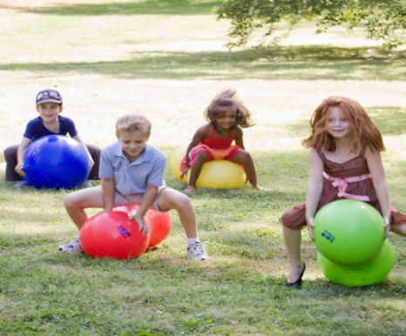
Calming Activities:
- Lie on your back, or tummy on a mat and have an adult roll the ball over your body (down each leg and arm - being mindful of your head) in all directions to provide some deep pressure.
- Sit on the ball planting both feet on the ground and have an adult put pressure through your shoulders.
- Roll over the ball on your tummy and place your hands on the floor and walk forward or have an adult press down on your hips for deep pressure.
- Place the ball against a wall, lay on your back and push with your legs as hard as you can against it.
- Give your peanut ball a big hug and squeeze.

Alerting Activities:
- Sit on the ball with support from an adult (planting both feet into the ground) and bounce gently, or relax and rock while singing your favourite songs, naming colours, or watching TV.
- Play drums with your hands on your peanut ball.
- Roll over the ball on your tummy to reach for your favourite toys or practise playing games and activities like placing shapes and puzzle pieces in a box.
- Roll on your back with your peanut ball with support from an adult.
- Try to balance and keep the peanut ball up in the air with your feet.
Please be mindful of the safety of you and your child and your home when using a peanut ball. If your child becomes over excited and over stimulated, practice the calming activities, or put the peanut ball away somewhere safe and come back to it at a different time. Your child may need gentle encouragement to build up their confidence and a routine to using the peanut ball. If you haven’t seen any benefits of using the peanut ball, the difficulties your child is experiencing may not be sensory related.
See video for demonstration of ball exercises: https://www.youtube.com/watch?v=NfWGPfK47SA
See link to purchase your own peanut ball: Amazon.co.uk : peanut balls (for size measure the distance from child’s armpit to middle finger tip and match this measurement to the height of the ball within 5cm)
See link for more information on ball therapy: https://www.sensorydirect.com/blog/peanut-balls-benefits-ball-therapy/

