Standing
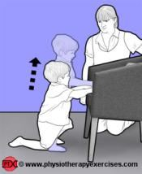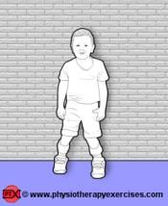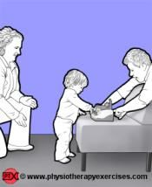
Why standing is important
- Strengthen antigravity muscles
- View the world from an upright positon
- Improves digestion
- Improve bone density
- Learn standing balance as precursor to walking
- Optimum positon for some joints and muscles

What to check for
- Symmetry
- Posture
- Not overusing arms
- Weight through both legs
- Hips straight and apart
- Knees straight
- Heels down
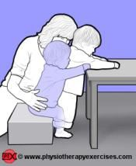
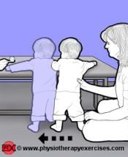
- Ask your physiotherapist the best way to transfer to standing
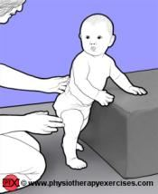
How to progress
- Reach for toys
- Crouch towards floor for toys
- Sit to stand or rise from the floor to standing
- Cruise
- Stepping
August 2017

