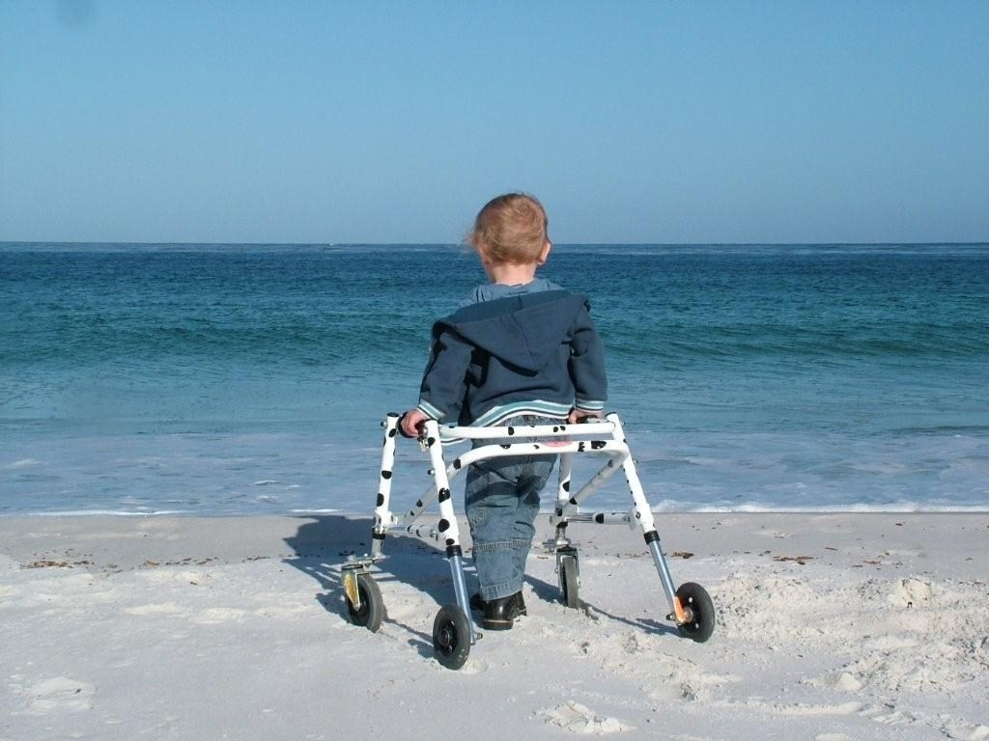

Children's Integrated Therapy Service

Equipment Guidelines

Contents

Introduction 3

What equipment the Physiotherapy Service provides 5

What support the Physiotherapy Service provides 6

What equipment the Occupational Service provides 7

What support the Occupational Therapy Service provides 7

Provision, maintenance and repairs of equipment 9

Bed rail safety information 11

Electrical equipment 13

Recycling of equipment 14

Moving equipment 14

Stair lifts, step lifts and through floor lifts 15

Discharge/end of episode of care 16

Transition to adult therapy services 17

Equipment for school 18

Charity equipment applications 18

Contact details 19

Accessibility 20

# Introduction

Children’s Community therapists assess, recommend and supply specific equipment to children and young people aged 0 - 18 years who are permanent residents of Oxfordshire and who are registered with an Oxfordshire GP.

The therapist will assess your child to see what equipment they need as part of their therapy.

Equipment is provided to increase or maintain functional independence, safe moving and handling, to minimise risks, and for postural management and health needs.

Commercially available equipment will be considered in the first instance.

If the need for specialist equipment is identified, a principle of minimum intervention will apply e.g. low specification items will be tried in the first instance.

This will be reused equipment where appropriate.

We aim to ensure that provision of equipment is safe, fair, transparent, efficient and effective.

While the equipment is on loan to a child, the expectation is that it will be looked after as per instructions and any modifications made are reported to the prescribing therapist, e.g. mattress is changed on a bed.

Parents and carers will contact the prescribing therapist if there is any suspected damage to the equipment or if a review is considered required.

The Children's Integrated Therapy service reviews equipment on an ongoing basis and as needs arise.

The equipment will be returned to the service when it is no longer required.

We aim to provide equipment with room for growth so that it will not need to be replaced too soon.

We can provide one set of equipment for your child.

If you are moving out of area, give us plenty of notice and we can refer your child to the next Physiotherapy team to ensure a smooth handover.

If your child is reliant on certain items every day you may take this/these with you with the expectation that it will be returned, when the new therapy team provide their items.

Equipment is provided for specific individuals in their permanent place of residence and, if portable, this equipment should travel with them (if practical) to alternative places of residence.

Equipment is managed by the local integrated community equipment store, Millbrook. They can deliver, move, repair and collect equipment.

# What equipment the Physiotherapy Service provides

* Walking aids such as sticks, posterior walkers or rollators. We will provide the one clinically most appropriate for your child
* Walking aids with a high level of trunk support may be provided if your child can stand to transfer into it and steer
* Standing frame. If your child is unable to stand for sufficient time on their own and they have adequate range at their hips, knees and ankles they may use a standing frame
* Sleep systems for children in need of postural support during the night

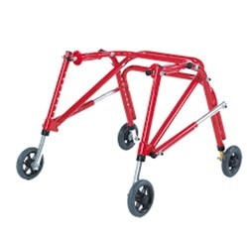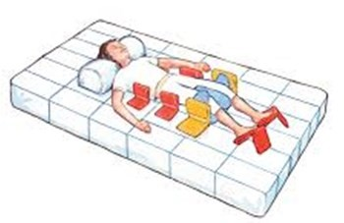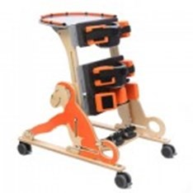

# What support the Physiotherapy Service provides

Advice on appropriate footwear

Information on how to choose a gym ball and where you can buy them

Letters of support if you are applying to a charity for a piece of equipment such as a tricycle

Information to schools on where to purchase equipment they may need

Advice on Kinesio tape suppliers

We will refer to other services where appropriate to provide equipment such as:

* Specialist footwear
* Orthotics: an orthosis is an external device a child wears to improve the alignment of a joint, such as an ankle foot orthosis or angled gaiters for tight knees
* Complex sleep systems

# What equipment the Occupational Service provides

* Specialist seating systems
* Specialist Bathing aids
* Specialist toileting aids
* Height adjustable cots/beds
* Bed rails
* Hoists
* Slings

# What support the Occupational Therapy Service provides

We will show you examples of small items of equipment such as cutlery or pencil grips, and parents and teachers can try before you buy.

Details can be found on our website or we can suggest suppliers. [Equipment - Children’s Integrated Therapies](https://www.oxfordhealth.nhs.uk/cit/resources/equipment/)

We can show you examples of standard small equipment and aids e.g. toilet inserts, potties and standard children’s chairs and beds

Car seats are bought by parents from the ‘In-Car Safety Centre’ or car seat clinics held around the county by OT at Regional Driving Assessment Centre. Sometimes car seats may be supported by charity funding and we can provide a supporting letter of information. [In Car Safety Centre | Child Car Seats | Booster Seats | ERF Seats](https://incarsafetycentre.co.uk/)

Specialist buggies and wheelchairs are provided and maintained by Oxfordshire Wheelchair Service, Nuffield Orthopaedic Centre. [Oxfordshire Wheelchair Service - Oxford Centre for Enablement (OCE) - Oxford University Hospitals](https://www.ouh.nhs.uk/oce/services/wheelchair-service/)

They can be contacted at owsadministration@nhs.net or on 01865-227273

# Provision, maintenance and repairs of equipment

Standing frames, walkers with gas struts, hoists and slings are serviced annually by Millbrook.

Posterior walkers, rollators and other pieces of small equipment will be reviewed by the service on request

All equipment should have a visual check by you each time you use it.

This is especially important for slings which should be checked for tears or damage to the loops (see specific instructions).

* It is the parent/carer's responsibility to highlight any concerns. If you have any concerns regarding equipment, stop using it and contact your physiotherapist as detailed below:

Millbrook, our contracted supplier provides our larger pieces of Oxford Health therapy equipment.

They will contact you directly to arrange a time and date for delivery.

Once a child’s piece of equipment has been approved and delivered, please contact a member of the therapy team before you use the equipment.

Equipment should not be used until your therapist has advised that it is safe to do so.

Delivery times will vary depending upon whether the item is a stock or a non-stock item.

For complex pieces of equipment e.g. seating system, standing frame, bed, your Occupational Therapist or Physiotherapist will visit after delivery to set this up.

The therapist will then demonstrate safe use and check that an instruction manual/booklet has been provided by Millbrook.

These are also available on our website and the manufacturers website. [Equipment - Children’s Integrated Therapies](https://www.oxfordhealth.nhs.uk/cit/resources/equipment/)

General safety advice for use of equipment:

* Posterior walkers, rollators and other pieces of small equipment will be reviewed by the service on request
* Use according to instruction manual, as demonstrated by therapist and any instructions for use.
* Use for intended use only and for the child that the equipment has been provided for
* Use safety features on the equipment such as straps and brakes as appropriate e.g. do not use breaks on the mobile hoist when in active use
* Use height adjustable features (if supplied) to minimise risk of injury to the carer, e.g. put at suitable height for task required to ensure good posture
* Any modifications made should be reported immediately to the prescribing therapist even if this modification has been made by another health professional e.g. pro-vision of Repose tissue viability overlay to a bed.

# Bed rail safety information

* To prevent the user from rolling or falling out of bed.
* To enhance safety to the user during provision of personal care or fitting of slings

The bed rail should always be secured to the base of the bed by a trained technician or health professional (according to manufacturer’s instructions)

Use of bumpers (padding) is recommended to reduce risk of entrapment and injury.

Bed rails and accessories must be compatible with bed provided.

#### Contact Millbrook for:

Broken/ damaged equipment (including fixings)

reinstalling or moving bed rails to a new bed.

Bed rail becoming loose or having excessive movement when in use

Advice before privately installing additional equipment to your bed

#### Contact your Occupational Therapist if:

You are concerned that the design of the bed or the rails could lead to a risk of the user could become trapped in any gaps that are present.

The bed rail is being used to prevent a person from getting out of bed or to contain them in the bed against their wishes (if this is different to when bed was supplied to you, when this need may have been discussed).

If the user is observed attempting to climb over the bed rails.

If you have concerns around the safe use of the equipment and would like a reassessment.

If there is any ongoing difficulty with lowering or raising side rails.

# Electrical equipment

Millbrook will arrange to come to service electrical goods that require regular servicing.

They should visit and complete a check on all hoists, slings and mechanical bath lifts every six months.

They should also complete a check of all beds and chairs with electric motors every year.

Equipment that has an electrical connection will also be PAT tested every year.

# Recycling of equipment

All equipment supplied to a child’s home can be recycled if it is no longer needed.

Please contact Millbrook to arrange collection.

Within a school setting please contact the Special Educational Needs Physical Disability Team to arrange collection.

# Moving equipment

If you need your large pieces of equipment supplied by us moving e.g. beds, mechanical chairs, and hoists either within your property or a new property in Oxfordshire please contact your OT.

If you are moving out of Oxfordshire, please discuss this with the therapy team with regards to referring your child on and equipment provision.

# Stair lifts, step lifts and through floor lifts

These items are normally be provided via a Disabled Facilities Grant, after assessment by an Occupational Therapist.

This grant is administered by your local District Council. Please see separate leaflet regarding home adaptations in Oxfordshire on the Oxfordshire County Council website. [disabled-facilities-grant-leaflet---children](https://www.oxfordhealth.nhs.uk/wp-content/uploads/sites/22/2025/07/ChildDisabledA5BookletFULL_2023__3_.pdf)

All lifts should have a visual inspection completed every 6 months and a service visit every 12 months.

There may also be insurance checks completed. For children 0- 18 years this service would normally be provided without charge.

If your Housing Association is providing this service, they may make a small charge.

As part of this, you should be provided with details of who to contact if this equipment breaks down, including out of hours contact details.

# Discharge/end of episode of care

If your child has been discharged from the Occupational Therapy service and you still have equipment supplied by Oxford Health, this becomes your responsibility to monitor and identify any concerns.

Please contact Millbrook with maintenance support or for collection of no longer required equipment.

If you feel any equipment needs to be re-assessed, please contact us.

# Transition to adult therapy services

There should be no change in general equipment arrangements when your child turns 18.

All equipment is supplied on long term loan.

You should contact Millbrook to arrange repairs or collections, if equipment is no longer used or you move out of Oxfordshire.

If you require new equipment or re-assessment, you can make a referral to Adult Social Care for an assessment.

The service arrangements for hoists will also remain the same.

If your lift was installed via a Disabled Facilities Grant and/or your Housing Association does not provide a maintenance service agreement, then Oxfordshire County Council may have taken on payment responsibility for this service.

When your child turns 18 you will become responsible for organising your own servicing and maintenance and the County Council should inform you of this.

You should contact Adult Social Care directly to discuss this with them if you feel that you are unable to fund this and the lift is still in use.

# Equipment for school

A child may need special equipment in a school or early years setting.

The therapists will assess and recommend equipment and the funding for this will come through the county council and not the NHS.

In a mainstream school the first £250 contribution in each financial year will come through the school and after that the Special Educational Needs Support Services will top up any additional funding.

The equipment is still managed by the local equipment store, Millbrook.

# Charity equipment applications

Occupational therapists and Physiotherapists may be able to write letters of support if you are applying to a charity for a piece of equipment such as specialist wheelchair, tricycle etc.

# Contact details

Telephone 01865 904435.

Email: [oxonchildrens.therapies@oxfordhealth.nhs.uk](mailto:oxonchildrens.therapies@oxfordhealth.nhs.uk)

Millbrook Therapy Equipment:

Telephone: 01865 536425

Email: [Contactusoxford@millbrookhealthcare.co.uk](mailto:Contactusoxford@millbrookhealthcare.co.uk)

Millbrook Hoist and Chair lifts:

Telephone: 0333 999 0870

Email: [ceiling.hoistsoxford@millbrookhealthcare.co.uk](mailto:ceiling.hoistsoxford@millbrookhealthcare.co.uk)

Oxfordshire Wheelchair Service:

Telephone (new provision): 01865 227273

[Oxfordshire Wheelchair Service - Oxford Centre for Enablement (OCE) - Oxford University Hospitals](https://www.ouh.nhs.uk/oce/services/wheelchair-service/)

Wheelchair maintenance: 01865 223881

# Accessibility

An accessible version of this leaflet can be found on our website: www.oxfordhealth.nhs.uk/leaflets

### Get in touch

Address Oxford Health NHS Foundation Trust

Trust Headquarters

Littlemore Mental Health Centre  
Sandford Road, Oxford OX4 4XN

Phone 01865 901 000

Email enquiries@oxfordhealth.nhs.uk

Website www.oxfordhealth.nhs.uk

### Feedback

Our Patient Advice and Liaison Service (PALS) provides advice and support to patients, families, and carers, helping to resolve any problems, concerns, or complaints you may have.

Phone 0800 328 7971

Email PALS@oxfordhealth.nhs.uk

Become a member of our foundation trust: www.ohftnhs.uk/membership

Support Oxford Health Charity, making a difference to patients, their families and staff who care for them: www.oxfordhealth.charity