Hand Arches – Primary Children
What is it? There are several arches within the palm of your hand that enable the hand to grasp objects of different sizes and shapes. These arches direct the skilled movement of your fingers and control the power of your grasp. In your hand there are three main arches, two transverse and one longitudinal arch. One arch is rigid, but the other two are flexible and are maintained by the use of those tiny muscles in your hand. You can see the shape of your arches by touching thumb to index finger or thumb to little finger.
Why is it important? Hand arches are important for cutting with cutlery and scissor work, for precise grasps and for handwriting. The three arches work to balance stability and mobility in the hand. The arches and bones in the hand work together to provide the stability needed for writing, gripping or lifting objects, and other fine motor tasks. Mobility of the hand is necessary for using your fingers or for adjusting the tightness of your grip depending on the size of the object you’re holding.
How you can help: Demonstrate to your child how to hold objects, or weight bear on the hands in order to develop these muscles

- Offer you child plenty of everyday opportunities to handle objects of various sizes (if safe and appropriate) to practice weight bearing e.g. crawling, or wheelbarrow walks, crab walks and bear walks
- 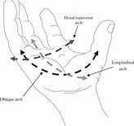Show your child how to weight bear using hands
- Ensure your child is sitting with a comfortable and supported posture (e.g. feet on the floor, and elbows resting on the table at a 90-degree angle) or is standing up at a vertical surface.

The following is a list of games and activities to help develop hand arches:
- 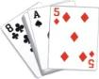Encourage child to cut with scissors, use a stapler and punch
- Draw around small circles and fill in small circles.
- Teach how to snap fingers
- Play with spinning tops
- 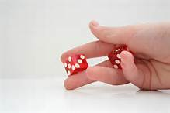Cupped hand activities: shaking dice, playing cards
- Form fingers into a spider then bend and straighten fingers, can place an elastic band around flexed finger to add resistance
- Tongs, tweezers, connected chop sticks, cherry hullers: use these to pick up small objects for sorting, such as beads,
- Marbles games
- 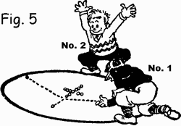Geoboards: make shapes and letters using rubber bands on geoboards
- Pick-up sticks, Jenga, cards
- Coin flipping contest: line up rows of coins and see how fast you can flip them over
- Dressing up dolls
- Tiddly winks games, jumping frogs
- 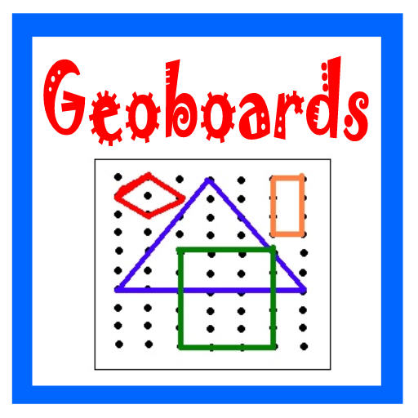Hiding small objects (beads, pennies, beans) inside putty and then try pulling them out
- Use a rolling pin to flatten out cookie dough, then use cookie cutters to make shapes
- Construction toys - Mecano

