Hand Arches – Under 5’s
What is it? There are several arches within the palm of your hand that enable the hand to grasp objects of different sizes and shapes. These arches direct the skilled movement of your fingers and control the power of your grasp. In your hand there are three main arches, two transverse and one longitudinal arch. One arch is rigid, but the other two are flexible and are maintained by the use of those tiny muscles in your hand. You can see the shape of your arches by touching thumb to index finger or thumb to little finger.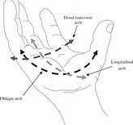
Why is it important? Hand arches are important for cutting with cutlery and scissor work, for precise grasps and for handwriting. The three arches work to balance, stabilise, and mobilise the hand. The arches and bones in the hand work together to provide the stability needed for writing, gripping, or lifting objects, and other fine motor tasks. Mobility of the hand is necessary for using your fingers or for adjusting the tightness of your grip depending on the size of the object you’re holding.
How you can help: Demonstrate to your child how to hold objects, or weight bear on the hands in order to develop these muscles

- Offer your child plenty of everyday opportunities to handle objects of various sizes (if safe and appropriate) to practice weight bearing e.g. crawling, or wheelbarrow walks, crab walks and bear walks

- For sitting activities, ensure your child is sitting with a comfortable and supported posture (e.g. feet on the floor, and elbows resting on the table at a 90-degree angle) or is standing up at a vertical surface.

The following is a list of games and activities to help develop hand arches:
- Encourage crawling on hands and knees, wheelbarrow walks
- Encourage child to place his or her forearms on a table surface and try to rake small objects (rice, raisins, and dried peas) under the palms using fingertips.
- 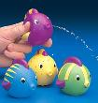Pinch small objects as above using thumb and index finger and/or middle finger together. Place these in small containers, e.g. bottles
- Squeeze water squirters, windup toys
- Seal plastic bags with a zip fastening.
- Encourage your child to practise with tools held with the handle across the palm, index finger providing direction and downwards pressure e.g. cutting Velcro vegetables with a plastic knife, rolling a dressmaker’s wheel on play dough or cutting pliable material with a pizza cutting wheel.
- 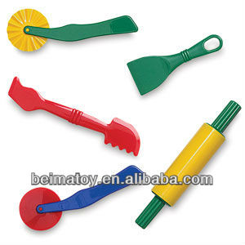Rotate a doorknob using the tips of the thumb, index, and middle fingers. Move in both directions. Parents or familiar adults may be successful in providing hand over hand assistance.
- Scrunch a fine scarf, towel, or bandage under the palms by using the fingers to pull.
- Engage in as much outdoor/large physical activity as possible where power grasps are used by the hands to climb and to maintain balance when moving the whole body.
- 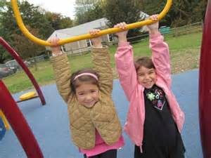Working with play dough roll out sausages, make ball shapes and cut
