Hand Dominance - Primary
What is it? Hand dominance is the preference of one hand to perform fine and gross motor tasks, such as writing, cutting or catching and throwing a ball. When one hand is consistently used more than the other hand and is more skilled at tasks than the other hand. This is also referred to as hand preference. Children typically develop hand dominance between the age of 2 and 4 years.
The dominant hand and the non-dominant hand play significant roles in completing tasks. Both hands working together is known as bilateral coordination and is important in many school-related tasks.
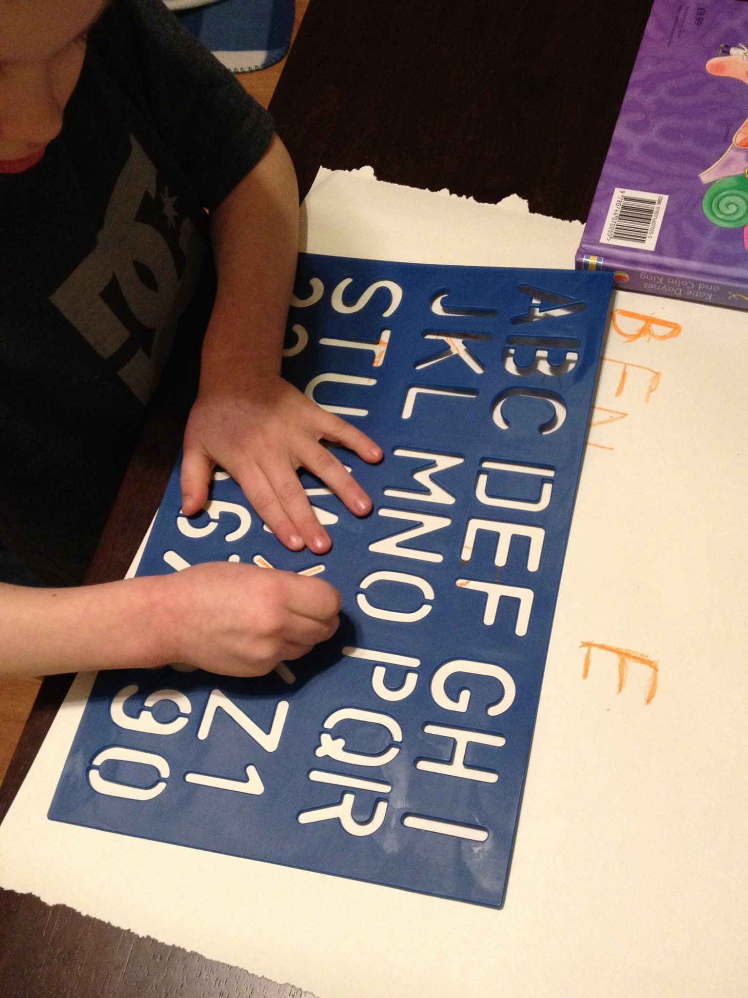Why is it important? Some people are good at using both hands (ambidextrous) but it is much better for a child to develop strength and dexterity in one hand. This will help them to develop accuracy and speed with fine motor tasks, particularly handwriting. It is far better to have a specialised hand to do the job well than two less developed hands.
How you can help:

- Offer your child plenty of everyday opportunities to participate in developing their hand skills. When working on establishing dominance, encourage daily activities that require continued use of one hand without direction as to which hand to use. Place materials at the child’s midline (directly in front of the middle of their trunk) and allow the child to choose and switch hand freely during these activities and other activities.
- Ensure your child is sitting with a comfortable and supported posture (e.g. feet on the floor, and elbows resting on the table at a 90-degree angle) or is standing up at a vertical surface.
- Minimise emphasis on dominant and non-dominant hand and allow child to freely alternate hand use.
- After several weeks of daily undirected hand activity, watch for one hand to be chosen more frequently for one handed activities or used more consistently for grasping for writing implements, scissors etc.
- When you note preference for one hand emerges, focus on developing the dominant and assisting roles for the two hands.

The following is a list of games and activities to help develop hand dominance:
- Large scribbling on the chalkboard or drawing on mural paper that is on an easel or taped to the wall or floor.
- Using Stencils - Holding a stencil in one hand and pencil in the other. This may be easier with the child standing up to put weight through the stencil. Drawing, writing, or painting with one hand, stabilising paper with the other
- Cooking- Holding the bowl and stirring, the more the resistance the better e.g. crunchies, custard, flapjacks. jelly, gravy, beating eggs. holding in one hand and cutting - fruit salad, apples for pie, using a manual whisk to make chocolate/or milk shake.

Examples or activities to include when the dominant hand is chosen:
- Cutting with one hand, stabilising and turning paper with the other.
- Threading Lacing cards, making jewellery.
- Ball games: ten pin bowling
- Pick- up games: pick- up sticks, coins, snakes and ladders, connect 4
- Opening containers, such as jars or plastic containers with lids that require stabilisation with one hand and action with other.

