Hand Strength - Primary
What is it? Hand Strength is the amount of resistance or tension achievable within the muscles. It includes the ability to initiate and maintain movements/positions within the hands.
Why is it important? Hand strength influences fine motor skills, in particular, pencil grasp and handwriting, cutting with scissors and self-care such as dressing, eating with a knife and fork as well as drinking from a cup.
How you can help: Warm-up the hands with finger exercises and light massage. When trying fine motor activities stabilise as many joints as possible, e.g. sitting correctly, both elbows/forearms resting on the table. Be aware that fatigue may occur. Offer you child plenty of everyday opportunities to handle small objects (if safe and appropriate) to practice using their index finger to point and isolate fingers for play e.g. play finger soccer, use keypad gadgets see activities below

- Ensure your child is sitting with a comfortable and supported posture (e.g. feet on the floor, and elbows resting on the table at a 90-degree angle) or is standing up at a vertical surface.
- Work within your limits and gradually increase the length of sessions. Work on two or three of the following activity ideas daily, using different activities each day.

The following is a list of games and activities to help hand strength development:

- Animal walks. Crab, Bear, Bunny hop and wheelbarrow walks
- 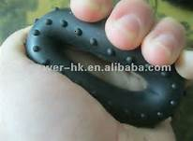Squeeze soft balls such as juggling balls, stress balls and rings. Work on two or three of the following activity ideas daily, using different activities each day.
- Opening containers with screw on lids.
- Use “theraputty”: Squash the putty with your fist. Use a powerful squeeze so that it oozes out between the fingers. Do this with both hands.
- Make various size balls with the dough/putty Start by rolling the dough between your 2 hands. Then make 2 separate balls simultaneously by rolling them on a table. Try to get the hands to go in opposite directions i.e. one hand clockwise, the other anti-clockwise – then change over.
- Using both hands together, make a long snake by rolling the dough/putty out on a table. Using a pincer grip i.e. thumb and first finger squeeze the dough/putty to make patterns on the “snakes” back. You can alternate fingers using thumb and middle finger, thumb and ring finger, thumb and little finger.
- Poking holes. Using each finger on its own, press hard into the dough/putty. As you get better you can make the dough/putty layer thicker, thereby having to press down harder.
- Twist it. Using both hands together, twist the dough/putty around and around. Make one hand go clockwise and the other anti-clockwise. Then start again and make each hand go in the opposite direction.
- Pinch and twist it. Holding the dough/putty in one hand, grab the end with the other hand. Holding the dough/putty between your thumb and index finger and twist it around. Start again with the next finger and go through all fingers on the one hand. Then swap hands and do the same.
- 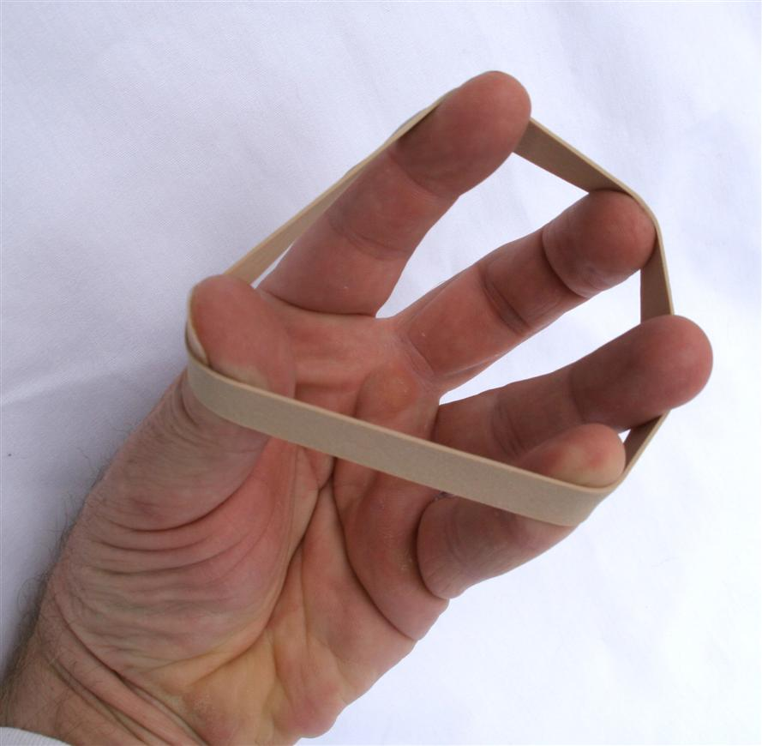Elastic band stretches
- Picking things up with tweezers or clothes pegs – you can make it harder by wrapping rubber bands around the ends to make it more difficult to squeeze.
- Climbing, basketball, cricket
- Playing piano, flute, guitar.

