Hand Strength
What is it? Hand Strength is the amount of resistance or tension achievable within the muscles. It includes the ability to initiate and maintain movements/positions within the hands.
Why is it important? Hand strength influences fine motor skills, in particular, pencil grasp and handwriting, cutting with scissors and self-care such as dressing, eating with a knife and fork as well as drinking from a cup.
How you can help: Warm-up the hands with finger exercises and light massage. When trying fine motor activities stabilise as many joints as possible, e.g. sitting correctly, both elbows/forearms resting on the table. Be aware that fatigue may occur. Offer you child plenty of everyday opportunities to handle small objects (if safe and appropriate) to practice using their index finger to point and isolate fingers for play e.g. play finger soccer, use keypad gadgets see activities below

- Ensure your child is sitting with a comfortable and supported posture (e.g. feet on the floor, and elbows resting on the table at a 90-degree angle) or is standing up at a vertical surface.
- Work within your limits and gradually increase the length of sessions. Work on two or three of the following activity ideas daily, using different activities each day.

The following is a list of games and activities to help hand strength development:

- 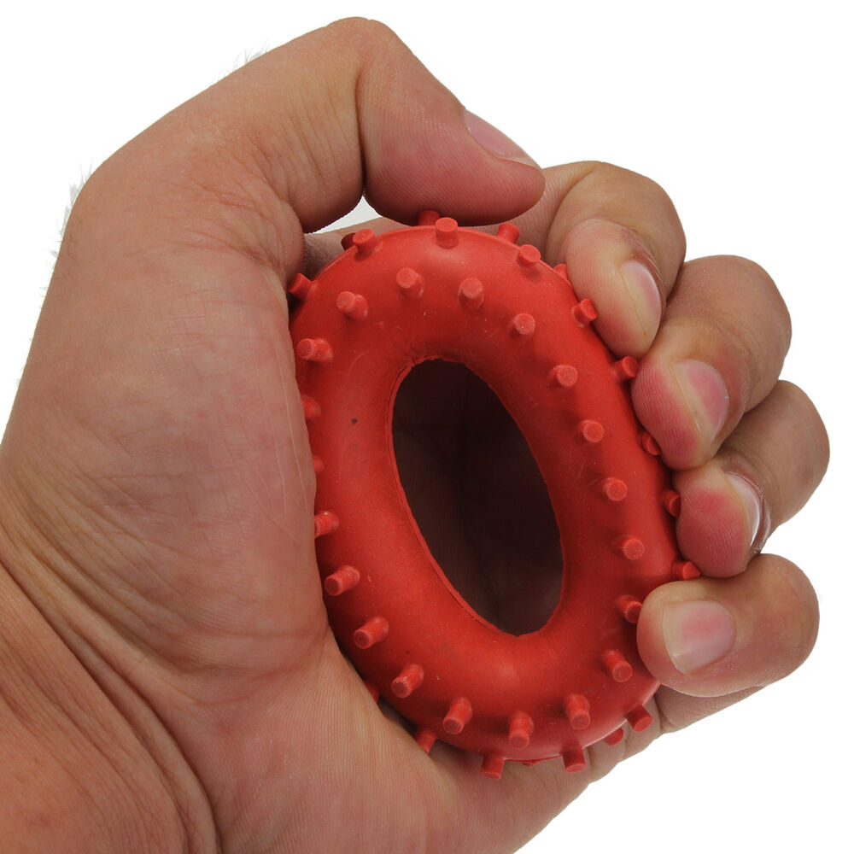Squeeze soft balls such as juggling balls, stress balls and rings.
- Opening containers with screw on lids, Squeezing toothpaste tubes
- Play card games
- 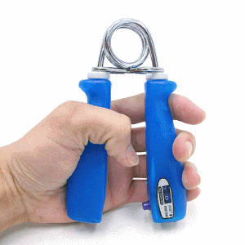Rolling dice games
- Baking bread, biscuits and making cakes
- Bat and Ball Games
- Use hand grip with moulded handles
- 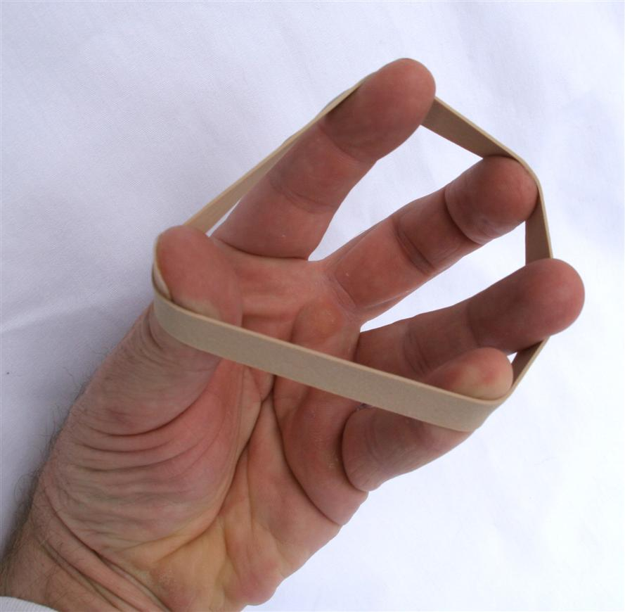Elastic band stretches
- Climbing, basketball
- Playing piano, flute, guitar
- Theraputty of different strengths use for stretching, rolling, twisting, and pulling
- Keyboard games i.e. computer games requiring a keyboard
- Ten pin bowling
- 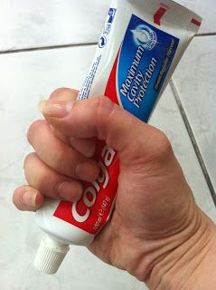Use a hand master exercise ball
- Picking up objects with tweezers or clothes pegs clips – you can increase the difficulty by wrapping a rubber band around the end to make it harder to squeeze open.
