Hand and Shoulder Strength
What is it and Why it is important? The ability to have good stability at the shoulder and strength in the hands is essential for effective manipulation of objects such as handwriting or using cutlery to eat.
How you can help:

Participate in daily activities that help to build up the muscles in the shoulder and hands. Below are a few suggestions.

Hand Strength Activities:

- Use tongs to pick up small objects – maybe have races to see who can move all their objects from pot to another fastest.

- 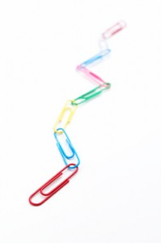Tear tissue paper or material into small strips and scrunch it up into small balls to make a collage (this is also developing bilateral integration).

- You can also tear up paper and have flicking races against each other.

- Tug of war games

- Put an elastic band around your finger and thumb and pull apart to stretch the band.

- Squeeze, pull and knead dough

- Origami

- Use paper clips to make a chain

- Squeezy bottles – squeeze the air out to chase a ping pong ball along the table.

Shoulder Strength Activities:

- Big arm movements – all big arm movements are great! You could start with circles and then try to make windmills, doing the opposite direction with each arm.

- Practice doing big drawings or letters in the air or on the white board.

- Pour heavy drinks – start close to your body and move the cup further away.

- Wheelbarrow races with your friends

- Chair push ups and wall push ups – place your hands on your chair and lift your bottom of the seat or lean against a wall with your arms and push back.

