In Hand Manipulation - Primary
What is it? In Hand manipulation is the ability to use the small muscles of the hand and to move objects around in the palm of your hand and to your fingertips. Explorative and manipulative play usually starts at age 3 months when babies engage in finger play.
Why is it important? This is a prerequisite for sensory development, fine motor movements and hand eye co-ordination and for developing good manipulative skills. It helps the child understand the permanence of objects and an appreciation of time and space. We use in hand manipulation in order to move small objects within the hand or use tools with precise detail. In hand manipulation is important when writing.
How you can help:

- Demonstrate to the child how to complete the activity
- Talk about what the fingers need to do
- Offer you child plenty of everyday opportunities to handle various shaped objects (if safe and appropriate) and how to practice using their hand grasps for play.
- Begin with larger activities involving one object
- 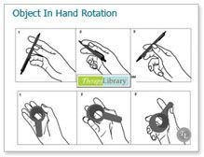When more objects required add them slowly
- Ensure your child is sitting with a comfortable and supported posture (e.g. feet on the floor, and elbows resting on the table at a 90-degree angle) or is standing up at a vertical surface.

The following is a list of games and activities to help in hand manipulation
- Pegboard – Hold two pegs in hand and move one to tips of fingers and place in peg board. Increase the number you start with to ten. Playing battleships with pegs
- Connect 4, Connecting Straws, Dominoes
- 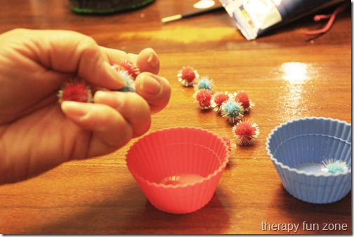Pencil walk and flip: hold a pencil as if you are going to write with it. Keeping the tripod position, walk your fingers up towards the eraser. When you get there, flip the pencil over without using other hand or a surface to brace it. Walk fingers back to the other end, keeping the tripod position, and repeat.
- Place two pennies and two paper clips in palm of hand.
- Try to move one penny to fingertips and place on table without using other hand, then one paper clip, and so on. Try it with more items as it gets easy.
- Spin coins on their edge. See how many you can get to spin at the same time
- Threading- making jewellery, lacing cards, sewing kits, embroidery, knitting
- Carpentry, hammering, woodwork, building things with mecano sets, Lego
- Wring out sponges (when helping to clean the car/wash windows).
- Gardening, planting, painting with brushes, sweeping/raking leaves, sweeping floor
- 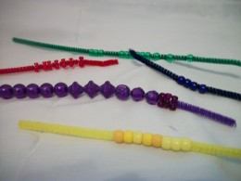Marble games i.e. squeeze a marble in between each finger of one hand and try to keep them from dropping out
- Cutting out shapes in various thickness of card, paper, foil and fabrics, tie ribbons
- Hold a small plastic cup filled with water (the lid from liquid laundry detergent works well for this) upright in the tips of fingers. Turn the lid without spilling by turning it in fingertips.

