Three fingered (tripod) grasp
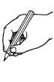What is it? A three fingered or tripod grasp is when the thumb, index finger and middle finger work together to pick up small objects.
Why is it important? A tripod grasp is used throughout the day and is used for feeding ourselves, dressing ourselves and holding a crayon or pencil efficiently.
How you can help: Demonstrate to your child how you use a tripod grasp and....

- Offer your child plenty of every day opportunities to handle small objects (if safe and appropriate) to practice using a tripod grasp e.g. helping to put tops on tubes; helping to zip up things; taking tops of felt tip pens; picking up and eating raisins or similar etc.

The following is a list of games and activities that help to develop and strengthen a tripod grasp:

- Play games where there are small parts e.g. dice, counters
- Playing with clothes pegs, tweezers, tongs, and scissors.
- Winding up toys
- Peeling off stickers
- Building with (small to medium sized) construction toys.
- Pick up as many small objects as you can and conceal them in your hand (a game that is sometimes called Jacks)
- Playing with play dough; poking and pinching; ripping and tearing etc.

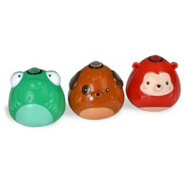How to help develop a tripod grasp for mark making and handwriting: (children typically develop a tripod grasp for mark making between the ages of 4 and 6).

- Show your child how you hold a pen/pencil with a tripod grasp.
- Ensure your child is sitting with a comfortable and supported posture (e.g. feet on the floor, and elbows resting on the table at a 90-degree angle) or is standing up at a vertical surface to mark-make.
- Offer your child small broken pieces of crayon or chalk to mark-make with.
- Egg shaped chalks, triangular crayons, and Crayola Tadoodles (see picture) help to develop a more mature pencil grasp
- If offering your child a pencil, put the tip/lead of the pencil so it faces their tummy; ask them to pick the pencil up and then flip the end of the pencil towards themselves – you should see a perfect tripod grasp!
- You could try using triangular pencils or a special pencil grip e.g. ultra-grip (available http://www.tts-group.co.uk/shops/tts/Range/Pens-Pencils-and-Grips/)
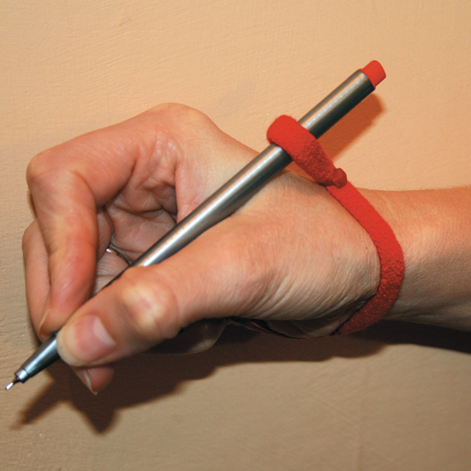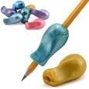
- You may want to buy (or make out of hair bands) a Handiwriter (available from http://www.specialdirect.com/shops/sd/Products/PD2056318/Handiwriter/) that helps keep the fingers and pencil in the right place (the child holds a small charm in their ring and little finger whilst wearing the band around the wrist and pencil)
- Another version of the ‘Handiwriter’ is to ask the child to hold a small marble in their ring and little finger; until they feel comfortable with the tripod grasp; or peg a normal sized clothes peg to the shaft of the pencil and ask the child to wrap their ring and little finger round the peg (more comfortable than it sounds!)

