Sitting posture- Why is it important
Occupational therapists are aware of good sitting posture, because it is essential for the development of hand skills. A child seated correctly is in a better position to learn to use cutlery, playing, writing and it can help them sit for longer periods.
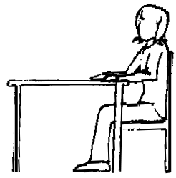
Where possible:
- Bottom well back in the chair
- Knees in line with the hips
- Feet flat on the floor, a stable footrest may be used
- Both arms resting comfortably on the desk, without causing the shoulders to shrug

What could you do to help?
If the chair is too big? If the chair is too small?

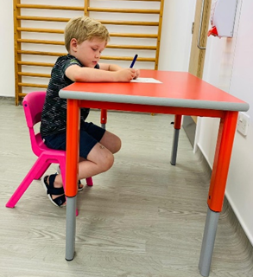
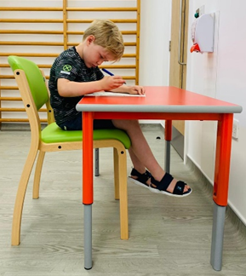

Quick solutions
A foot block/ tray anything to put their feet on to ensure feet are supported.
A cushion behind back if the chair is too large
Look in other classes for appropriate height tables and chairs.
Just right and with a sloped board/ surface
