General Fine Motor Activities to help develop the hand for Handwriting - Primary
What is it? Handwriting refers to a person’s unique way of writing characters. Handwriting requires the multiple coordination of various muscles and joints in the hand, wrist, elbow and shoulder in order to form characters.
Why is it important? It is important to have legible handwriting for academic achievement in school and basic written communication e.g. to fill in a form, write a note.
How you can help:

- Offer your child plenty opportunities daily to practice using their hands and fingers for play e.g. play finger soccer, use keypad gadgets see activities below. Offer encouragement to practice handwriting every day.
- 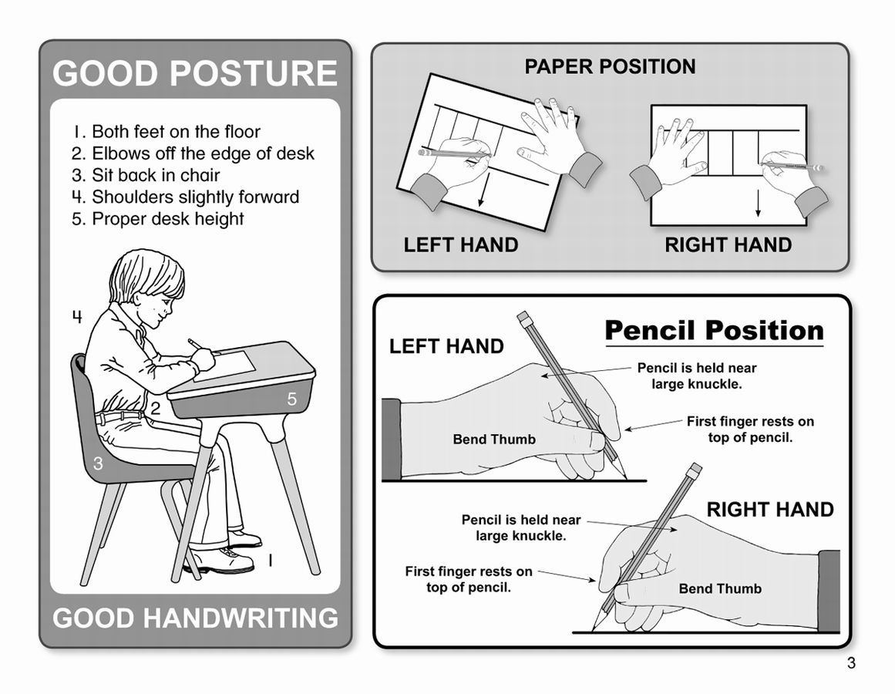Reduce pressure on pencil
- Improving wrist stabilization
- Develop hand arches
- Improve strength of hand muscles
- Position the paper correctly and ensure other hand acts as a support
- Ensure your child is sitting with a comfortable and supported posture (e.g. feet on the floor, and elbows resting on the table at a 90-degree angle) or is standing up at a vertical surface.

The following is a list of games and activities to help develop handwriting skills:
Improve hand skills:

- Write on a vertical surface at eye level with writing tool
- Work in vertical to do small manipulatives; lacing eye hooks, peg board, lmagna doodle, colouring, painting, and manipulating putty.
- 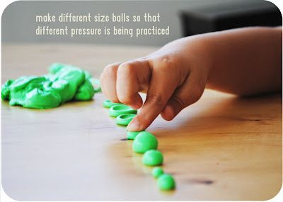Rolling pin to flatten therapy putty, play dough

Improve hand arches:

- Pinch small objects
- Scrunch paper towel or newspaper under palm
- 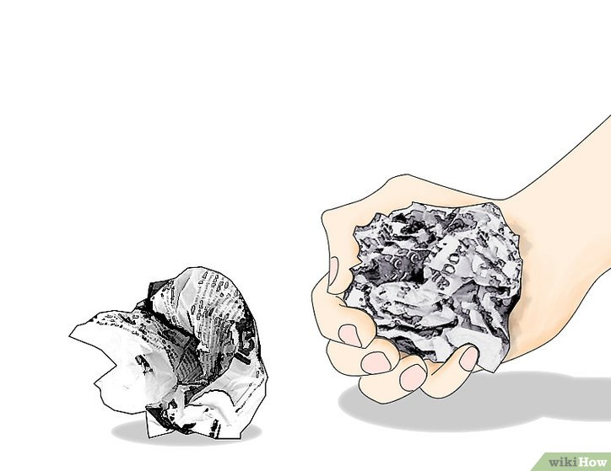Press round shaped object or toy into palm
- Press open clothes pins
- Find pennies hidden in therapy putty
- Spider in the mirror game
- Roll up hands to roll dice
- Turn over a row of pennies
- Cut therapy putty or play dough with a plastic knife or small scissors
- Pinch Ziploc bag to close

Improve separation of parts of the hand:

- Squeeze trigger of ‘spray bottle’ to squirt water to clean off target on blackboard
- Roll therapy putty between thumb and index finger or thumb to index and middle fingers
- Snap fingers

- ‘Squirrel' objects into palm of hand using only finger movements (use pennies, paper clips, small dice or tiny lite brite pegs
- Play finger pattern games where child is instructed to lift/separate/bend /straighten fingers; Start by having child place both their hands-on table to motor plan movements by moving finger in space.

Precision skills of intrinsic: (tiny muscles within the hand) - improve small muscles of the hand:

- Oppose thumb with each fingertip
- Tug of war with fingers using coffee stirrer and/or tongue depressor
- Place pennies into small slot such as a piggy bank
- Hold and pinch therapy putty or play dough
- Wrap a rubber band or therapy putty around child’s flexed fingers; as he/she straightens out fingers, spread fingers apart against resistance
- Hold a flat book or tray from underneath on extended fingers; Balance something on top
- Wring out small sponges

Translation Movements:

- Wrap a rubber band or therapy putty around child’s flexed fingers; as he/she straightens out fingers, spread fingers apart against resistance
- Hold a flat book or tray from underneath on extended fingers; Balance something on top
- 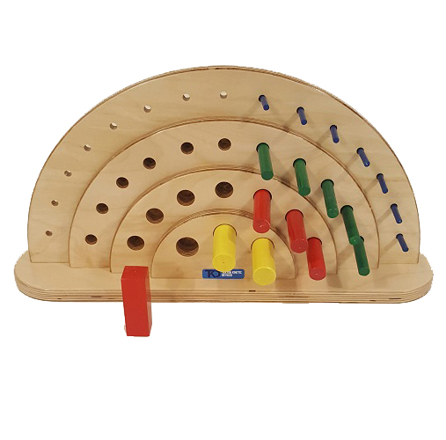Wring out small sponges

Finger Isolation:

- Lace through eye loop design board
- Insert pegs into peg board placed in vertical
- String beads
- ‘Feed’ or withdraw pipe cleaner, coffee stirrers, plastic lace into snug opening in cardboard or leather

Improve or Modulate Delicate Touch:

- Line up dominoes on their long, narrow side – Gently tap first one to see if all fall in sequence
- Pick up fragile items with fingers/tweezers: cornflakes, mini-marshmallows, bits of foam, without breaking or denting them
- 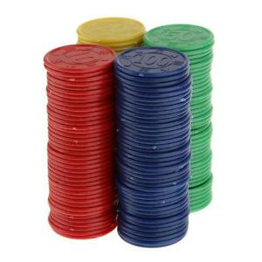Play pick- up sticks using fingers or a magnet
- Drop specific number of droplets of water from an eye dropper

Improve awareness of Body Position (KINESTHESIA)

- Weighted cuff, weighted vests
- Heavy work – pick up heavy objects
- Follow a path on top of a card, by using a magnet under the card to direct and
- Move the marble on top through a maze
- Stack poker chips; build a tower at midline without looking. Pile like colours to right and some other colour on left of midline. See if child can build a ‘striped’ tower without vision.
- Draw a vertical line at midline, on board. See if child is able to simultaneously hold a writing tool in each hand and make a series of straight, convex and concave lines from midline in an upward and outward pattern (Emphasize, rhythm, speed, and uniformity)

