Mark Making
What is it? Mark making is the early developmental skill of being able to use your finger or a crayon etc to make a mark on a surface e.g. drawing with a finger on a steamed-up window or scribbling on paper with a crayon
Why is it important? Mark making lays the foundation skills for handwriting and academic skills e.g. Maths, Art etc. By mark making young children learn to express themselves visually.
How you can help:
- Ensure that your child has plenty of opportunities to mark make creatively and with a sense of fun. Provide the tools and the time to mark make.
- Help your child to understand the importance of mark making by showing your child how you make marks and what you use them for e.g. writing notes, cards, lists.
- Use a variety of different tools and surfaces to make marks e.g. crayons, paints, lolly sticks, feathers and fingers and toes; as for surfaces try newspaper, wrapping paper, wall paper, fabric, walls and windows, sand and mud, shaving foam or play dough. You can also encourage your child to create collages as a way of early mark making.
- Mark making does not need to be done sitting down – encourage standing up or lying on your tummy. Mark making on vertical surfaces e.g. an easel is developmentally appropriate for very young children.
- Mark making is an INDOOR and OUTDOOR activity; use every opportunity to make marks and a reason why to make them e.g. leaving clues in the mud/sand to help our friends to find us; play pavement chalk games or set up a camp with posters and signs....
- Once a child is mark making talk to them about what it is they are making? Is it a picture or a story? Ask them to tell you about what they are making. This is important to help children understand the symbolic meaning of mark making. Encourage mark making to help children explore language, pictures, and numbers.
- 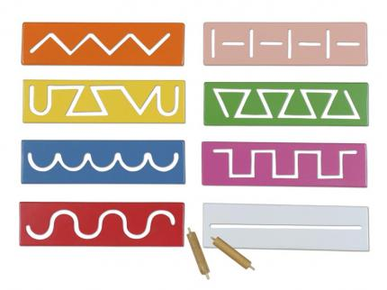You can gently and positively encourage your child to make marks that form the early patterns of handwriting e.g. single vertical and horizontal lines, circles and spirals, wavy lines, and zig zag lines. During this stage encourage large mark making and where your child ‘crosses their midline’ e.g. where they take their right or left hand over to the other side of their body to start mark making.

Fine motor games such as threading, board games, posting and sorting will all help a child develop the manipulative skills for mark making.
Gross motor games such as ball games, rough and tumble, climbing and playing on playground equipment will help children develop postural and shoulder strength needed for mark making.
Visual perceptual games such as dot to dot, puzzles and mazes will help children develop the perceptual skills needed for mark making.

