Organisational skills

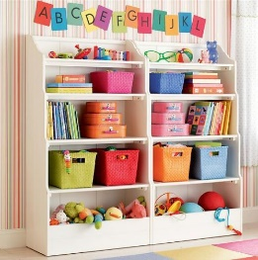
What is it? Essential components of organisation are motor planning, body awareness, timing and memory. Organisational skills influence a child’s ability to organise him/herself in different daily and learning activities. Children may have difficulties with:

- Organisation of self and belongings
- Preparing for the school day
- Presentation and layout of work
- Performing practical tasks
- Learning new skills

Why is it important? Organisational skills are essential for developing independence. It is important for a child to become responsible for themselves and their belongings.
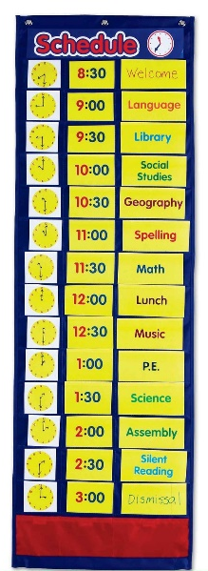
How you can help:

- A joint approach is essential between home and school

- Help develop consistent routine at home

- Involve the child in planning their day/week

- Ask questions about what the child is going to do, how they are going to do it and what they need rather than telling them what they need or what they have forgotten.

- Give one direction at a time. Avoid overloading

- Check that the child has fully understood what is expected of them

- Use diaries, visual prompts. Include the child in setting this up e.g.

  - The use of a blackboard or whiteboard in a prominent place within the home
  - Set them up when there are no time constraints
  - Encourage the child to photograph belongings to create a visual checklist - can be put on the back of the door when leaving the home / bedroom as a visual prompt / check to ensure they have everything
  - Flow chart / Check list of daily routines e.g. getting ready for school – e.g. wash, dress, breakfast. Break it down as much as needed e.g. break down wash to clean face, dry face, put towel back on the rails, brush teeth, brush hair etc

- Gross motor activities, which require sequences of movement

- Problem solving games and puzzles

- Give lots of positive feedback

