Physical education reasonable adjustments for young people in school
Some students may have some difficulties in planning their body’s movements and coordinating their body in the way that is being asked, making it difficult for them to carry out activities that their peers manage easily. Providing more time and practice to master these physical skills should be considered. Below are some adaptations that can be put into place to help create a success and reduce challenges.

Getting Ready for PE
Extra Time:
Allow for additional time to change into and out of PE uniform, as getting dressed may take longer.
Alternative Clothing:
Consider adaptations to the school PE kit, e.g., Velcro-fastened shoes, looser-fitting clothes, elasticated for easier dressing.
Visual Supports:
Having visuals with step-by-step picture guide for changing.
Assisting:
Staff to consider offering discreet support or checking in if they need help with laces, buttons, clasps or sequencing.
Changing Space/room:
Providing access to a less busy area to reduce sensory stimulation and social anxiety. Having access to full length mirror to check.
Further adjustments to consider:
Allowing children to wear their PE kit into school, to minimise the efforts and challenges for getting ready and dressed for PE. They could be in a high state of anxiety even before starting the PE or games lesson.

Participating in PE
Support to help develop the skill:
Consider smaller groups or 1:1 practice before lessons to build confidence. Provide opportunities to practice hand-over-hand guidance if needed.
Using MATCH as a strategy:
This can support students reach their potential. Considering this strategy will help make sure the task and the learning environment are right for the child.
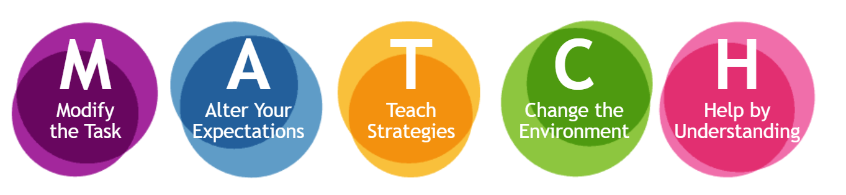
https://www.elearningcanchild.ca/dcd_workshop/match.html

Instruction & Support
Step by step:
Break down task into manageable steps, ensure one skill is mastered before introducing the next.
Clear instructions:
Give clear, step-by-step verbal and visual instructions. One instruction at a time and allow time for them to organise their body into position before giving the next.
Alter expectations:
Focus on effort and engagement. Meeting their level of physical development to promote a positive, supportive environment to build their confidence.

