**Dressing Skills – Buttons and Zips**

**Zips**

Practice whilst sitting on a chair. Give a step by step demonstration, talking through what you are doing. Use the same instructions each time. To make grasp easier, attach a keyring or ribbon on the zipper. You can also purchase accessories such as Zipz ([www.meru.org.uk](http://www.meru.org.uk)).



* 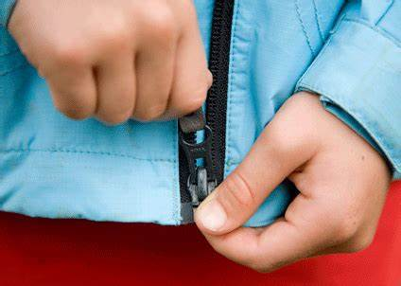Zip and unzip jacket once on track.
* Unzip jacket, separating zipper at the bottom.
* Zip jacket after latching it together.

**Buttons**

Practice whilst sitting on a chair. Give a step by step demonstration, talking through what you are doing. Use the same instructions each time – ‘pinch, poke, pull’

* Start by teaching your child to do buttons when they are not wearing the garment. At first you can provide a garment with large buttons and once this is mastered move onto a garment with smaller buttons.
* Use Button boards or play cubes. These can be made to give the child practice at certain types of fastenings inc. buttons, laces, poppers.
* Allow your child to do up those buttons which they can see (e.g. at the bottom of a shirt).
* Start the task if necessary but then get them to finish e.g. pull the button through.
* Replace frequently used small buttons with larger ones (e.g. on coat or school shirt) as these will be easier to do up and a good place to start.
* Buttons are easier to grasp if they are flat (instead of concave) large, textured or sewn slightly above the surface of the garment. Be sure buttonholes are large enough for buttoning ease.
* Sit next to, in front of, or directly behind your child during the activity. Guide them through the task. For some children, it may help to sit in front of a mirror so they can see.
* Encourage your child to practice this skill when time is less of an issue e.g. evenings and weekends.
* Use a reward chart to increase your child’s motivation for the task.

**Fine Motor Activities to assist with fasteners:**

* Practice activities that need your child to use two hands together e.g. rolling with a rolling pin, clapping games, or catching a ball during play.
* Activities that encourage your child to use a fine pincer grip (pad of thumb and index finger) e.g. picking up raisins, using tweezers to pick up small objects