Self Care Skills – Sensory
Teeth Cleaning:

- Apply deep pressure to cheeks with both hands-on cheeks before teeth cleaning – blow up cheeks and squash flat
- Play tongue games before brushing – e.g. count teeth on left side with tongue, put tongue in cheek etc
- Use minimal toothpaste, bicarbonate based – helps stop gagging
- Use an electrical toothbrush – provides deep pressure and vibration to help calm and organise
- General blowing a sucking games during the day – blowing bubbles, party poppers, drinking through a straw

Toileting:

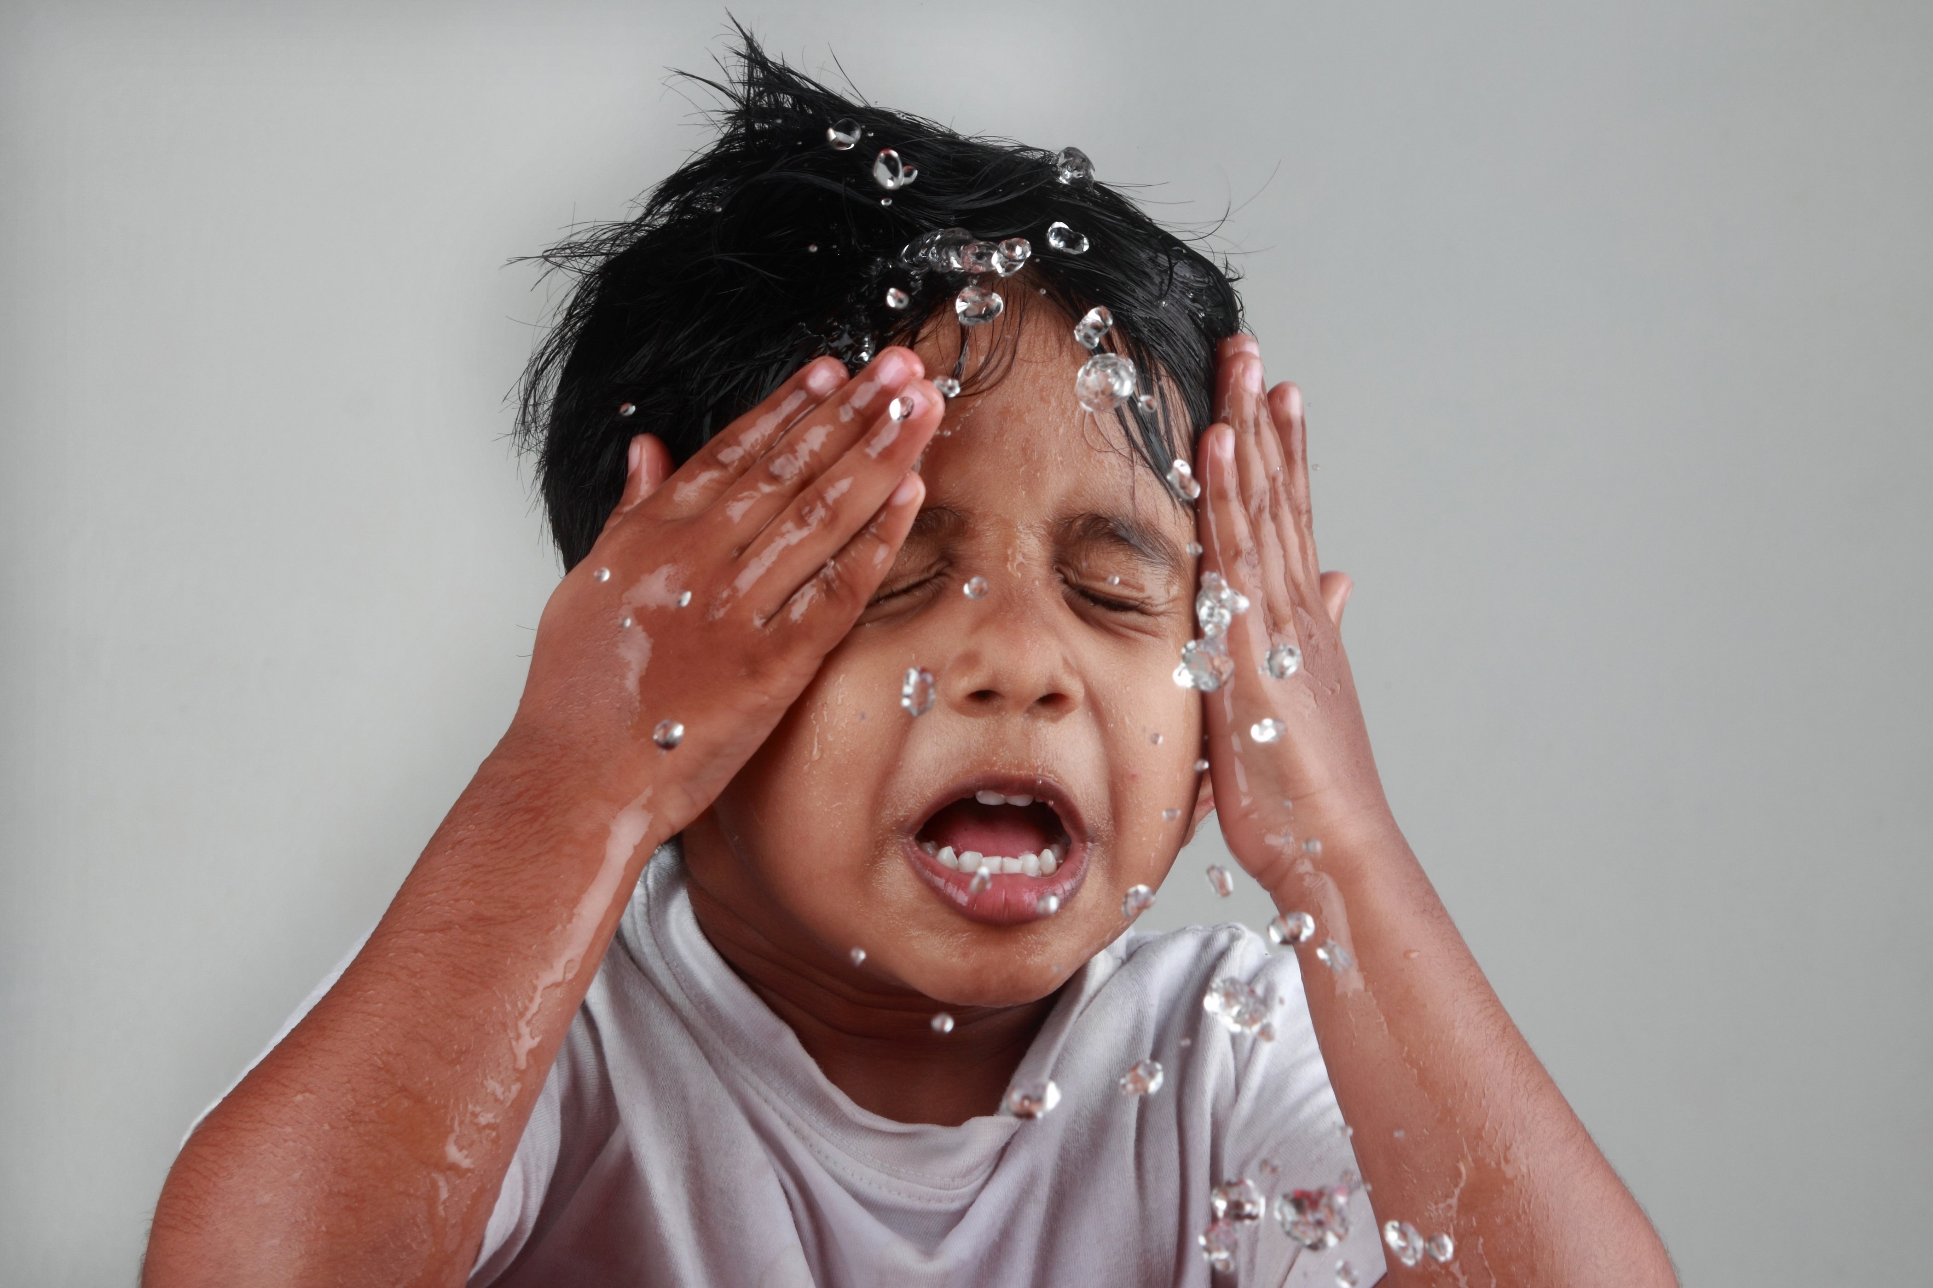
- Use moist toilet roll / wipes
- Keep visual and auditory stimulation to a minimum
- Toilet seat – might be too hard, use a padded child toilet seat

Dislike of baths / showers:

- Do resistive (pushing, pulling, carrying, rolling) activities before to provide deep pressure
- Encourage child to wash own body / face
- Use large sponge and rub firmly
- Fragrance free soap
- Use hand held shower head – increased control
- Use large towel to wrap and firmly dry afterwards – pat firmly or leave to dry
- Deep massage when putting on cream
- Run bath before child enters the room to reduce the anxiety build up

Hair Washing / Cutting:

- Sit child firmly on lap, squeeze child between your knees
- Place hands on head, apply gently but firm downward pressure – wear a tight hat prior to help desensitise
- Counting whilst doing the task
- Get child to scoop and pour water
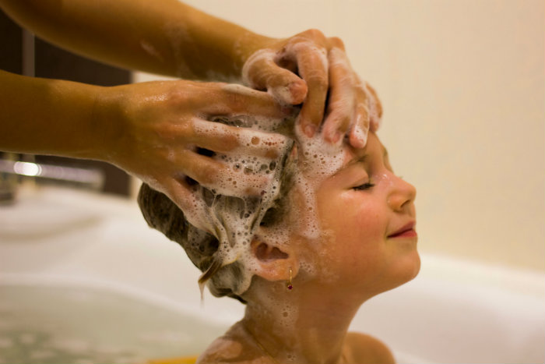
- Fold flannel over eyes to prevent soap getting into eyes
- Tip head back to pour water over
- Firm touch when massaging shampoo
- Use a soft hairbrush
- Hold top of hair whilst brushing out tangles

Sleeping:

- Provide firm deep pressure massage prior to bed, avoid tummy area
- Establish good routine, calming bath – dry with firm rubs of the towel, story
- Tuck the blankets / sheets into the mattress to help provide deep pressure in the night
- Add extra weight – more blankets, wheat bags onto the legs on top of the blankets to provide further deep pressure
- Sleep in a sleeping bag – gives sense of security
- Have extra pillows between legs or arms to help cuddle into
- Use of a night light

