**Dressing Skills - Shoelaces**

Practice whilst sitting at a table or with the shoe on their lap. Use long, wide shoelaces initially. Place a ‘practice’ shoe on the table that has two different coloured laces. Give a step by step demonstration, talking through what you are doing. Use the same instructions each time.

**Method 1:**

* 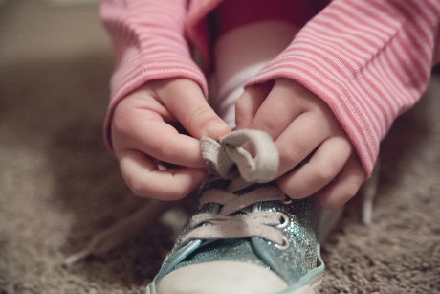**Stage 1 - Knot**

Tie a knot with a lace by crossing the laces and push one lace under the other twice, then pull to make the laces secure

* **Stage 2 - Making a loop**

Make a loop or “bunny ear” and hold the bottom of the loop between thumb and finger.

* **Stage 3 – Going around the loop**

Take the other lace and loop it around the bunny ear. Push it through the ‘burrow’, hold each loop in each hand and pull tight.

The important thing is for the child to keep holding the bunny ear. Encourage the child to pull tight and finish the task so they feel successful.

**Method 2:**

* A child pulls both laces tight
* 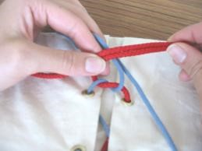A child crosses laces and pushes one lace under another twice making a knot
* A child makes one loop with one shoelace and another loop with another lace “Bunny Ears”
* A child crosses the loops leaving one finger inside a ‘triangle’ between laces
* Child pushes another loop through a ‘triangle’ created by laces

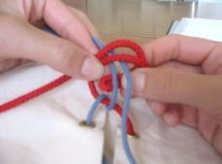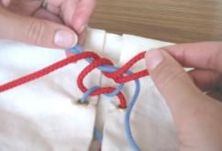

* Child holds both loops and pulls them tight

# Other Ideas

* Practice using rope as this may be easier to make the loops
* Try elastic shoelaces or spring laces – coilers
* Use Velcro fastenings or slip-on trainers/shoes