Toilet Training Techniques for children with ASD
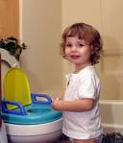
What follows is a brief review of various toilet training techniques that address the unique needs of autistic children.
- In order to address the communication deficits associated with Autism, visual versus verbal cues may result in higher favourable response rates- use a system of picture icons for each step.
- Ensure the picture system indicates "what happens when I'm finished" picture because task completion is a powerful motivator for most children with Autism
- To address difficulties with the recognition of the urge to eliminate, timers may help the Autistic child learn to recognize when they are ready to eliminate.
- A transition object (e.g., a preferred toy or book) may be used initially to shape smooth transitioning behaviour. If the child has become accustomed to taking a certain book or doll to the bathroom when prompted by an adult, they may indicate the need to go by picking up this item on their own.
- A photograph of the toilet can also be used as an effective way to communicate the need to eliminate. This can be especially helpful for children with deficits in their use of verbal language.
- To accommodate autistic children's resistance to change, it is recommended that instructors introduce the bathroom routine gradually, first requiring the child to enter the bathroom clothed, then to sit clothed on the toilet, then in diapers, then unclothed.
- The use of potty chairs are not encouraged with autistic children as the adjustment to the toilet may take longer if they have become adjusted to the potty chair.
- If a child resists eliminating on the toilet, the use of a water prompt can facilitate a child's recognition of the sensation of having to eliminate
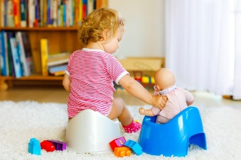
- As it is important to reduce as many outside distractions and obstacles as possible, the use of a small half bathroom is recommended.
Other general toilet training tips:

- Let the child watch you go to the toilet
- Practice with a doll or a teddy going to the toilet
- Keep a chart for a week or 2 to identify when they go to the toilet. If you can identify a pattern, put the child on the toilet when it is close to the time they would usually go.
(Also place them on when you know that they are making the signs of going)
- Practice having them on the toilet for 1-2 mins, increase to 5 mins
- Praise them for sitting on the toilet and their attempts and successes. Do not tell them off
- Put them on the toilet if they are dry in the morning or after a nap. This may be a good time to achieve success.

Remember the child may not be ready for toilet training.
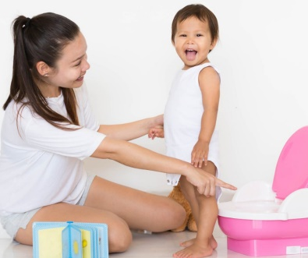
The following behaviours indicate that they will be ready for training:

- Remains dry for 2 hours
- Understands simple instructions
- Is interested in doing things for themselves
- Takes pride in new skills they have learnt
- Lets you know when they are wet or soiled

