Children’s Integrated Occupational Therapy
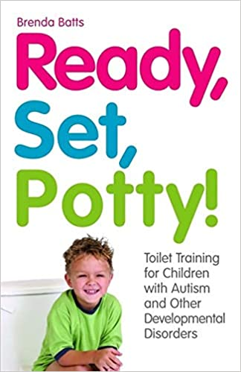
Helping your child to develop good toileting practice: advice for parents
Ready, Set Potty – by Brenda Batts – Toilet training children with Autism and other developmental disorders. The information below is a summary of this book and with some additional information. The OT recommends reading this book in full to get a deeper understanding of the strategies to support toileting children with special educational needs. Or accessing the other resources listed including the Autism Speaks – Toilet Training Guide (PDF). The OT also recommends talking to your GP, Paediatrician or seeking a referral to Children’s Bladder and Bowel service if you are concerned for your child.
Why it’s difficult for children | When you should consider toilet training | What helps
It’s a new concept,  They find acquiring a new skill difficult and they have difficulty generalising skills.  The child has got used to nappies and doesn’t understand the need to change to using a toilet | When your child has a preference to foods, can communicate in some form, can choose something, can follow a two-step instruction, responds to praise and your voice. Starting early in your child’s life is highly recommended. | Order – help your child to understand what the task is and how to preform it.  Predictability – help your child to sequence the task and setting expectations.  Routine – offer your child consistency e.g., knowing that the task needs to be done the same under all circumstances. | Structured program and clear written goals  An individualised approach e.g., child’s learning mode, likes and dislikes, any relevant sensory issues  Diet, active movement, and digestive health all contribute to regulation of the intestines.
Things to consider and do to begin with:
- Recognise and acknowledge your child’s individualised needs e.g., anxious, avoidant, transitions difficult; likes dinosaurs and story books.
- Set a goal e.g., for my child to be relaxed enough to go into the bathroom without having a meltdown
- Outline objectives/plan: use picture schedule to develop routine, create a potty- training social story, use picture sequence chart, use visual reward chart, use highly motivating rewards, continuously evaluate objectives/ progress.
- Plan – when, where, how often, for how long, who etc, where will resources be stored?
- Consider setting an alarm on your mobile phone to remind you to take your child to the toilet. Scheduling toilet sessions may
- You may need to tailor resources specifically to bowel movements and your child may start ‘holding onto their poo’ at the beginning of the toilet training program
- Consider teaching a boy to wee sitting down on the toilet rather than standing.
- Use consistent language for the toilet.
- Bottom wiping must be taught separately.
- Night-time toilet training starts after successful daytime training.
Next steps: Below is a list of steps to start toilet training. These steps are available in full detail in the Ready, Set, Potty book with more detailed explanation. You will need to prepare and resources BEFORE you start toilet training. We have separated out the steps that you do to prepare resources and the bathroom and the ones you do with your child. We understand that toilet training can cause additional financial costs to you and your family. Toilet training is intensive to start with so extra time and energy will be needed to set up and commit to toilet training. Ask for help from family and friends and let them know what you hoping to achieve. In preparation:
- Pick a day to start – not a Monday and the holidays may not be the best. Pick a day and time that will give the highest predictability for success.
- Potty training should be undertaken in all environments/settings with the same order, predictability, and routine e.g., home and school. You may need to liaise directly with school before you start.
- Pick a theme – this is the motivator that will be in the bathroom (only the bathroom) e.g., your child loves dinosaurs – so lots of dinosaur shapes, pictures etc ONLY in the bathroom.
- Decorate the bathroom with the ‘theme’ and anything else that helps e.g., calm neutral colours/fewer distracting objects? You only need to create the ‘just right environment’ in one bathroom/toilet. Stick to using this one place to potty train at home and apply this to other settings
- Make your child’s pants unique that may follow the ‘theme ‘in the bathroom. Consider ‘decorating’ white cotton pants with the ‘theme’ e.g., some children love balls so a yellow circle on the front of the pants could support this. And no balls anywhere else.
- Have your child’s motivating objects and toys in the bathroom ready for when sitting on the toilet. Place them in a basket so they can be seen. Your child can only play with these when they are sat on the toilet. School may be able to create a basket of similar objects (infection controls will need to be put in place).
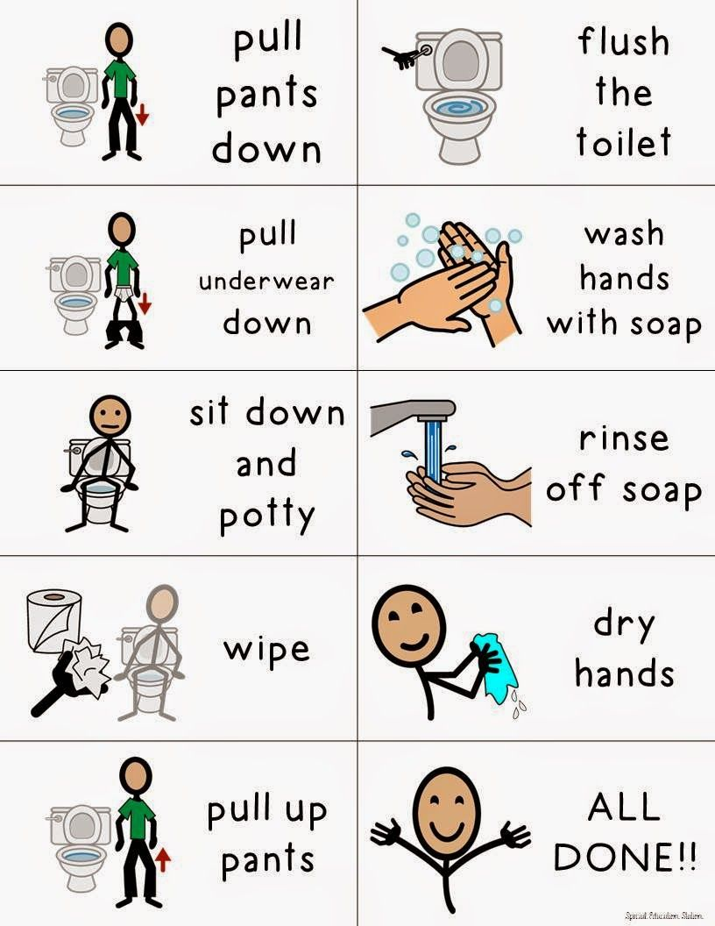
- Cutting out and laminating a set of footprints and taping these to the floor can help children to understand where they need to put their feet when toileting. Anxiety of falling into the toilet can be common so do find out ways of supporting your child’s sitting position e.g., a stool for their feet. Do tape the footprints to the stool and only use the stool for when sitting on the toilet (so not to confuse your child).
- Place stickers on the front and back of the toilet to help a child know where to sit. A potty insert is not recommended as the child may get used to this at home, but this will not be in every toilet they use. Help your child to generalise the toilet training skills they learn at home.
- Create a behaviour strip (visual sequence chart of what needs to be done in what order). Put this near the toilet paper or where can be easily seen. (See picture for an example).
- Create a picture story (see Appendix) and a “Now and Next” chart – keep this plain and simple – laminate and stick a picture of the toilet and then the reward.
Toilet training with your child: Whilst toilet training accidents may/will increase.
- Establish a baseline for your child’s natural elimination pattern. Use a chart to help establish this baseline e.g., child needs to be taken to the toilet 6 times a day at these set times….
- Accept that potty accidents will happen and take away the nappies and put your child into pants. Make it an event when you get rid of the nappies and involve your child.
- Teach the concept of wet and dry underwear. Wet some clean pants and when relaxed and comfortable, present wet and dry pants to your child to touch and recognise the difference.
- Celebrate/party the night before you start potty training. This helps to set a positive note to the proceedings and reinforces predictability for you child. Give your child the decorated underwear as a gift!
- Sit your child on the toilet for a few minutes – any longer may seem a punishment.
- Don’t stand too close to your child or sing or read stories; your child needs to become independent, and your toilet training rewards/behaviour reinforces should be sustainable (by everyone and everywhere).
- Accidents – keep clothes near by to change your child. Try and change them in standing and not lying down.
- Use rewards that are immediate, relevant, to the point and short duration. Brenda Batts put a see-through jar of potato crisps in the bathroom and her son got 3 crisps each time he had a wee in the toilet. She advises against offering the TV as a reward as this is not ‘short duration’.
- Be consistent, keep going – you may need to re-evaluate and make some changes but don’t stop.
- Take your child regularly to the toilet. Let them know why you are taking them.
Appendix:
A: Creating a picture story – this is a picture then a story statement in words “…”
Page 1. Picture of your child
Page 2. “My name is …and I am …years old”
Page 3. Picture of toilet
Page 4: “This is my toilet where I wee or poo”
Page 5: Picture of your child pulling down pants
Page 6: “First I pull down my pants”
Page 7: Picture of child sitting on toilet
Page 8: “Next I wee or poo only in the toilet”

Add the desired pictures and words to follow on from page 8. Add a picture and words about getting a reward at the end. And a picture of your child looking happy. You may need to add pictures and words specific to your child such as behind the couch and “I do not poo here”.

B: Teaching bottom wiping – You will need to do this for your child to start with.
Place your hand and then your child’s hand on top
Place your hand immediately in the area that needs wiping so your chid understands exactly where needs wiping. Once you have wiped like this, say to your child ‘your turn, you wipe’
You may want to try thick toilet paper or wet wipes as this can help.
This is a comprehensive list of resources that the OT service is aware of and cannot rate any resource over another.

Resources:
- Pediatrician Dr. Harvey Karp wrote a book, The Happiest Toddler on the Block. A recommended book to help use behavioural strategies with your child
- The Practical Guide to Toilet Training Your Child with Low Muscle Tone by Cathy Ann Collyer, OTR, LMT
- Coucouvanis, Judith A. (2008) The Potty Journey: Guide to Toilet Training Children with Special Needs, Including Autism and Related Disorders. Autism Asperger Publishing Company, Shawnee Mission, Kansas.
- Wheeler, Maria, M.ED (2007) Toileting Training for Individuals with Autism or Other Developmental Issues. Future Horizons Publishing Company, Arlington, Texas
- Arzin and Foxx – toilet training in less than a day (Arzin and Foxx established a ‘rapid method of toileting training in 1971 and are well cited in research) and have published this book.
- Arzin and Foxx have a PDF summary of their toilet training method at https://storage.outreach.psu.edu/autism/96.%20Handout%206.pdf The centre for Autism Treatment - Guidelines for Potty Training Program by Foxx and Azrin-
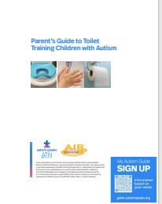
- Toilet Training Guide.pdf (autismspeaks.org) –
- Potty training children with additional needs | ERIC
- Toileting - a guide for parents and carers (autism.org.uk)
- article-toilet-training-children-with-special-needs.pdf (cedwvu.org)
- https://do2learn.com/picturecards/printcards/selfhelp_toileting.htm
- Advice on Bladder and Bowel Problems in Children and Young People (bbuk.org.uk)
- Tips - Toilet Time

