Children’s Integrated Occupational Therapy
Picky Eating / Extreme food refusal
Children learn to like foods they are given in the first year of their life. They learn to accept and eat different tastes and textures. As they move in to their second year it is very common for some children to show a fear of trying new foods. This fear is a part of normal development.
Most children will move through this but others can continue to find eating / accepting new foods very challenging for a variety of different reasons.
What can cause this?
- A phobia.
- Current or a history of medical e.g. feeding tubes/reflux, breathing/cardiac difficulties.
- Constipation – this has a huge impact on appetite.
- Negative association reinforced over time e.g. poor oral latch leading to stress cycle in early feeding
- Allergies e.g. feeling sick, tummy aches leading to avoidance of food
- Lack of internal registration for hunger/thirst
- Sensory sensitivity – defensive to textures, smells, tastes leading to reinforced negative association over time and avoidance
- Behaviour/emotional insecurities - to gain control, to communicate feelings, to express stress or anxiety
Children who may experience any of the above may not gain any pleasure from food.
They may restrict their food groups to ‘safe’ foods that they feel able to manage.
It can be extremely worrying for a parent when their child doesn’t eat a varied diet.
What to do ?
Start with the child. Take off all pressure off them (and yourself) to try and get them to eat.
Speak to well-meaning friends and family members about this too. So they understand and can support you as a parent, rather than tell you ‘rules’ to make your child eat. E.g. starve them and they WILL eat.
Children often need a predictable routine to feel secure and safe, try to keep consistent times for mealtimes where possible. Having the same or similar set up at home as well as other locations can help. E.g. sitting at a table and having a similar placemat with a favourite character on.
Remember stress and pressure can reinforce the child’s negative association with food – think about the environment for eating, is it calm? Is it happy?

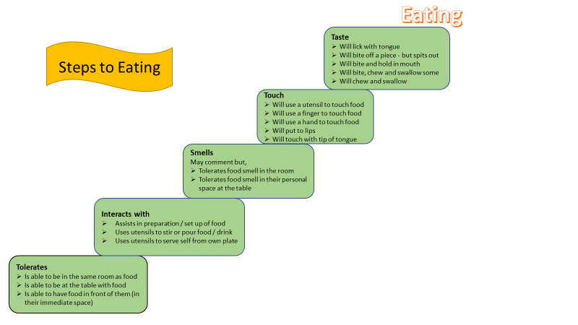
"I had a big problem with food. I liked to eat things that were bland and uncomplicated…I didn't want to try anything new…I was supersensitive to the texture of food, and I had to touch everything with my fingers to see how it felt before I could put it in my mouth."
Environmental considerations
“The person might find it too distracting to eat in a noisy canteen – find out if they could eat in a quiet room instead.
Playing some favourite music or a story in the background can be relaxing, distracting the person from the usual anxiety around eating.”
- Lighting – is it too bright / severe (florescent lighting)
- Noise levels – too noisy or lots of different sources of noise e.g. other children chatting, TV on, radio on.
- Smell – some children are sensitive to smell, being aware of this and acknowledging this can help.
- Consider relaxing music to calm
- Are there too many smell/flavour variations for the child to cope with? Some children tune into beige food more than colourful foods

Be Positive
Build a positive relationship with food without pressure to eat it. This can achieved in :
- messy play,
- cooking activities,
- role play,
- share food platters. Where your child can see the food and watch everyone enjoying food and trying it.
- Use their interests and bring in food
In all of the above do not place any expectation on your children to try any of the food or even taste it. The activity needs to be fun and enjoyable with no pressure.
Family Mealtimes
- Exposure to non- preferred foods- most children will need to be exposed to a new food 15-20 times before accepting it.
- Offer small & frequent portions so that your child is not overwhelmed
- Give drinks at the end of meals or at snack time to avoid children filling up on them
- Consider easy grip or angled cutlery and non-slip plates if coordination of utensils is an added frustration.
- Compartment plates particularly helpful for children with autism. Choose plates and cups with favourite characters / colours.
- Ensure good posture and feet grounded – use footstep if needed.
Make gradual changes
Think about what your child will currently eat- is it a certain brand, a particular texture (e.g, if they don’t like food with lumps), a certain temperature, or a particular flavour?
Consider what changes you can add to this, changing only one quality at a time.
Take branded products out of the packaging – get your child used to not seeing the packaging, so that they don’t have the visual clue of something being different.
 | Do | Reason
 | Encourage your child to experience different textures through ‘messy’ play every day. Your child may find some textures (like playdough) very difficult, so start with textures that they are happy to touch. These are generally dry textures such as rice or lentils. Gradually progress to more messy/wet substances allowing them to gain confidence. If they don’t want to touch it with their hand – give them a spoon so they can’t explore it without touching it initially. If you don’t like mess or touching messy things yourself, you can take younger child to a playgroup in your area where they do ‘messy play’. | Many children who are extreme food refusers are very sensitive to touch on the hands and mouth and will not even pick up new foods. Messy play can help them to get used to new textures.
 | Give small frequent meals of food that your child accepts | Some children are very anxious at mealtimes and are sometimes very slow eaters. Small frequent meals will help them to take in the calories that they need.
 | Remember, even children who are extremely picky eaters can grow and develop normally, if they are given the foods that they will accept. | It is important to keep your child growing well, and even children who only have a very small list of foods they eat still grow as we would expect them to, if they have enough of the food they will eat.

 | Don’t | Reason
x | Refuse to give high energy foods like ice cream, cakes, biscuits and chocolate, in the hope you child will eat ‘proper’ meals and ‘healthy foods’ | This is not a good way to get your child to eat new foods, and your child may start to lose weight if you withhold their safe foods
x | Try to force your child to eat food | This will make your child even more anxious and even fearful at mealtimes, this may even cause them to vomit food back up. Being sick will only reinforce that, that food is not safe and make them refuse more.
x | Starve you child. Leaving long gaps between meals to try and make your child more hungry to then eat other foods, does not work. | This will make your child less hungry over time and may lead to weight loss.
x | Hide foods inside foods that your child already likes. Your Toddler may just stop eating the liked foods | Some children can very easily detect new tastes and smells even when hidden in other foods. You may put them off one of their ‘safe’ foods reducing their food list down further.

Professionals who could help
Your GP might refer you to one or more of the following professionals or places.
Dentist: eating difficulties may result in, or be affected by, poor dental hygiene management or toothache.
Dietitian: they offer assessment and treatment of dietary related health problems such as constipation, allergies and intolerances as well as practical advice on eating problems, weight gain and weight loss. Ask your GP or consultant to refer you to an NHS dietitian or find a private dietitian.
Eating disorder clinic.
Clinical psychologist or psychiatrist: if the problem is thought to be psychological, these professionals can help with behaviour strategies.
Paediatrician: experts in child health issues who can help provide solutions to dietary issues and investigate underlying problems.
Occupational therapist (OT): may be able to offer advice on how you manage the situation at home and school.
Speech and language therapist (SALT): can advise on feeding issues and swallowing problems (dysphagia).
Counsellor: trained to talk through a variety of issues.

Resources: This guide had been put together with information from
• The Toddler & Infant Forum, Managing extreme food refusal.
• National Autistic Society – Advice & Guidance / Behaviour / Eating
• ARFID Awareness UK

