

Children’s Integrated Occupational Therapy

**Helping your child to develop good sleep practice: advice for parents**

All children and families are different, and some people need less sleep than others. In general, though, children need 10 hours of sleep to feel restored. Lack of sleep can cause physical, emotional, and social difficulties. An overtired child can have increased behavioural or sensory difficulties.

There are different types of sleep difficulties e.g., not settling to sleep, waking, and not going back to sleep, waking early and a normal sleep phase but at the wrong time. Other difficulties may be night terrors or bed wetting. This advice is a summary from a range of sources which is listed below in resources. All advice recommends environmental, behavioural, and cognitive strategies alongside a good consistent bedtime routine which is tailored to your child’s individual needs.



|  |  |
| --- | --- |
| STOP | Offering caffeinated drinks and sugary food – especially an hour or so before bedtime.  1. Napping after 3 years of age – encourage rest if tired. An overtired child may have difficulty sleeping. 2. Screen time – at least an hour before bedtime. Avoid exciting and thrilling TV that could overstimulate before bedtime. 3. Offering large and heavy meals/snacks before bedtime |
| START | 1. Keeping a sleep diary for a week or so; try and understand what sleep difficulty your child is having and possible reasons why. 2. Start by making small changes and easy wins; set a goal which is achievable 3. Get everyone involved on board and agreeing the ‘sleep plan’ Be consistent with the sleep plan – for at least 2 weeks 4. Start the sleep plan on a Friday so you have the weekend to get through the first few nights 5. **Offering your child more time outside during the day and increase exercise and activities.** |

|  |  |
| --- | --- |
| ESTABLISH | * A good consistent bedtime routine – keep bedtime boring. Bedtime and waking time should be the same each day. * Some children will need help transitioning from night-time to bedtime: visual timetables and auditory cues may help such as music is played at the same time each night to indicate the start of the bedtime routine * A bedtime routine should be started upstairs and last 15 to 30 minutes. * Dim the lights in the house, settle the house down to be quiet, stay calm and quiet yourself. * Use relaxation techniques, Yoga, massage, warm bath, bedtime stories, breathing techniques. * Be consistent with any individualised strategies you use. * A ‘goodnight’ phrase that you use for resettling |

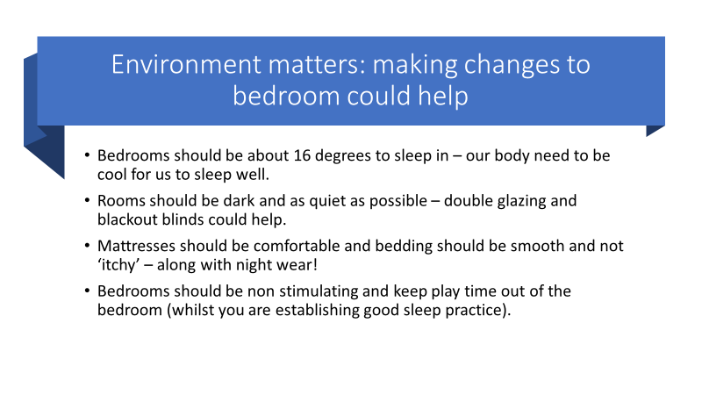**Mental Health Matters**.

|  |  |
| --- | --- |
| Your child’s stress, anxiety, and unhappiness (for whatever reason) will be having an impact on their sleep. Lack of sleep will then make their worries etc seem larger and more unmanageable.  Help your child to leave their worries outside of the bedroom. A worry tree can help.  *Seek out any support you can from school, speech and language therapy, communication and interaction team, child, and adolescent mental health to support your child with their worries etc.*  Usually, thinking and cognitive strategies help children with their mental health difficulties. |  |

# See the source image**Special tailored interventions:**

## Social stories can help explain the need to sleep (see Carol Gray’s books)

## Visual supports, books on sleep, visual timetables can support the sleep routine

## Safe bedroom – this will help you relax if you know your child is safe in their bedroom

## Consider tightly tucking your child in bed or ‘heavier’ bedding.

## Extra pillows may help with snuggling up and positioning in bed (or soft plush teddies)

## Sleep sacs – if bedding falls off regularly

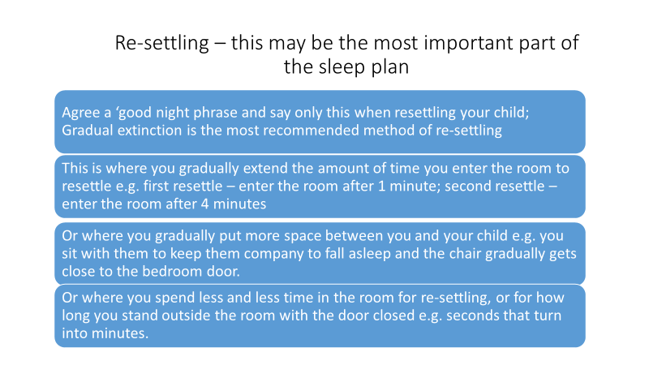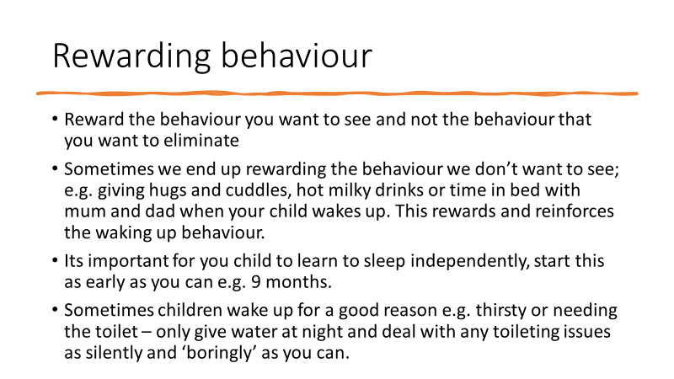**Teaching your child to learn to sleep**: You may have to change the way you respond to your child for them to learn to change their behaviour. Ultimately you are trying to teach your child a different way of falling and staying asleep. Re-settling them is going to be a part of this along with the above environmental considerations, behavioural strategies, and a good bedtime routine. If you child becomes unwell, then minimise any changes to your routine.

|  |  |
| --- | --- |
| **REWARD THE BEHAVIOUR**  **YOU WANT TO SEE** | * Children need to be rewarded ‘there and then’! So, if your child gets back into bed when you ask them to, you can put a marble in a jar. When the jar is full of marbles then the child gets a reward (a pre-agreed reward). * Bedtime pass – this is a card (object) that your child gives you if they wake at night and can use this for a hug or sip of water. Your child can use this ‘only once’. You can reward your child in the morning if this pass has not been used. * Your child should know how to get the reward, be rewarded as quickly as possible and every time they behave in the desired way. * You may need to be very specific about what behaviour you want to see e.g. being good is not enough information – “getting back in bed the first time I tell you to” gives the child more direction/information. |

**Bad dreams:** Some children wake from unpleasant dreams. If you child can do this, help them invent a power person/animal that can ‘parachute’ into any of their dreams. If they are able, help the to write about this character, draw, tell a story. This can help create positive neural pathways for your child. Your child may need specialist advice if bad dreams are persistent or troubling (night terrors/nightmares).

**Bedwetting and night-time feeds** – you may need to seek specialist advice for advice. See you GP for initial advice.

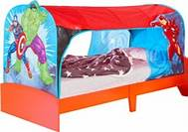**Highly specialised strategies/services**: if you have committed and tried all the above in a consistent and regular way and your child has made no progress and their behaviour is significantly challenging then you may need an assessment from an occupational therapist. Some children do benefit from highly specialist beds; however, these are constrictive and can be considered to ‘deprive a child of liberty’. You may want to try an overbed tent in the first instance (for the younger child).

If you child is not safe in their bedroom or at home, then you may need an assessment for an occupational therapist who is specialised in housing assessments. This occupational therapist may also assess for a specialist bed.

**Resources**: This has been a brief guide on helping you to help your child learn to sleep. See other more detailed resources at:

* Autism Speaks – sleep strategies for children with autism
* **Solve your child’s sleep problems – book by Dr Richard Ferber (essential reading)**
* Mind – howe to cope with sleep problems
* Sleep Scotland
* Scope – sleeping solutions
* Cerebra – sleep advice
* The sleep charity (sleepcharity.org)
* National Autistic Society