**How to adjust the height of a Zimmer frame**

Most Zimmer frames are height adjustable. This is achieved by either a ball bearing or E clip adjuster on each leg. Typically, a frame will have 5 different height possibilities normally at 1″ increments.

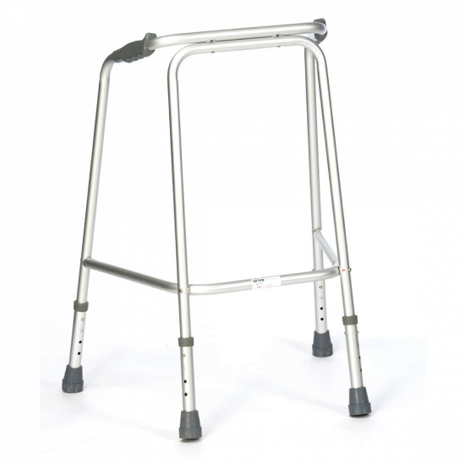

Ball bearing to adjust height.

To accommodate all possible heights of users, the frames that are provided by CHSS are available in three different height ranges. A small frame is 28.5-32.5 inches, the medium is 31.5-34.5 inches and the large is 35.5-38 inches.

You can also get slimline frames for smaller spaces.

**Correct height of Zimmer frame:**

The height of the walking frame is extremely important – too low and you will find yourself stooping when you walk; too high and you will put strain on your elbows and not be able to transmit your body weight effectively through to the frame.

The height of the frame is always measured to the height of the handgrips not to the maximum height of the frame. All measurements will be with respect to hand height.

The ideal height is measured as the height of the wrist bone from the floor when standing upright with arms at your side. Remember not to straighten your arms but measure it when your elbows are very slightly bent. You should also wear your regular indoor footwear when carrying out the measurement.