**Changing ferrules or skis on a Zimmer frame**

If you can see the metal of the bottom of the leg of the Zimmer frame, then the ferrules need to be changed. New ferrules for the Zimmer frame can be purchased from the below link:

<https://www.amazon.co.uk/Crutch-Rubber-Ferrules-Replacement-ferrules/dp/B07BSM1GN1/ref=sr_1_19_sspa?crid=2SY3NS2WXLXB7&keywords=ferrules&qid=1677615386&sprefix=ferrules%2Caps%2C198&sr=8-19-spons&sp_csd=d2lkZ2V0TmFtZT1zcF9tdGY&smid=A1YCINCOFV2IB0&th=1>

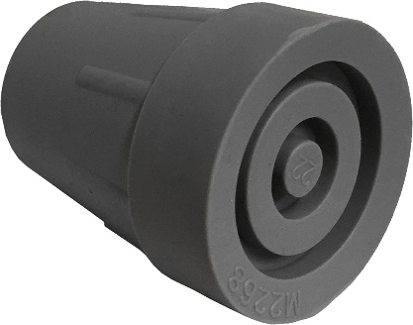

Some residents may be more suited to having skis attached to the back two legs of their wheeled Zimmer frame to make it glide more easily along the floor. If a resident appears to be getting stuck moving the Zimmer frame with ferrules, then they may requires skis. Skis can be purchased from the below link:

<https://www.amazon.co.uk/Zimmer-Walking-Walker-Ferrules-Lifeswonderful%C2%AE/dp/B07B8MVHVH/ref=sr_1_5?crid=3CSZ6YJNAJ5A2&keywords=skis+for+zimmer+frames&qid=1677615609&sprefix=skis+for+zimmer+frames%2Caps%2C197&sr=8-5>

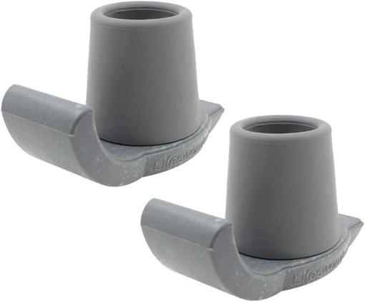

Both ferrules and skis are not something that CHSS provide.

**How to remove a ferrule from a Zimmer frame:**

The best way is to wriggle the ferrule off carefully but firmly. Ferrules can appear to be almost impossible to remove. A tip for gaining a bit of extra grip is to remove the ferrule whilst wearing a pair of rubber gloves and twist the ferrule holding the Zimmer frame as still as you can (a second pair of hands always helps!).

Once the ferrule is off, you can put your replacement ferrule on. Again, it will appear that the ferrule won’t simply slip onto the Zimmer frame. Firmly twist the ferrule on to the end of the walking aid.