Exercise Plan-

1. Deep breathing: Sit comfortably and maintain a good posture. Now, gently breath in and out for 2 minutes.
2. Neck Side Stretch: Move your head sideways to the right as much as possible towards your shoulder then bring it back to the centre.

Now move your head sideways to the left as much as possible towards your shoulder then bring it back to the centre.

Repeat 5- 10 times; take rest in between if needed.

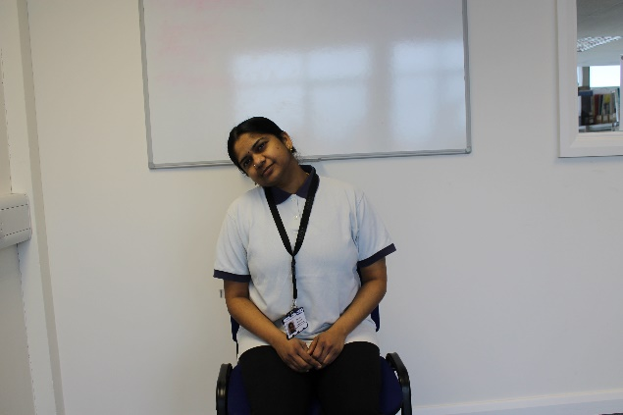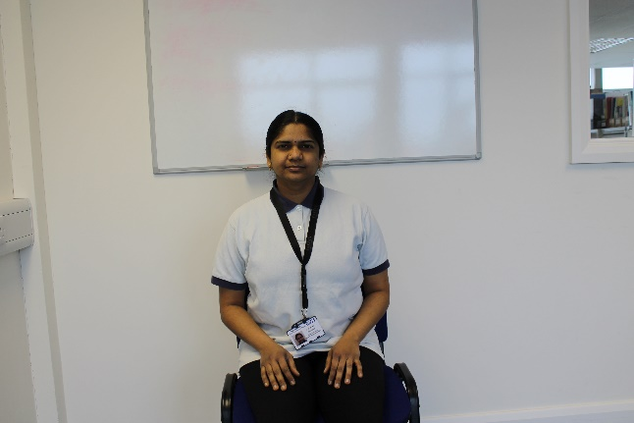

1. Head up and down: Move your head down taking your chin towards your chest as much as possible then return to the centre. Now move your head up to look at the ceiling then return to the centre. Repeat it for 5-10times.

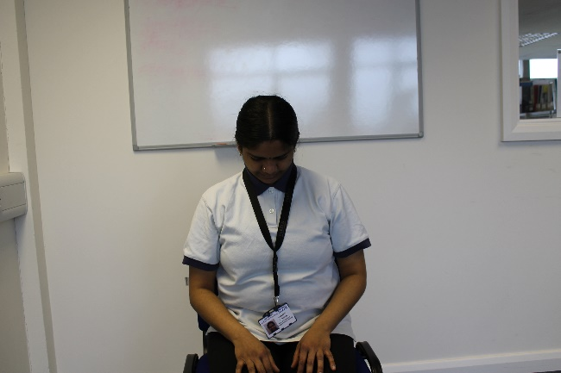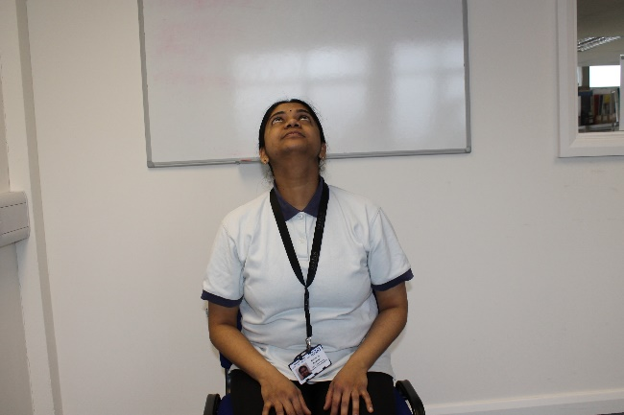

1. Hand and arm flicks:

Sit with big posture.

Flick your whole arm out in front of you – at shoulder height if possible and hands open so all your fingers straighten.

Repeat 5 - 10 times with both arms.

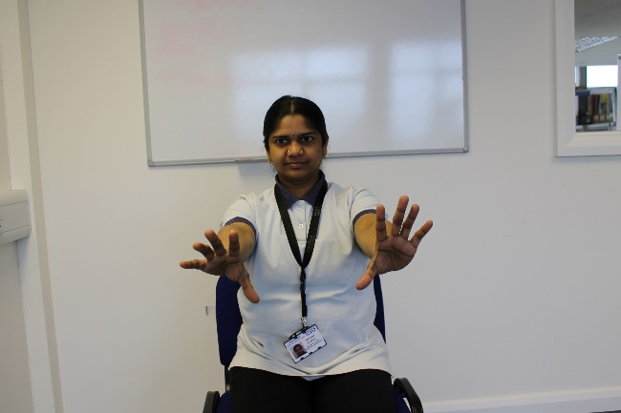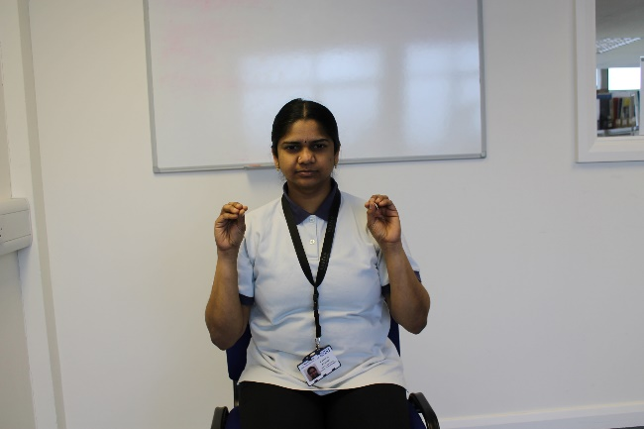

5- Finger interlock Hand stretch:

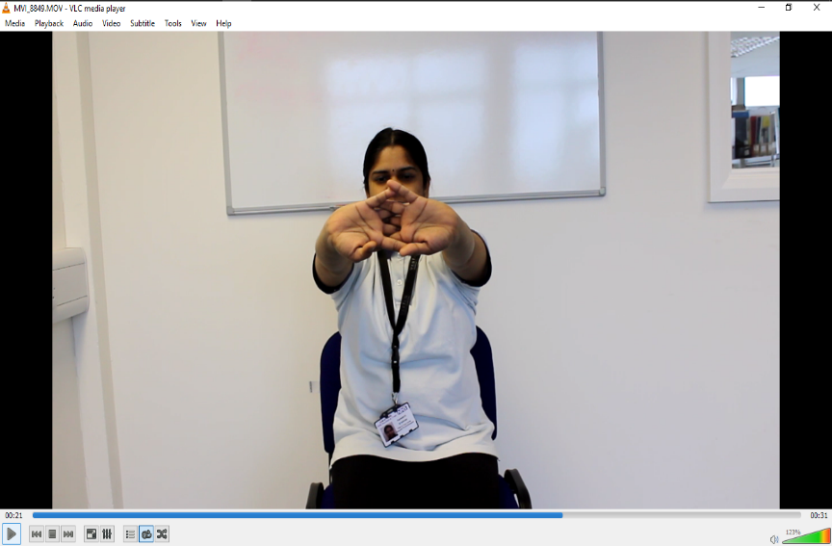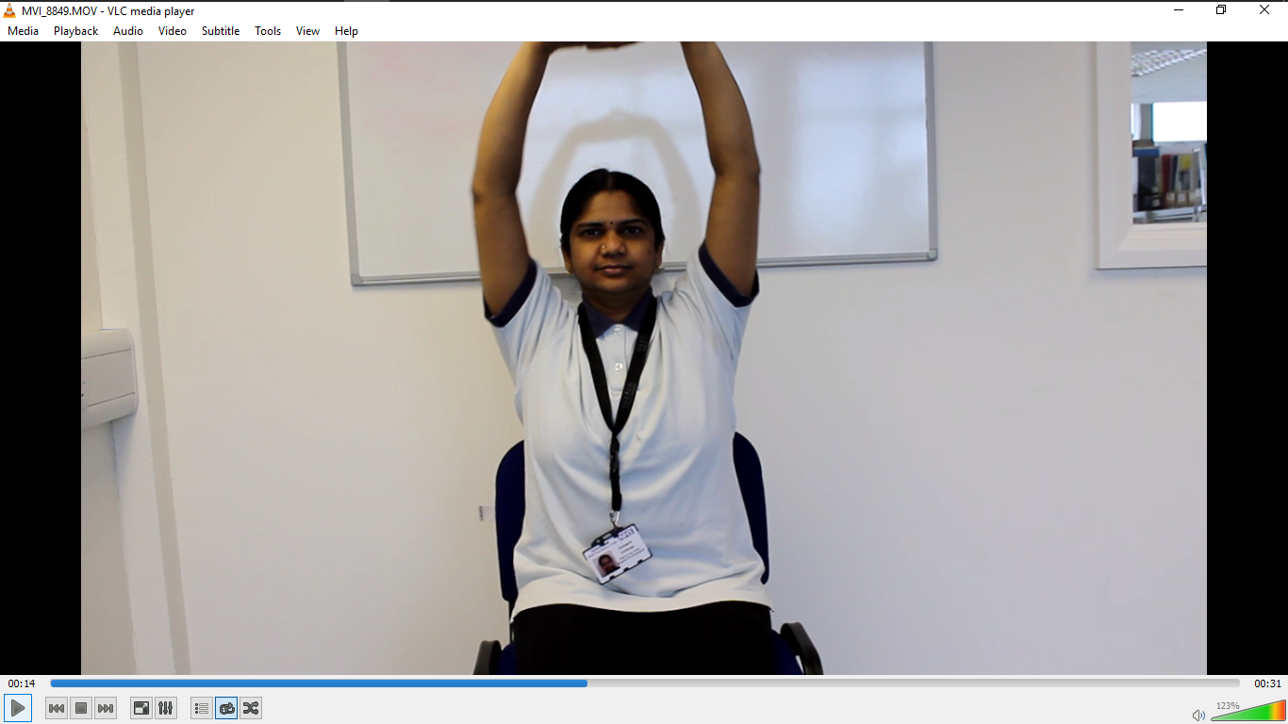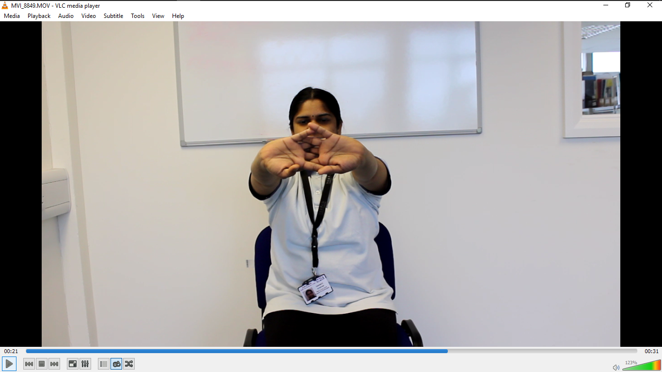

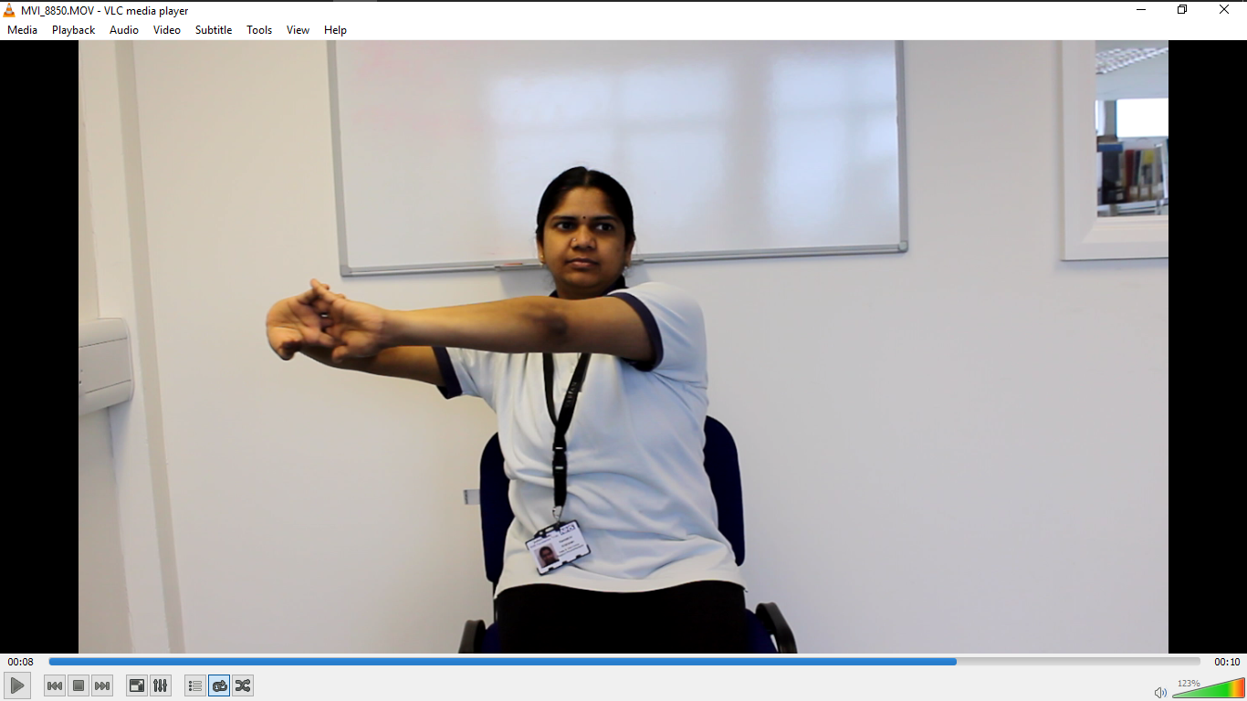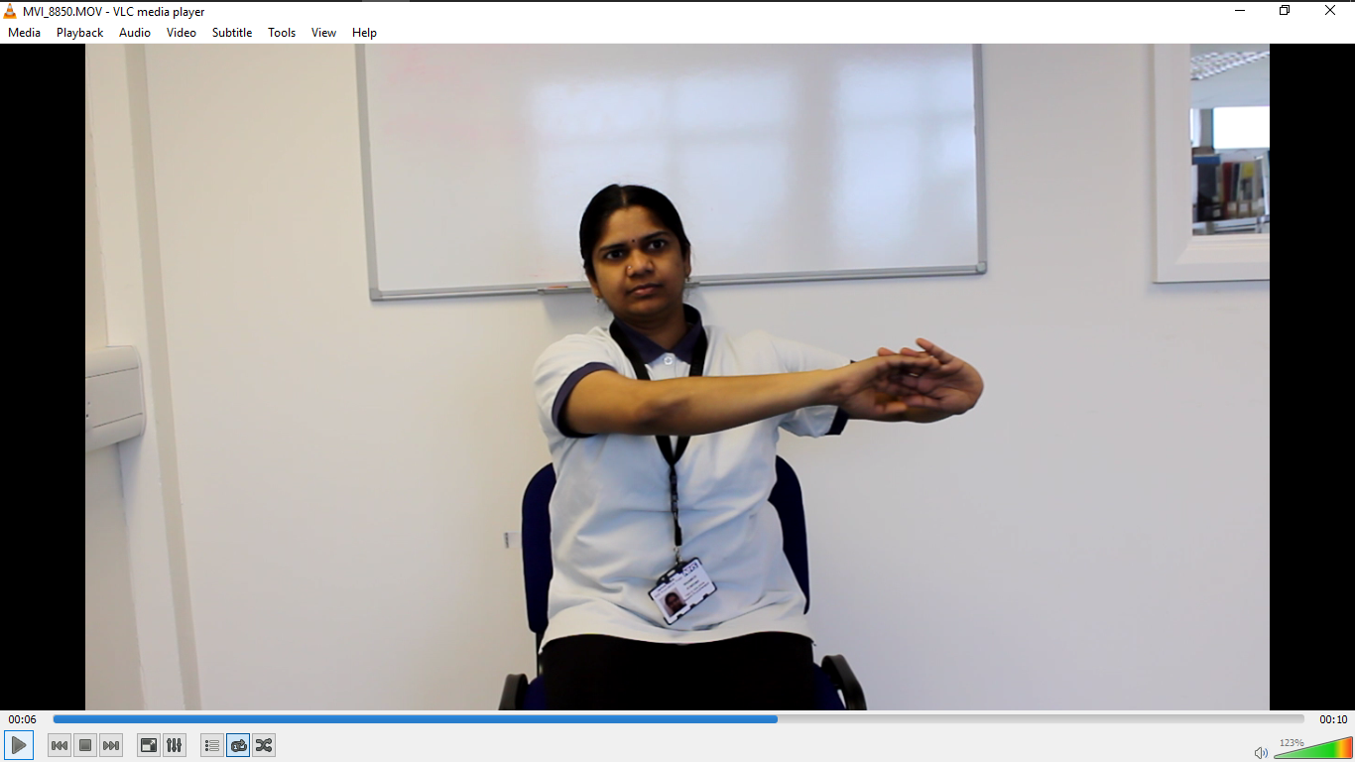

1. Upwards:

Now interlock your fingers, keep your elbows straight as much as possible. Take both arms up and bring it down. Repeat 5-10 times with both arms.

Upwards: Interlock your fingers, keep your elbows straight as much as possible. Now take both arms forwards and bring it down. Repeat 5-10 times with both arms.

Sideways: Interlock your fingers, keep your elbows straight as much as possible. Now take both arms sideways and bring it down. Repeat 5-10 times with both arms.

7. Shoulder Circles: Place your hands on the shoulders.

a. Rotate the shoulder forwards making a circle with your elbows; 5- 10 times.

b. Rotate the shoulder backwards making a circle with your elbows; 5- 10 times.

c. Bring your elbows together as much as possible then move it back to the normal

position; 5 – 10 times.

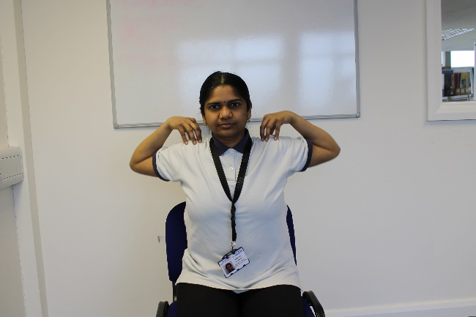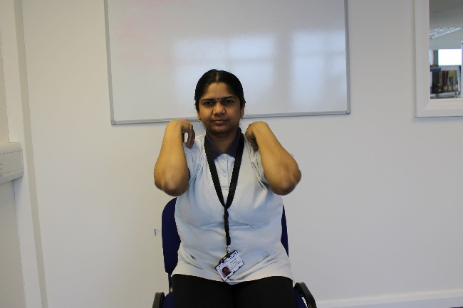

1. Shoulder Shrugging: Place your hands on the thighs.

Now lift both shoulders up at the same time and relax. Repeat 5 - 10 times.

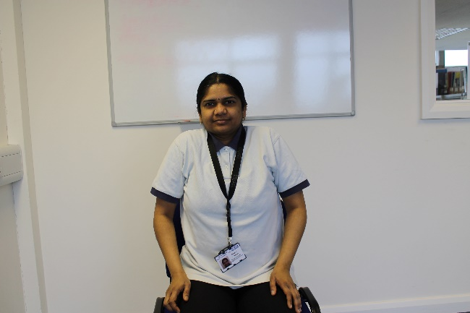

1. Trunk Rotation:

Sit up tall on the chair with good posture.

Straighten your arms sideways. Turn to look behind you.

Return to the centre and then turn to the other side.

Repeat 5 - 10 times.

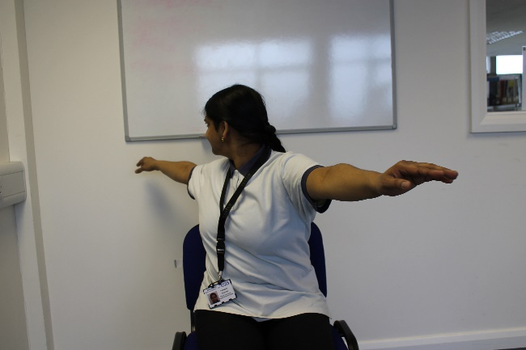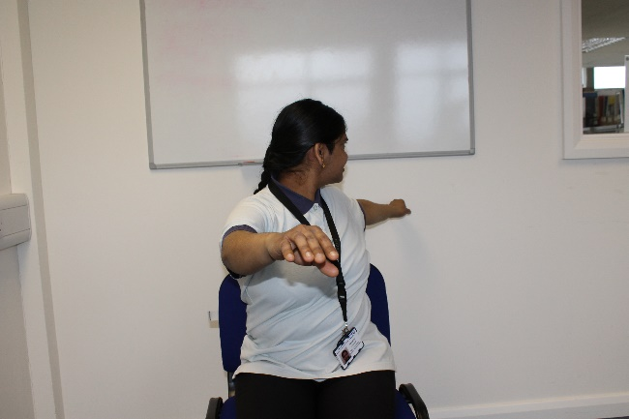

1. Chest Stretch:

Keep your hands in front of your chest; maintain elbows at shoulder level if possible.

Move your elbows back and then bring it in. Repeat 5 – 10 times.

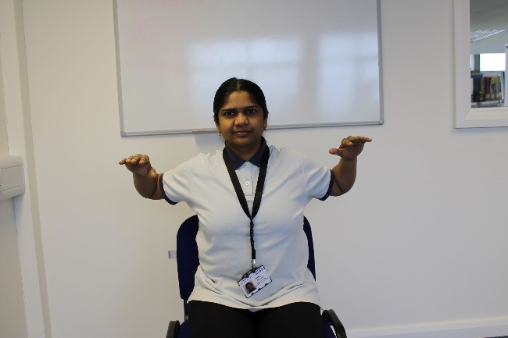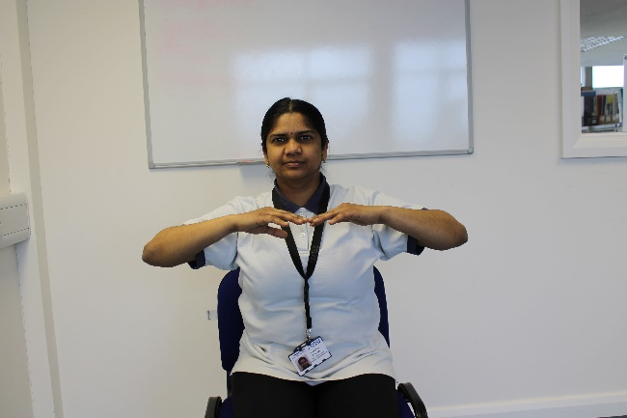

1. Static hip work:

Sit up tall in the chair. Place your hands together and put it in between the knees. Squeeze the knees together at the same time squeeze the cheeks of the bottom together so you will slightly rise up in the chair. Hold for 3- 5 seconds then relax. Repeat 5 – 10 times.

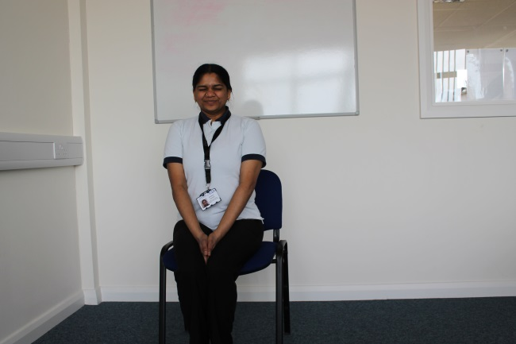

1. Side bends:

Keep your hands on your hips. Now bend sideways to the right, return to the centre and then bend sideways to the left.

This can also be practised by holding right hand to the chair and bend towards the right side with left arm up in the air. Return to the centre; hold left hand to the chair and bend towards the left side with right arm up in the air.

Repeat 5 – 10 times.

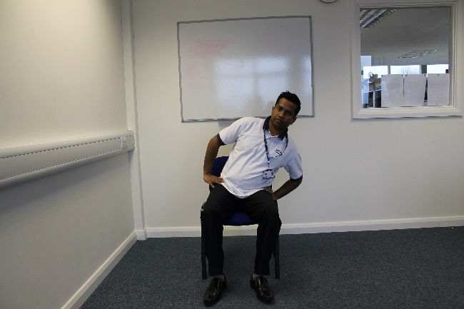

15. Hip March:

Sit on a chair; march on the spot.

Raise your right knee as high as you can. Hold for 3 - 5 seconds and slowly relax your leg, put it down, then repeat the same with your left knee. Practitioner can also hold the arms of the chair if needed.

Repeat 5 – 10 times.

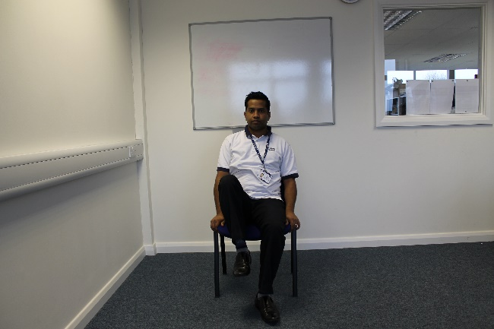

16. Straight leg rise:

Sit on a chair; Lift your right leg up; toes pointing you and straighten your knee.

Hold for 3 - 5 seconds and slowly relax your leg.

Now repeat the same with left leg.

Repeat 5 – 10 times each leg.

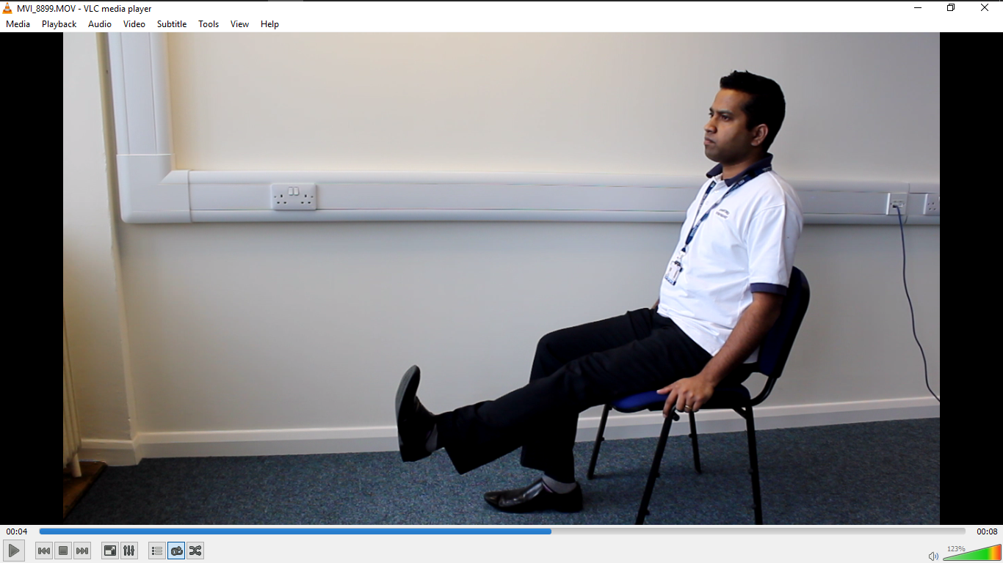

17. Toe and heel lift:

Sit on a chair with big posture.

Keep your heels on the ground, lift your toes and heels up and down alternatively; both feet together at the same time. Repeat 5 – 10 times.

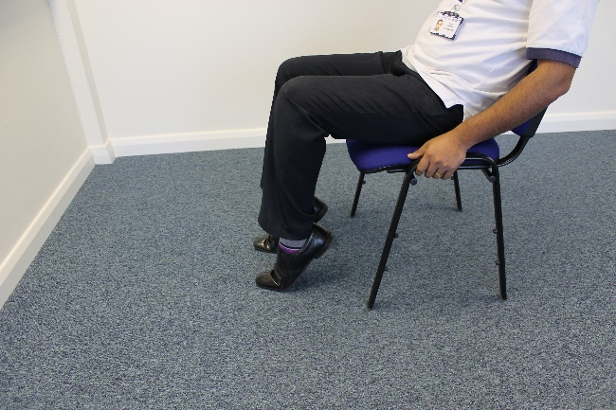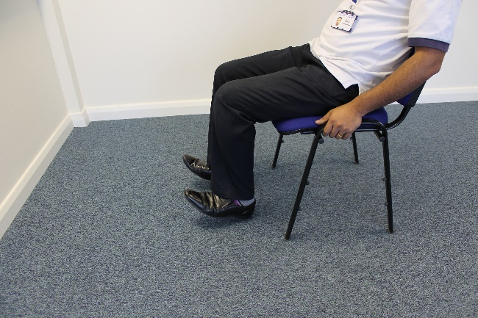

**If any of the exercise causing pain or discomfort, please stop it immediately and report to the nurse in charge. Please contact CHSS team on 01865 903400 for further assistance.**