Patient guide to using the Web Portal

An Information Guide for patients to complete and submit their clinical questionnaires.

Patient guide to using the Web Portal

Introduction
One aspect of your care with NHS Oxfordshire Talking Therapies is the strong emphasis for us to assess and monitor your progress on your journey with us. We therefore routinely use patient health questionnaires (mood questionnaires) to help us assess the level of difficulties you are experiencing and to help us agree the best treatment option with you.
You will be asked to complete these questionnaires before every appointment. To make the process as easy as possible, you can complete these questionnaires securely online through our patient portal.

Logging onto the portal before your appointment
Patients can complete the portal questionnaires on any device i.e a smartphone or a computer.
- You will be sent a welcome text message or email which will contain your portal Secure ID. Please keep these safe. There will also be a link to the patient portal user guide.
- This will be followed by another text message approximately 48 hours before your appointment with NHS Oxfordshire Talking Therapies, with a link to the patient portal for you to complete your questionnaires. If you are using a smartphone, you can click on the link directly from the text message which will take you straight to the portal. Alternatively, you can copy and paste the portal link https://www.iaptportal.co.uk/Home.aspx?AutoServiceID=208692901 into the web browser on any internet-enabled phone, tablet or computer.
If you indicated you did not want to receive SMS text messages and have agreed to receiving emails, we will provide the link and password to the patient portal in your appointment confirmation email and can be accessed by copy and pasting the link into a web browser.

- Once you have clicked on the link or copied it into your web browser, please enter Secure ID and your Date of Birth.
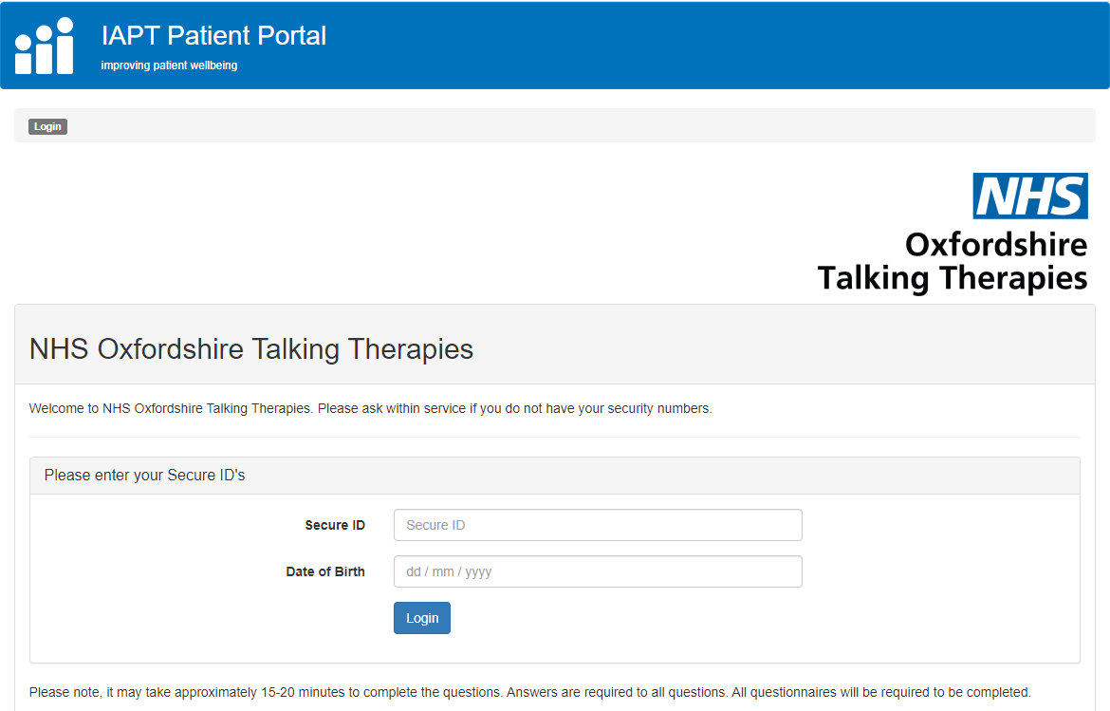
- Once logged in you can start to complete all the questionnaires listed. Click on ‘Next’, once the questionnaire is complete, to navigate to the next questionnaire. Please note that once you have clicked ‘Next’, you will not be able to return to the questionnaire you have completed.
Information: The number of questionnaires to complete at every appointment may vary depending on where you are on your journey with us.
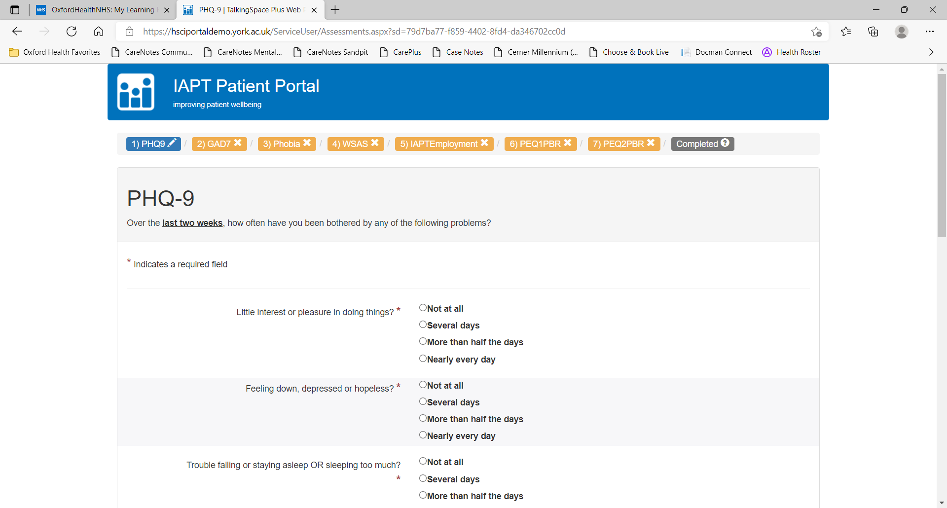
- When all assessments have been completed, you can exit the website.
.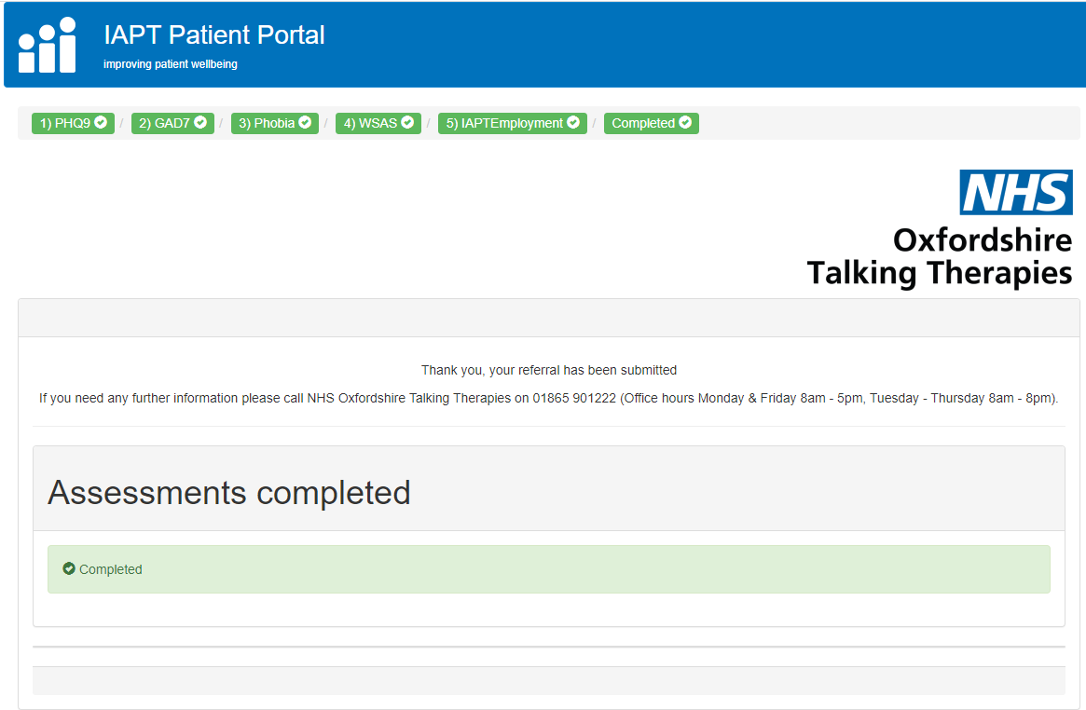
Information:
- Please complete all questions before clicking on ‘Next’ to go to the next questionnaire.
- If, for any reason, the internet session is interrupted or the web browser experiences any problems, you can log back into the web portal and complete the remaining questionnaires later.
- Any questionnaires that were completed in the original session will have been recorded. You will be notified of this on that particular questionnaire screen and can click on ‘Next’ to navigate straight through to the next incomplete questionnaire.
- It is only possible for you to complete the questionnaires once each day. If you try to log in and complete them again in the same day you will get a message on the screen advising that the questionnaires have already been completed for today.
- You can opt out of text alerts at any time and agree an alternative way to complete questionnaires with your practitioner
- Any problems please call 01865 901222

Confidentiality and your Health Record

We take security and confidentiality of the information you provide to us very seriously. The information you provide is kept on a secure electronic clinical recording system and we use this to provide you with the best possible service. This system is separate to the one used by your GP. Only NHS Oxfordshire Talking Therapies staff will routinely have access to this information. All NHS staff are required to abide by strict codes of conduct and everyone in the NHS has a legal duty to keep information about you confidential. This means that we only share information with those who have a genuine need to know, such as your GP, but it may also include people who provide care to you from organisations other than the NHS. They too have a legal duty to keep this information confidential.

Please discuss with your worker if you have concerns about informing your GP or others involved in your care of your contact with NHS Oxfordshire Talking Therapies.

We also need to let you know that, on some occasions, we are not able to keep confidentiality. An example of this would be if we become concerned about your safety or the safety/wellbeing of another person. Where possible, we would aim to discuss this with you beforehand and consider what steps are required to provide support necessary to ensure your safety and wellbeing.

