Collaborative Care Planning – Understanding Me and My goals
Dialogue is survey designed to measure how you rate your quality of life and your experience of the care you receive. Your responses can help structure a conversation with a healthcare professional about which areas are important to you putting you at the centre of the conversation.


The dialogue form is very simple and it only has 11 questions. The first eight questions cover different areas of you life and the last three are about your treatment.


You don’t have to write out long responses or give to much detail. Just choose a number from one to seven that best matches how you feel. Dialog is a personal measure. Two people giving the same number may mean different things. There are no wrong answers so be as honest as you can.

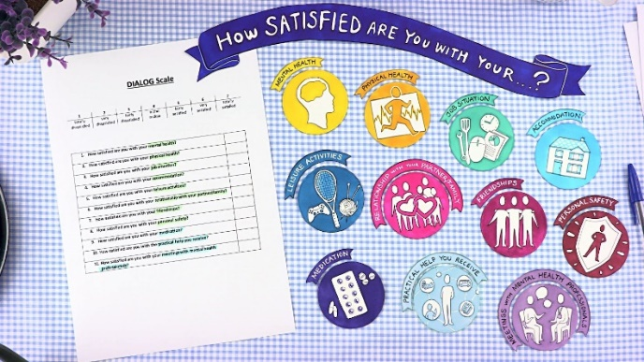
By filling in your answers at the beginning of your care you can get a really good idea of were you are starting from. Filling them in again sometime later, either during or at the end of your treatment, can be a useful record of where you are making progress and how well your treatment is working for you.


Any positive change is an achievement and can give you confidence but we don’t expect to see constant improvements all the time. If there isn’t a lot of change or your ratings get lower we might use this as a starting point to discuss making some changes to your treatment.
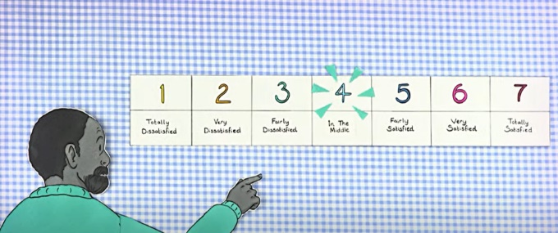
Using the dialog scale we will work with you to develop your care plan which sets out the help and support you need. Alongside this we will use the goal- based outcome scale which helps you identify key goals to work towards with us or our partners.
We will also use the recovering quality of life measure which helps assess your quality of life. By measuring this we can work together towards making a positive difference in your life both now and in the future.

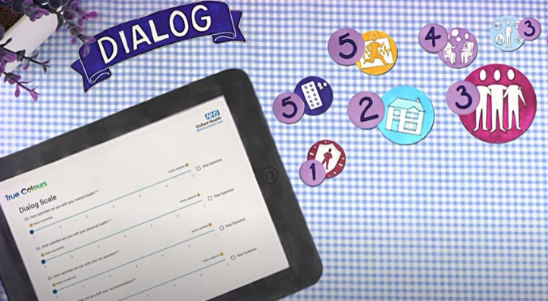
Reviewing these measure a number of times helps highlight areas that are meaningful and important to you and can help you understanding the parts of your life where you need to the most help and how well the help you are already getting is working.

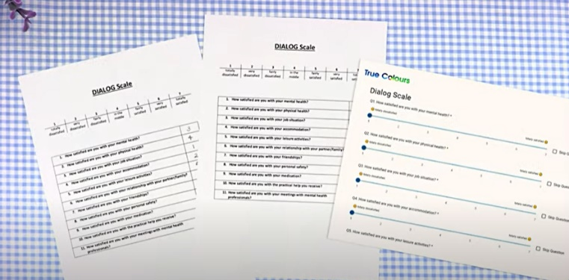
During your time with us you can ask about how you can use these measures as part of your care at any time.

