Oxfordshire Community Burns Wound Guidance

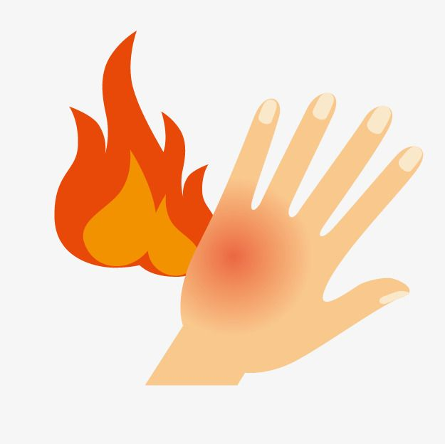

Contents

## Burns First Aid Guidelines……………………………………………………………………………………………3

## Burns Assessment……………………………………………………………………………………………………….5

## Causes of burns……………………………………………………………………………………………………………6

## Evaluating a burn injury: Assessing area and depth……………………………………………………..8

## Burn depth assessment……………………………………………………………………………………………….9

## Burn area assessment……………………………………………………………………………………………….10

## Stoke Mandeville Hospital Burn Service Referral Guidelines: Criteria for Referral………11

## Toxic Shock/Burns Sepsis Syndrome……………………………………………………………………….….11

## Burn Blister Management Guidelines………………………………………………………………………..12

Burns First Aid Guidelines

The prompt and effective application of burns first aid has been shown to positively impact on the burn outcome, preventing further tissue damage and reducing subsequent morbidity (Wood et al, 2016; Cuttle et al 2009; British Burn Association, 2018).

However, there is widespread variation in the first aid advice currently available for management of burns and scalds (Skinner and Peat, 2002; Varley, 2013; Wallace, 2013; Walker et al, 2005). The following recommendations are based on Stoke Mandeville Hospital Burns Unit guidelines based on evidence from a systematic literature review and form a minimum standard of care for first aid management of burns and scalds that is practical and effective to perform in any setting or environment (British Burn Association, 2018).

**Any patient suffering with extreme burns, >5% burns (Refer to Burns Assessment Document) or burns to the facial area, should be assessed within the Emergency Department and 999 MUST be called.**

**Immediacy of decontamination and dilution through irrigation of chemical injury is paramount as the duration of the chemical’s contact with the skin is a major determination of burn severity (Palao et al, 2010; Chau, Lee and Lo, 2012).**

**STOP** the burning process









Burns Assessment

250,000 people in the UK receive burn injuries every year (Wounds International, 2014). Around 90% of burn injuries in the UK are non-complex wounds that can be safely and effectively managed outside of specialist burn units (Wounds International, 2014). The quality of initial care will affect the pain and distress a patient may experience and will greatly influence the aesthetic and functional outcome (Enoch et al, 2009; Brigham and McLoughlin, 1996, American Burn Association, 2013; Hudspath and Rayatt, 2010).

All burn victims should be evaluated first as trauma patients, using advanced life-support guidelines and an ABCDE assessment.

There should be a particular emphasis on airway and breathing as these may be compromised by:

* Mechanical restriction of breathing (e.g. due to a circumferential deep thermal burn to the lower part of the face).
* Blast injury (e.g. causing penetration of the lung).
* Smoke inhalation (e.g. combustion products causing lung irritation and the effects of carboxyhaemoglobin).A patient history and physical examination should identify issues that impact on the immediate management of the patient:

*including any involvement of the face, eyes, ears, hands, genitals or feet

Causes of Burns

# Thermal

* **Flame injury** - e.g. gas flame when cooking, candle, open camp fire – can be any depth
* **Scalds** – frequently due to spilling of hot food, drinks and liquids or immersion in a hot bath/shower – tend to be superficial and partial thickness burns.
* **Contact burns** – when the skin touches an extremely hot object or a less hot object for a very long time e.g. when a patient has lost consciousness, such as those with epilepsy or misuse alcohol or drugs, or in older people after a fall. Common sources of contact burns include irons, oven doors, radiators and glass fronts of gas fires – tend to cause deep dermal or full thickness burns

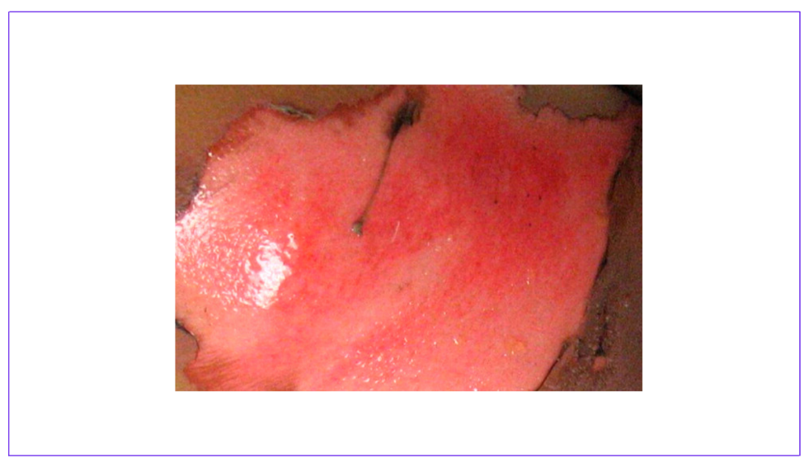 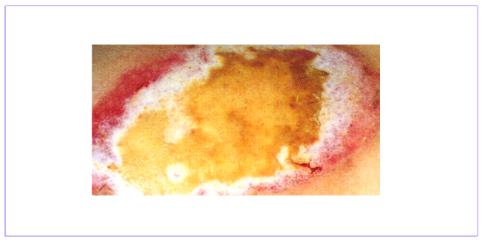

# Electrical

Electrical burns occur when electricity flows through the body from an entry point to an exit point. The burn is caused by the heat energy of the electric current damaging the tissue along its path of flow. The extend of tissue damage is determined by the voltage of the current. Electrical burns may cause arrythmias and so cardiac monitoring should be considered.

* **Low-voltage domestic current burns** – up to 220 to 220 volts - normally two small well-defined, deep partial thickness or full-thickness contact burns are seen at the entry (e.g. hands) and exit points (e.g. heels in contact with the ground)
* **High-voltage (direct contact) –** 1,000 volts or more – full thickness burns
* **High voltage (flash burns)** – occur when a person is exposed to an arc of high-voltage current, but the current does not actually enter the body. The associated heat energy causes superficial burns to exposed body parts such as the face, neck, hands and upper limbs. Ignited clothing may cause deeper burns - superficial partial thickness burns or full-thickness injury about an electric arc, with potential death.

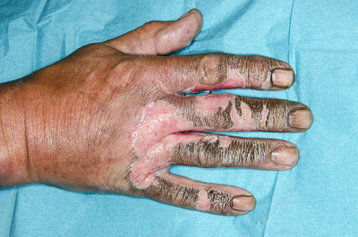 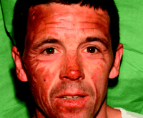 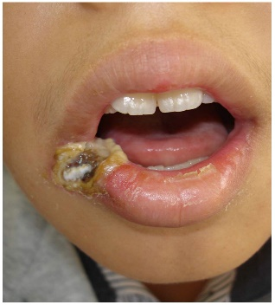 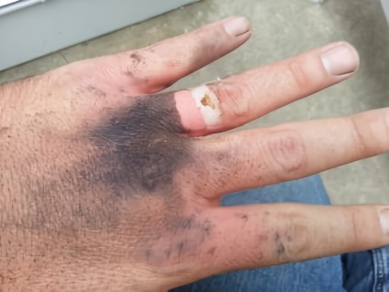 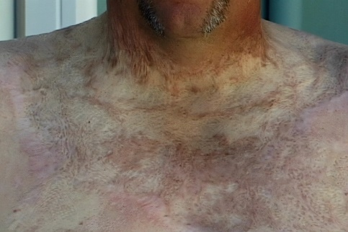 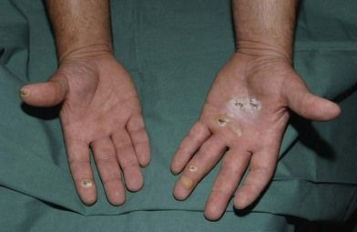

# Chemical

Chemical burn injuries from corrosive agents occur mainly in industrial accidents, but they can also result from products found in the home.

* **Acids** – sulphuric, nitric, hydrochloric, phosphoric etc.
* **Alkalis** – sodium or potassium hydroxide, ammonia, household cleaning agents such as bleach, cements
* Tend to cause deep dermal or full thickness burns because the tissue continues to be damaged until the chemical is completely removed.

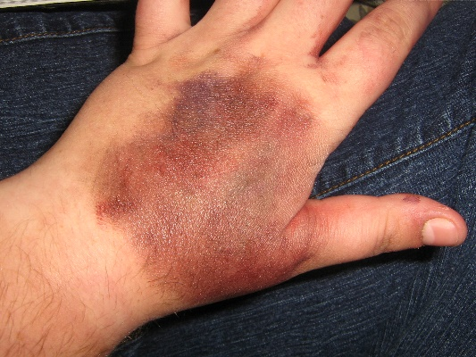 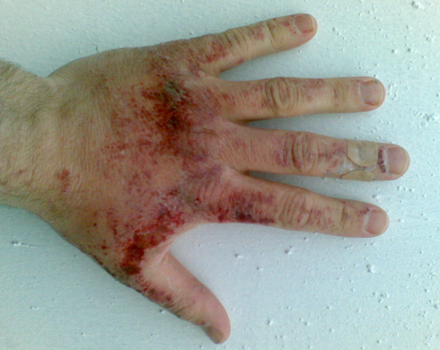 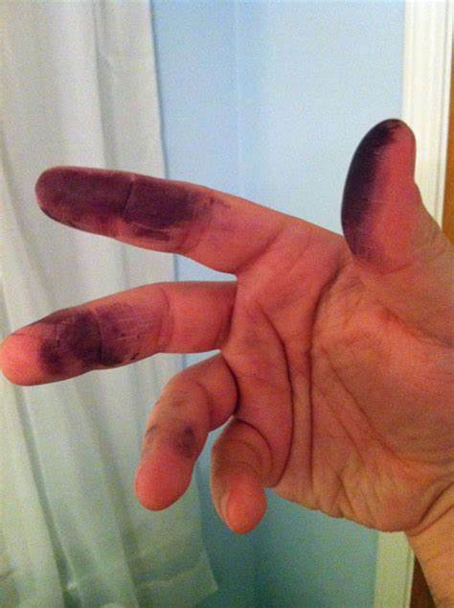 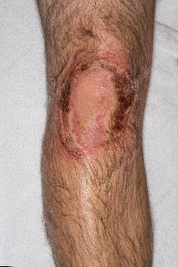 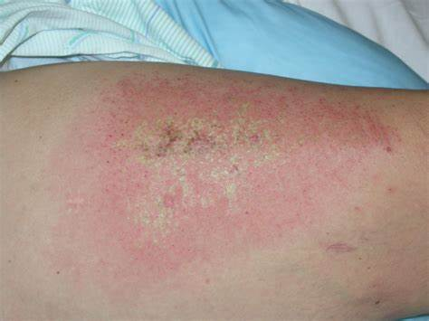

# Other

Other causes of burns include cold (frostbite) and radiation (radiotherapy).

Evaluating a burn injury: Assessing area and depth

Timely and accurate estimation of the surface area and depth of a burn injury is essential for determining appropriate management, ensuring rapid healing and preventing complications.

It is important to expose and assess **ALL** of the burn. With large burns, parts of the body can be uncovered in turn to help keep the patient warm.

***Burn depth may increase with time, so re-assessment after 24-72 hours is essential.***

**Assessing capillary refill** by applying light pressure with a sterile cotton bud on the reddened/discoloured area for 5 seconds. Following pressure removal, the area should go white then flush red very quickly (within 3 seconds). If the area remains red when the pressure is removed this is non-blanching.

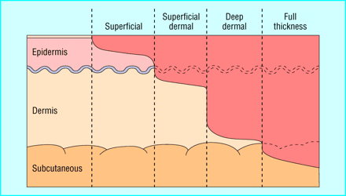

|  |  |  |  |  |
| --- | --- | --- | --- | --- |
| Depth of Burn | Layers of Skin Affected | Anatomy Diagram | Skin Examination/Presentation  Burn Depth Assessment | Oxford Health NHS Foundation Trust – ServiceNow – Customer StoryPhotograph Example |
| Superficial Epidermal / Erythema (for example, sunburn) | Epidermis is affected but dermis is intact |  | * Red * Brisk capillary refill (<3s) * Skin is dry and intact * No blisters * Painful * Heals within 3-7 days with analgesia and application of non-perfumed moisturiser | Burn - First Aid, Degrees of Burns and Treatment |
| Superficial Dermal / Partial Thickness | Epidermis and upper layers of dermis are involved |  | * Pale pink/red * Brisk capillary refill (<3s) * Exudate present * Intact or collapsed blisters may be present * Painful * Should heal within 14-21 days with non-adherent & absorbent dressings * Refer to Blister Management Guidelines * Refer to local Burn Service if >3% (adults) & >1% (children) | #1. Diagnosis & Classification of Burns | D&PS |
| Deep Dermal | Epidermis, upper and deeper layers or dermis are involved, but not underlying subcutaneous tissues |  | * Dark pink/red or white * Mottled, stained, cherry red * Delayed or absent capillary refill * Dull/variable sensation * Surgical intervention may be required * Circumferential burns need urgent discussion * Refer to local Burn Service >3% (adults) & >1% (children) |  |
| Full Thickness | The burn extends through all layers of skin to the subcutaneous tissue. If severe – into muscle and bone. |  | * White, black, brown or yellow * Dry and leathery * Thrombosed vessels may be visible * Eschar may be present * No capillary refill * No sensation * Surgical intervention & long-term scar management required * Circumferential burns need urgent discussion * Refer to local Burn Service |  |

# Oxford Health NHS Foundation Trust – ServiceNow – Customer StoryA diagram of a human skin Description automatically generatedBurn Depth Summary

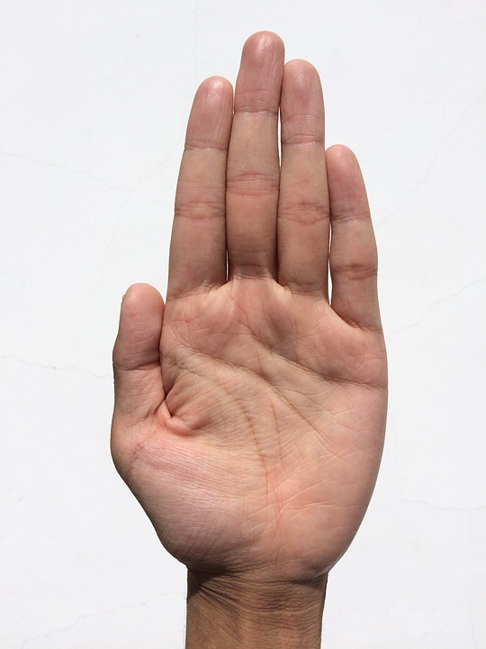Burn Area Assessment

Total burn area is expressed as the percentage of the total body surface area (TBSA). It is vital for establishing fluid resuscitation needs and for monitoring healing progress.

***When estimating TBSA, do not include simple erythema (reddening of the surrounding skin) in your calculation.***

**Palmar Surface**: A simple method to estimate burn area is to consider the palm of the patient’s hand (from crease of the wrist to tip of extended fingers) with closed fingers as representing approximately 1% of the body surface area. It is effective for estimating the area of small burns (<15%) or large burns (>85%). In larger burns, the burnt area can be quickly calculated by estimating the area of un-injured skin and subtracting it from 100.

Stoke Mandeville Hospital Burn Service Referral Guidelines: Criteria for Referral

*Telephone support and advice on initial care of any patient with a burn injury is available at all times (Stoke Mandeville Hospital, Aylesbury – Adults & Children – 01296 315 040)*

Toxic Shock/Burns Sepsis Syndrome

Usually manifests 2-4 days post injury and the patient often deteriorated rapidly. Once shock develops, mortality may be as high as 50%.

* Any patient, any size burn, any of the below symptoms = risk of toxic shock syndrome.
* Toxic shock / burns sepsis is a medical emergency – seek urgent medical assistance.

Burn Blister Management Guidelines

Burn blisters occur as a response to a burn injury whereby increased capillary permeability results in oedema formation that separates the epidermis from the underlying dermis. Burn blisters occur primarily in superficial partial thickness burns but also may overlay deeper burns.

De-roofing of a burn blister is a clinical procedure, which enable removal of the burn blister fluid and of the dead tissue.

**\*PLEASE CONTACT LOCAL BURNS SERVICE AND/OR TISSUE VIABILITY PRIOR TO DEROOFING ANY BURN BLISTERS\***

|  |  |  |
| --- | --- | --- |
| Criteria For Deroofing Burn Blisters | | |
| BLISTER TYPE ABOUT | | |
| LEAVE INTACT | Small non-tense blisters (<6mm) | Natural method of pain control. Unlikely to rupture spontaneously, damage underlying tissue, or impede healing |
| Deroofing is not the priority in care for severe and extensive burns | |
| DEROOF | Thick-walled blisters on fingertips, palm and soles of feet | Blisters on these areas are associated with discomfort and limited mobility. Alternative management is to cut a sizeable ‘window’ to remove fluid and enable assessment of the wound |
| Large (>6mm) and thin-walled blisters | Most likely to occur on hair-lined surfaces and ruptures spontaneously, which increases the risk of infection |
| Ruptured blisters and loose skin | Removes any necrotic and possibly contaminated material from the wound |

# Rationale for Deroofing Burn Blisters

* Allows proper observation of the wound bed and accurate assessment of the burn depth, including capillary refill time and sensation, to determine appropriate treatment.
* Remove non-viable tissue from the wound bed, allowing faster wound healing and decreasing likelihood of scarring.
* Evacuates blister fluid that may supress local and systemic immune function, improving the patient’s ability to defend against infection.
* Reduces the risk of wound infection associated with uncontrolled blister rupture and prolonged presence of non-viable tissue.
* Prevents pressure on underlying tissue, preserving the wound microcirculation and preventing the burn depth progression.
* Enables movement of joints, reducing the likelihood of burn contracture
* Improves the efficacy of topical wound therapy.

|  |  |
| --- | --- |
| Deroofing Procedure | |
| Skill Set | Only a practitioner experienced and confident in burn blister management technique should perform the deroofing procedure using appropriate tools |
| Timing | Perform on the day of initial assessment to avoid re-adherence of non-viable tissue to the wound bed |
| Technique | Administer analgesia and allow time to be effective, as deroofing procedure may transiently increase pain |
| Clean the wound with tap water or saline |
| Remove all non-viable tissue from the wound bed using either mechanical debridement with gauze or sharp dissection with scissors and forceps |
| Snip the blister, drain the fluid and cut away the dead or devitalised tissue carefully up to (but not including) the margin of sensate tissue |
| Do not perform blister needle aspiration as bacteria may be introduced into the site and incite infection |
| Send images of cleaned burns to the local burn service as Stoke Mandeville Hospital via [www.trips.nhs.uk](http://www.trips.nhs.uk) or to Tissue Viability |