Guidance – Opportunistic Maggots:

During the warmer months, it is not uncommon for district nursing teams to find maggots in wounds. This guide provides background information, what to do if you find an infestation of maggots in a wound bed, and patient advice.

**The Life Cycle as a Fly:**

* 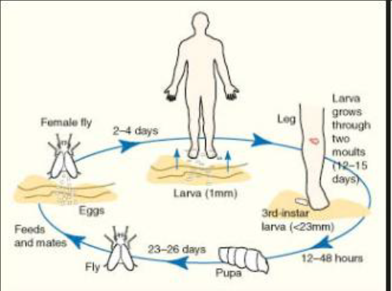Female flies lay between 50 and 300 eggs at a time.
* Flies can be attracted to the malodour of a wound and can lay the eggs on the surface of the bandages.
* These eggs hatch 8-12 hours later.
* Once the eggs hatch, the maggots can wriggle to a wound through bandages.
* Between 50-60 hours later, the life of the maggot has reached full growing potential, stops feeding and attempts to migrate the wound to find soil to pupate.
* Insects in this group typically ingest necrotic tissue and slough only.

**Red Flags to look for on finding Opportunistic Maggots:**

* Systemically unwell and/or Sepsis – requires admission and management accordingly.
* Recent foreign travel – in the past 7 days, flies from some continents (including South America and the west coast of Africa) are known to eat healthy tissue, therefore need to be removed immediately and aggressively.

**Concerns:**

* Infection:
  + Flies/Maggots originating from the United Kingdom will want to feed on devitalised tissue only. Opportunistic maggots are the same breed as medical grade maggots.
  + Maggots do not increase the risk of an infection, and in fact reduce the bacterial load of the wound beds including infections such as MRSA bacteria.
  + Maggots in the wound will be cleaning the wound and stimulating granulation tissue.
* Clinical Practice:
  + A Patient may be concerned and upset when maggots are discovered in their wounds however, this is not a reflection on poor clinical practice.
  + The presence of maggots is not a reflection on the clinician’s technique at dressing change.
  + The presence of maggots alone does not require a safeguarding alert.
  + The presence of maggots alone does not require admission to hospital.
  + Even though this is not an indication of poor care, please do complete an incident report.
* Dirtiness:
  + The presence of maggots does not reflect the dirtiness of a patient’s living conditions.

**This article is a helpful read and is still relevant today -** [**https://www.nursingtimes.net/clinical-archive/tissue-viability/myiasis-maggot-infestation/205571.article**](https://www.nursingtimes.net/clinical-archive/tissue-viability/myiasis-maggot-infestation/205571.article)**.**

**What to do when an infestation of maggots is found in a wound:**

1. Reassure the patient.
2. Exclude recent tropical travel.
3. Remove the maggots as best able using tap water or a shower, avoid using forceps to pick them up as this is likely to cause the maggots to tear apart.
4. Reassess the wound bed. The wound bed may be cleaner with less devitalised tissue having had maggots present. Reassess and dress the wound accordingly.
5. Check the wound for signs of infection and review if an antimicrobial dressing would be appropriate. Check if you think antibiotics are required if the wound appears acutely infected or there are signs of systemic infection.
6. Consider increasing visits or dressing changes to prevent reinfestation.
7. Document findings in the patients notes. Notify the GP for their records.

**Advice to patients:**

* Someone finding or being told they have maggots in their wound may come as quite a surprise as they may not be aware that the maggots are there.
* It is important to provide reassurance and education, as discussed above and to assert this has occurred not because they are unclean.
* It may be worth advising to those involved, that while non-medical maggots would not be of choice, the likelihood is that the fly source is the same as those used medically and the actual benefits of maggots to wounds is well researched.
* Reassurance about the clinician’s technique on dressing change, and the dressings used may also be helpful and dispel any fears about anything they have done.
* Advice could also include asking patients to look out for flies, especially during the warmer months when they are more prevalent as well buying fly repellent spray.