[](https://www.google.co.uk/imgres?imgurl=https://blogs.canterbury.ac.uk/studentnews/wp-content/uploads/sites/425/2018/08/Park-and-ride.jpg&imgrefurl=https://blogs.canterbury.ac.uk/studentnews/park-ride-update/&docid=r5cQ8n3WVgKVsM&tbnid=9RlXEhtZdpTOxM:&vet=10ahUKEwj1262Fh-bhAhXZDWMBHRNtAOAQMwh3KBwwHA..i&w=430&h=235&bih=694&biw=1024&q=park%20and%20ride&ved=0ahUKEwj1262Fh-bhAhXZDWMBHRNtAOAQMwh3KBwwHA&iact=mrc&uact=8) **Luther Street Medical Centre**

**Park and Ride:**

Seacourt Park and Ride, 234 Botley Road

Collects every 12 minutes, 11 minute Journey

**Bus 400 Park and Ride**

**Park and Ride**

[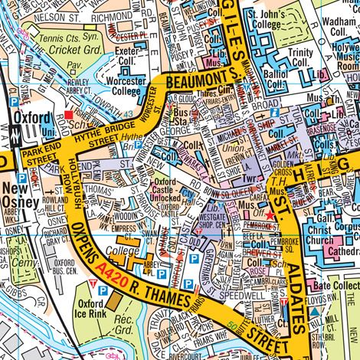](https://www.google.co.uk/url?sa=i&rct=j&q=&esrc=s&source=images&cd=&cad=rja&uact=8&ved=2ahUKEwjcgO64xujhAhVHUxoKHULyBeYQjRx6BAgBEAU&url=https://www.az.co.uk/oxford-a-z-street-atlas.html&psig=AOvVaw11jdDfxvsAIENVQQHz3Efh&ust=1556189120004874)****

**Local Bus Stops**

**Park and Ride:**

Redbridge Park and Ride, Abingdon Rd

Collects every 12 Minutes, 7 minute Journey

**Bus 300 Park and Ride**

**Local Bus Stop:**

St Aldates

Stop H2

5 Minute Journey, 0.3miles

**Bus 16: 34 Gold or S8 Gold**

**Bus 16A: NS8 Gold or S9 Gold**

**Luther Street is here**

**O’Hanlon House**

**Luther Street Medical Centre**

**ST Aldates**

**Tesco**

**Speedwell St**

**Cromwell Street**

**Park and Ride:**

Parkway Park and Ride (Stand B)

Collects every 30 minutes, 28 minute Journey

**Bus Sapphire 280/ Bus 400 Park and Ride**

**Park and Ride:**

Pear Tree Park and Ride, 21 Lakeside, Oxford

Collects every 12 Minutes, 23 minute Journey

**Bus 300 Park and Ride**

**Park and Ride:**

Parkway Park and Ride (Stand A) Water Eaton

Collects every 15 minutes, 53 minute Journey

**Bus 500/ Sapphire 280**

**Park and Ride:**

Oxford Thornhill Park and Ride

Collects every 9 minutes, 22 minute Journey

**Bus Sapphire 280 / U1 BROOKESbus**

**Local Bus Stop:**

Gloucester Green Bus Station

Every 3 minutes, 8 Minute Journey

Stops at Speedwell Street (Stop S2) and then a 1 minute walk to LSMC

**BUS: The Airline LHR/X9 Oxford/Oxford Tube**

**Local Bus Stop:**

Magdalen Street

Stop C4

Every 3 minutes, 12 minute Journey

**BUS: The Airline LHR/X9 Oxford/Oxford Tube**

**Local Bus stop:**

Queens Lane

Stop K5 or J3

Every 3 minutes, 6 minute Journey

**Bus: 400 Park and Ride/ Sapphire 280/3/3A/4/4A/5/8/9/10/13/T1/U1BROOKESbus / U5 BROOKESbus**