FOOD & BOWEL RECORD

Please record ALL you eat and drink each day, including times.

Day | Meal 1 | Meal 2 | Meal 3 | Snacks | Bowels  Type  (pto) | Other comments e.g, urgent, bleeding, straining exercising,  at work ??
Monday

Tuesday

Wednesday

Thursday

Friday

Saturday

Sunday

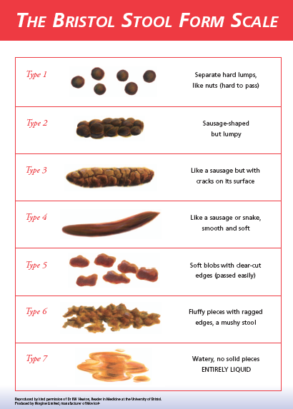

Please add any additional comments:

..................................................................................................................

..................................................................................................................

..................................................................................................................

..................................................................................................................

..................................................................................................................

..................................................................................................................

..................................................................................................................

..................................................................................................................

..................................................................................................................

..................................................................................................................

..................................................................................................................

..................................................................................................................

